A. P. Language and Composition Mr. Henry

Assignment: Independent Reading Critical Analysis

Rhetorical Mode: Expository/Argumentation
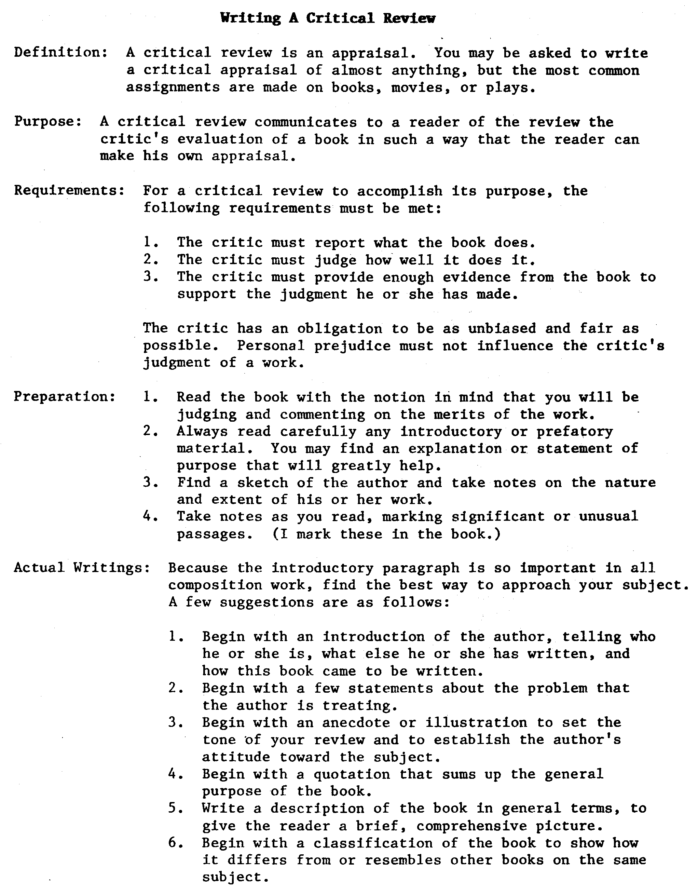
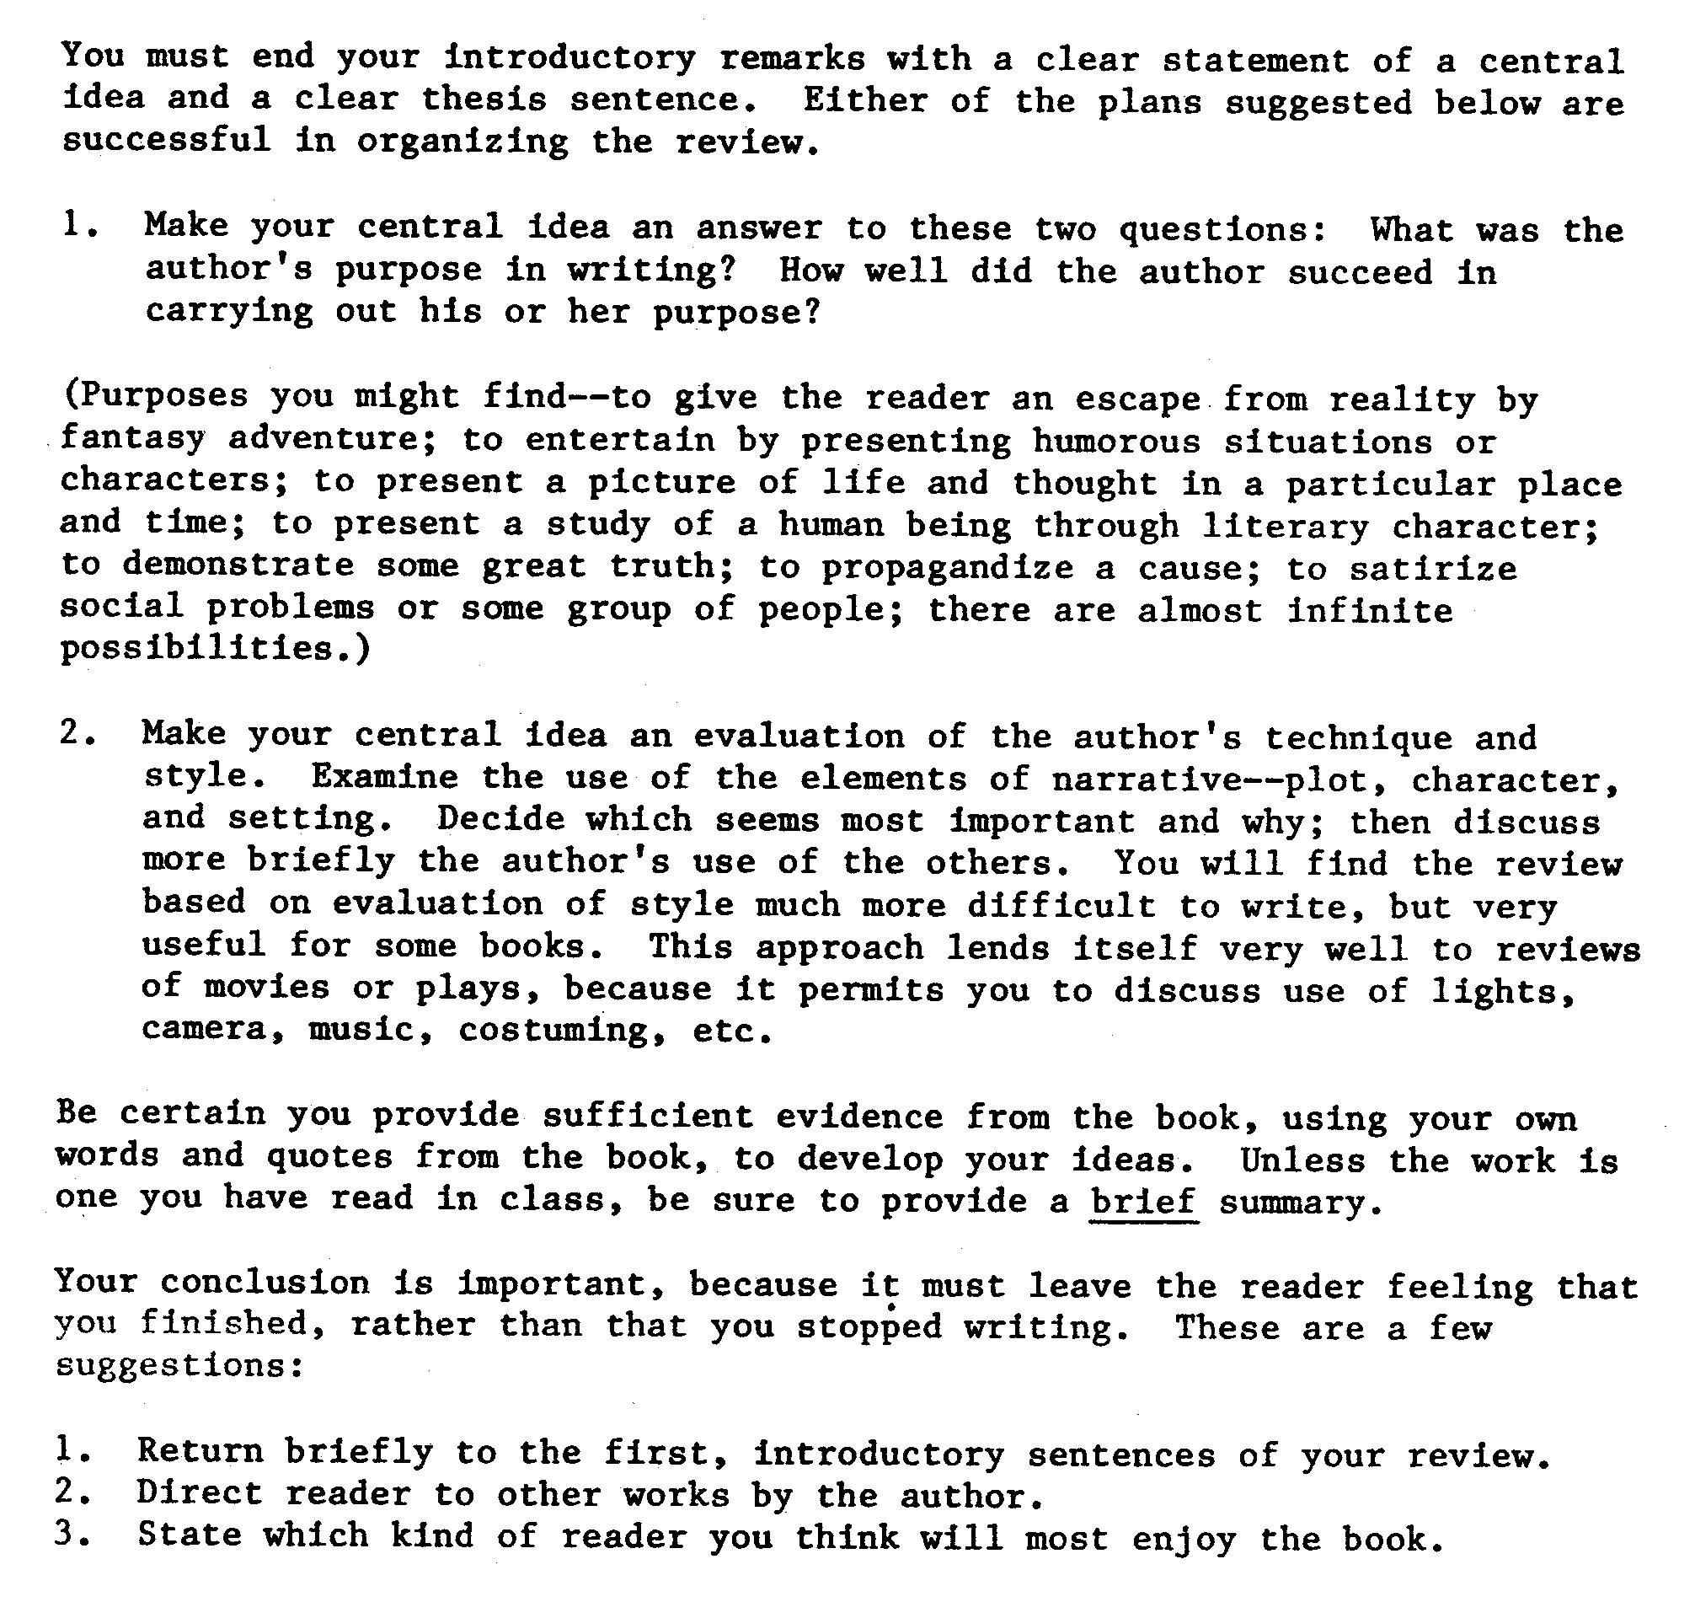

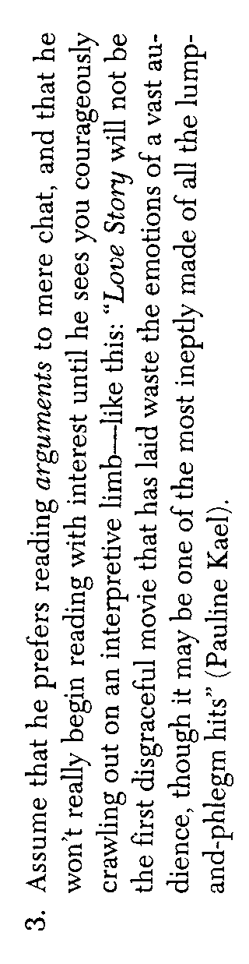
A. P. Language and Composition Mr. Henry 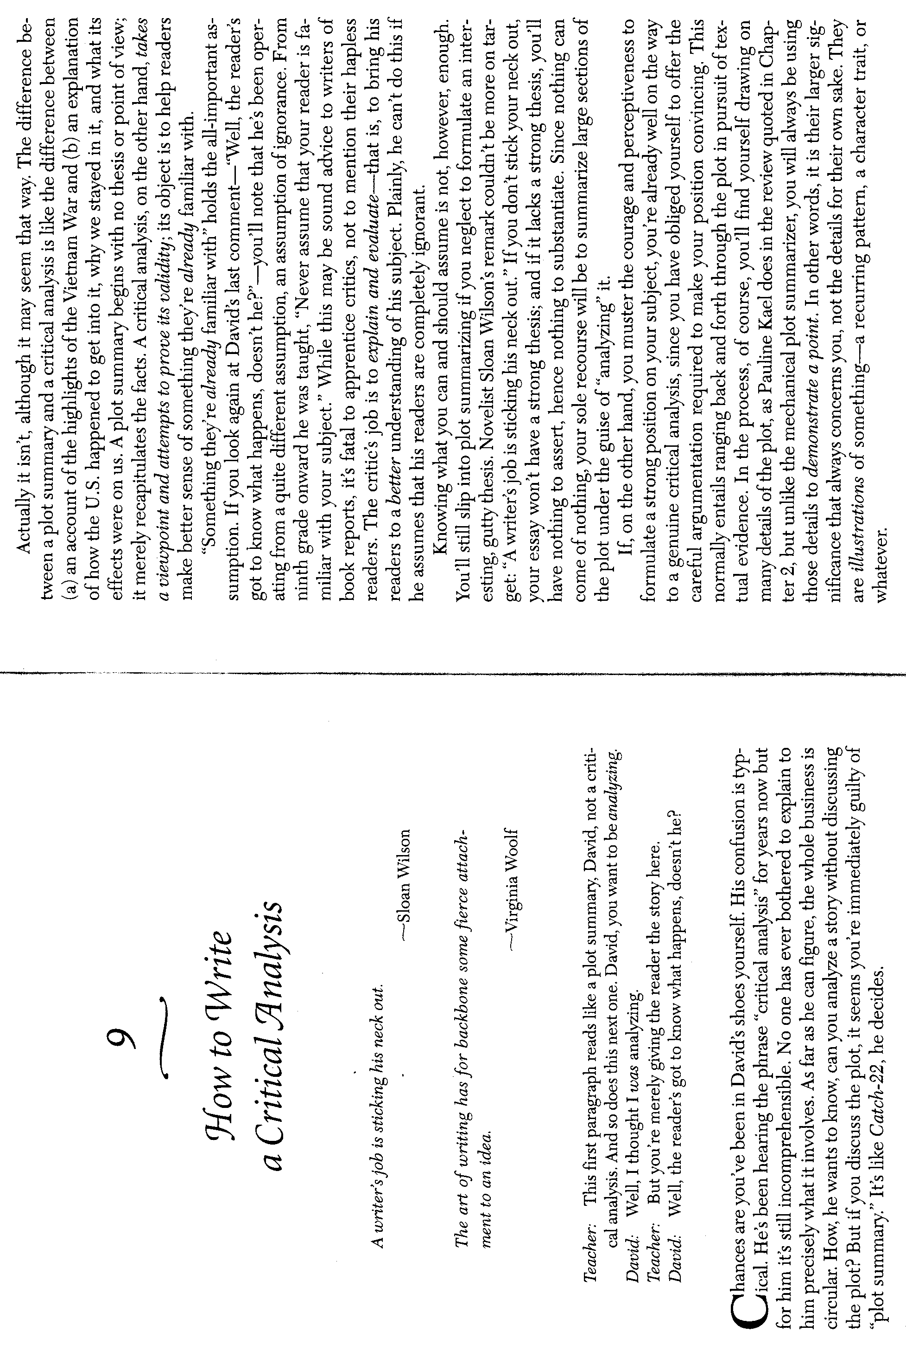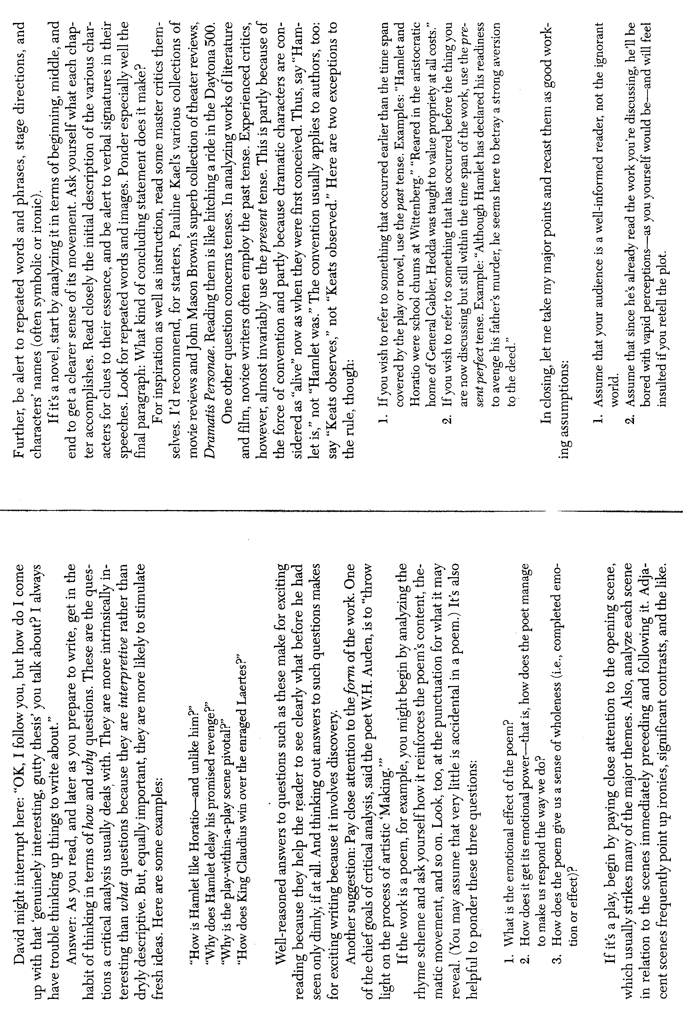
Assignment:Independent Reading Critical Analysis

Rhetorical Mode:Expository/Argumentation

