Chem 11 The Shape and Behaviour of Molecules Chapter 12 Notes

1. In General (refer to chapter 12-11)
- molecules have a geometric shape
- shapes of molecules influence some of the properties of matter

2. Molecules and Geometric Shapes
a. Evidence
- experimentally using X-rays, microwaves, and NMR spectroscopy
b. Valence Shell Electron Pair Repulsion Theory
- VSEPR

1. -All bonded atoms in a molecule will arrange themselves to maintain a minimum potential energy due to electron-electron repulsion
- Greatest repulsion felt between lone pairs of electrons (unbonded electrons)
- Lone pair and a bonded pair have less repulsion
- Least repulsion between two bonded pairs

2. – States that the geometry of molecules is determined by the number of bonded pairs and lone pairs of electrons around the central atom

c. Types of Geometric Shapes (pictures from http://www.chempage.de/theorie/vsepr.htm)

1. Linear  - 2 atoms bonded to central atom (CA)  - No lone electrons around CA  - 180° bond angle | 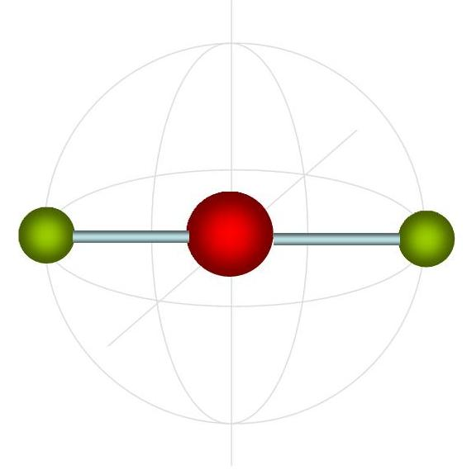
2. Trigonal Planar  - 3 atoms bonded to CA  - No lone electrons around CA  - 120° bond angle | 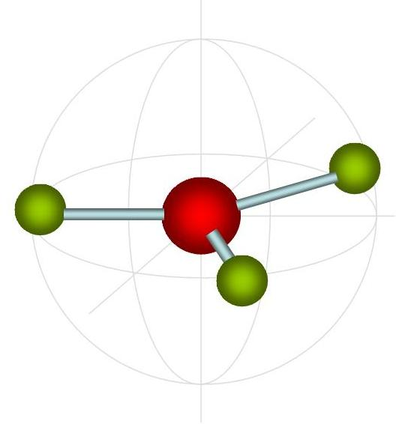
3. Tetrahedral  - 4 atoms bonded to CA  - No lone electrons around CA  - 109.5° bond angle | 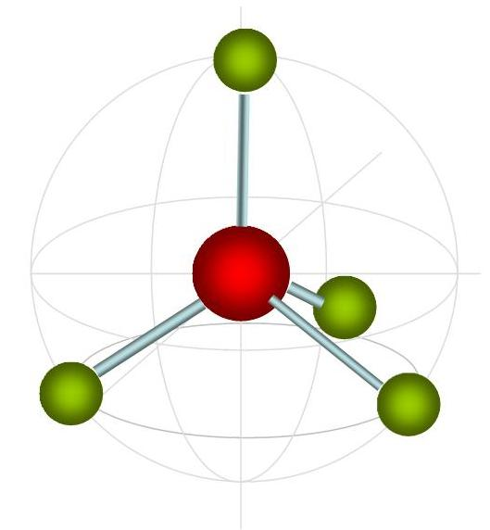
4. Trigonal Pyramidal  - 3 atoms bonded to CA  - 1 pair lone electrons around CA  - 107° bond angle | 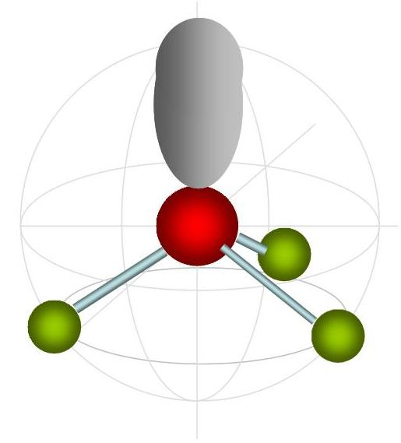
5. Angular  - 2 atoms bonded to CA  - 2 pair lone electrons around CA  - 104.5° bond angle | 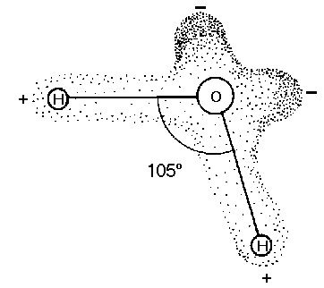
6. Trigonal Bipyramidal  - 5 atoms bonded to CA (d orbitals involved)  - No lone pair electrons around CA  - 90°, 120°, 180° bond angles  - 3 pair form triangle around CA with 1 above | 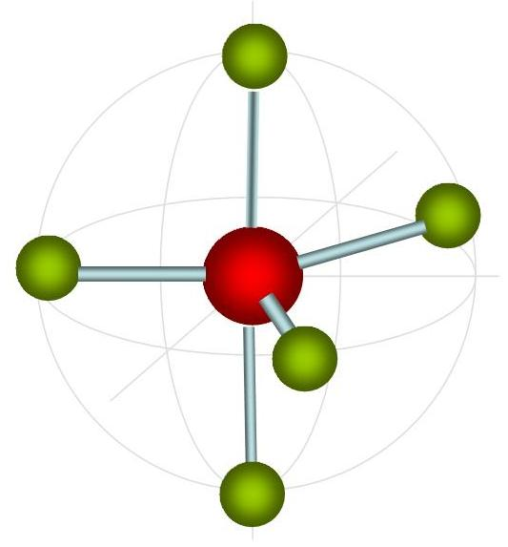
7. Octahedral  - 6 atoms bonded to CA  - No lone electrons around CA  - 90°, 180° bond angles (1 above & 1 below) | 