Real Date |  |  |  |  |  |  |  |  |  |  |  |  |  | Campaign Time
Adventure |  |  |  | Sanctioned ? |  |  |  |  | Yes |  |  |  | No |  |  | GM

 | Name |  |  |  |  |  |  |  |  |  |  |  |  |  |  |  |  |  |  |  |  |  | Class |  |  |  |  |  |  |  |  |  |  | Race |  |  |  |  |  |  |  | Level |  |  |  |  |  |  |  |  | Alignment |  |  |  |  |  |  |  |  |  |  | Player Name
 | Str |  |  |  |  |  | Dex |  |  |  |  |  |  | Con |  |  |  |  |  |  |  | Int |  |  |  |  |  |  |  |  | Wis |  |  |  |  |  | Cha |  |  |  |  |  |  | Com |  |  |  |  |  |  |  |  |  |  |  |  |  |  |  |  | Quirks/Flaws |  |  |  |  |  |  | Magic/Special
 |  |  | Max HP |  |  |  |  |  | Pain Threshold |  |  |  |  |  |  |  |  |  | Fatigue |  |  |  |  |  |  |  |  |  |  |  |  |  | AC |  |  |  |  |  |  |  |  |  |  |  |  | Honor |  |  |  |  |  | Fame
 |  |  |  |  |  |  |  | Combat Notes |  |  |  |  |  |  |  |  |  |  |  |  |  |  |  |  |  |  |  |  |  |  |  |  |  |  |  |  |  |  |  |  |  |  | Temp
 |  |  |  |  |  |  |  |  |  |  |  |  |  |  |  |  |  |  |  |  |  |  |  |  |  |  |  |  |  |  |  |  |  |  |  |  |  |  |  |  |  |  | Honor
 |  | Individual Experience Point Awards

 | Name |  |  |  |  |  |  |  |  |  |  |  |  |  |  |  |  |  |  |  |  |  | Class |  |  |  |  |  |  |  |  |  |  | Race |  |  |  |  |  |  |  | Level |  |  |  |  |  |  |  |  | Alignment |  |  |  |  |  |  |  |  |  |  | Player Name
 | Str |  |  |  |  |  | Dex |  |  |  |  |  |  | Con |  |  |  |  |  |  |  | Int |  |  |  |  |  |  |  |  | Wis |  |  |  |  |  | Cha |  |  |  |  |  |  | Com |  |  |  |  |  |  |  |  |  |  |  |  |  |  |  |  | Quirks/Flaws |  |  |  |  |  |  | Magic/Special
 |  |  | Max HP |  |  |  |  |  | Pain Threshold |  |  |  |  |  |  |  |  |  | Fatigue |  |  |  |  |  |  |  |  |  |  |  |  |  | AC |  |  |  |  |  |  |  |  |  |  |  |  | Honor |  |  |  |  |  | Fame
 |  |  |  |  |  |  |  | Combat Notes |  |  |  |  |  |  |  |  |  |  |  |  |  |  |  |  |  |  |  |  |  |  |  |  |  |  |  |  |  |  |  |  |  |  | Temp
 |  |  |  |  |  |  |  |  |  |  |  |  |  |  |  |  |  |  |  |  |  |  |  |  |  |  |  |  |  |  |  |  |  |  |  |  |  |  |  |  |  |  | Honor
 |  | Individual Experience Point Awards

 | Name |  |  |  |  |  |  |  |  |  |  |  |  |  |  |  |  |  |  |  |  |  | Class |  |  |  |  |  |  |  |  |  |  | Race |  |  |  |  |  |  |  | Level |  |  |  |  |  |  |  |  | Alignment |  |  |  |  |  |  |  |  |  |  | Player Name
 | Str |  |  |  |  |  | Dex |  |  |  |  |  |  | Con |  |  |  |  |  |  |  | Int |  |  |  |  |  |  |  |  | Wis |  |  |  |  |  | Cha |  |  |  |  |  |  | Com |  |  |  |  |  |  |  |  |  |  |  |  |  |  |  |  | Quirks/Flaws |  |  |  |  |  |  | Magic/Special
 |  |  | Max HP |  |  |  |  |  | Pain Threshold |  |  |  |  |  |  |  |  |  | Fatigue |  |  |  |  |  |  |  |  |  |  |  |  |  | AC |  |  |  |  |  |  |  |  |  |  |  |  | Honor |  |  |  |  |  | Fame
 |  |  |  |  |  |  |  | Combat Notes |  |  |  |  |  |  |  |  |  |  |  |  |  |  |  |  |  |  |  |  |  |  |  |  |  |  |  |  |  |  |  |  |  |  | Temp
 |  |  |  |  |  |  |  |  |  |  |  |  |  |  |  |  |  |  |  |  |  |  |  |  |  |  |  |  |  |  |  |  |  |  |  |  |  |  |  |  |  |  | Honor
 |  | Individual Experience Point Awards

 | Name |  |  |  |  |  |  |  |  |  |  |  |  |  |  |  |  |  |  |  |  |  | Class |  |  |  |  |  |  |  |  |  |  | Race |  |  |  |  |  |  |  | Level |  |  |  |  |  |  |  |  | Alignment |  |  |  |  |  |  |  |  |  |  | Player Name
 | Str |  |  |  |  |  | Dex |  |  |  |  |  |  | Con |  |  |  |  |  |  |  | Int |  |  |  |  |  |  |  |  | Wis |  |  |  |  |  | Cha |  |  |  |  |  |  | Com |  |  |  |  |  |  |  |  |  |  |  |  |  |  |  |  | Quirks/Flaws |  |  |  |  |  |  | Magic/Special
 |  |  | Max HP |  |  |  |  |  | Pain Threshold |  |  |  |  |  |  |  |  |  | Fatigue |  |  |  |  |  |  |  |  |  |  |  |  |  | AC |  |  |  |  |  |  |  |  |  |  |  |  | Honor |  |  |  |  |  | Fame
 |  |  |  |  |  |  |  | Combat Notes |  |  |  |  |  |  |  |  |  |  |  |  |  |  |  |  |  |  |  |  |  |  |  |  |  |  |  |  |  |  |  |  |  |  | Temp
 |  |  |  |  |  |  |  |  |  |  |  |  |  |  |  |  |  |  |  |  |  |  |  |  |  |  |  |  |  |  |  |  |  |  |  |  |  |  |  |  |  |  | Honor
 |  | Individual Experience Point Awards

 | Name |  |  |  |  |  |  |  |  |  |  |  |  |  |  |  |  |  |  |  |  |  | Class |  |  |  |  |  |  |  |  |  |  | Race |  |  |  |  |  |  |  | Level |  |  |  |  |  |  |  |  | Alignment |  |  |  |  |  |  |  |  |  |  | Player Name
 | Str |  |  |  |  |  | Dex |  |  |  |  |  |  | Con |  |  |  |  |  |  |  | Int |  |  |  |  |  |  |  |  | Wis |  |  |  |  |  | Cha |  |  |  |  |  |  | Com |  |  |  |  |  |  |  |  |  |  |  |  |  |  |  |  | Quirks/Flaws |  |  |  |  |  |  | Magic/Special
 |  |  | Max HP |  |  |  |  |  | Pain Threshold |  |  |  |  |  |  |  |  |  | Fatigue |  |  |  |  |  |  |  |  |  |  |  |  |  | AC |  |  |  |  |  |  |  |  |  |  |  |  | Honor |  |  |  |  |  | Fame
 |  |  |  |  |  |  |  | Combat Notes |  |  |  |  |  |  |  |  |  |  |  |  |  |  |  |  |  |  |  |  |  |  |  |  |  |  |  |  |  |  |  |  |  |  | Temp
 |  |  |  |  |  |  |  |  |  |  |  |  |  |  |  |  |  |  |  |  |  |  |  |  |  |  |  |  |  |  |  |  |  |  |  |  |  |  |  |  |  |  | Honor
 |  | Individual Experience Point Awards

 | Name |  |  |  |  |  |  |  |  |  |  |  |  |  |  |  |  |  |  |  |  |  | Class |  |  |  |  |  |  |  |  |  |  | Race |  |  |  |  |  |  |  | Level |  |  |  |  |  |  |  |  | Alignment |  |  |  |  |  |  |  |  |  |  | Player Name
 | Str |  |  |  |  |  | Dex |  |  |  |  |  |  | Con |  |  |  |  |  |  |  | Int |  |  |  |  |  |  |  |  | Wis |  |  |  |  |  | Cha |  |  |  |  |  |  | Com |  |  |  |  |  |  |  |  |  |  |  |  |  |  |  |  | Quirks/Flaws |  |  |  |  |  |  | Magic/Special
 |  |  | Max HP |  |  |  |  |  | Pain Threshold |  |  |  |  |  |  |  |  |  | Fatigue |  |  |  |  |  |  |  |  |  |  |  |  |  | AC |  |  |  |  |  |  |  |  |  |  |  |  | Honor |  |  |  |  |  | Fame
 |  |  |  |  |  |  |  | Combat Notes |  |  |  |  |  |  |  |  |  |  |  |  |  |  |  |  |  |  |  |  |  |  |  |  |  |  |  |  |  |  |  |  |  |  | Temp
 |  |  |  |  |  |  |  |  |  |  |  |  |  |  |  |  |  |  |  |  |  |  |  |  |  |  |  |  |  |  |  |  |  |  |  |  |  |  |  |  |  |  | Honor
 |  | Individual Experience Point Awards

Party Treasure/Loot Acquired |  |  |  | Party Experience Awards |  |  | Alignment Infraction/Adherence
Treasure | Type | Value |  | Occasion | EPs Awarded |  | Occasion | Points +/-

Monsters Encountered/Vanquished
Monster/Foe | HD | HackFactor | HP | AC | MV | Attacks/Defense Bonus | Damage | Treasure | EP Value
ALIGNMENT GRAPH
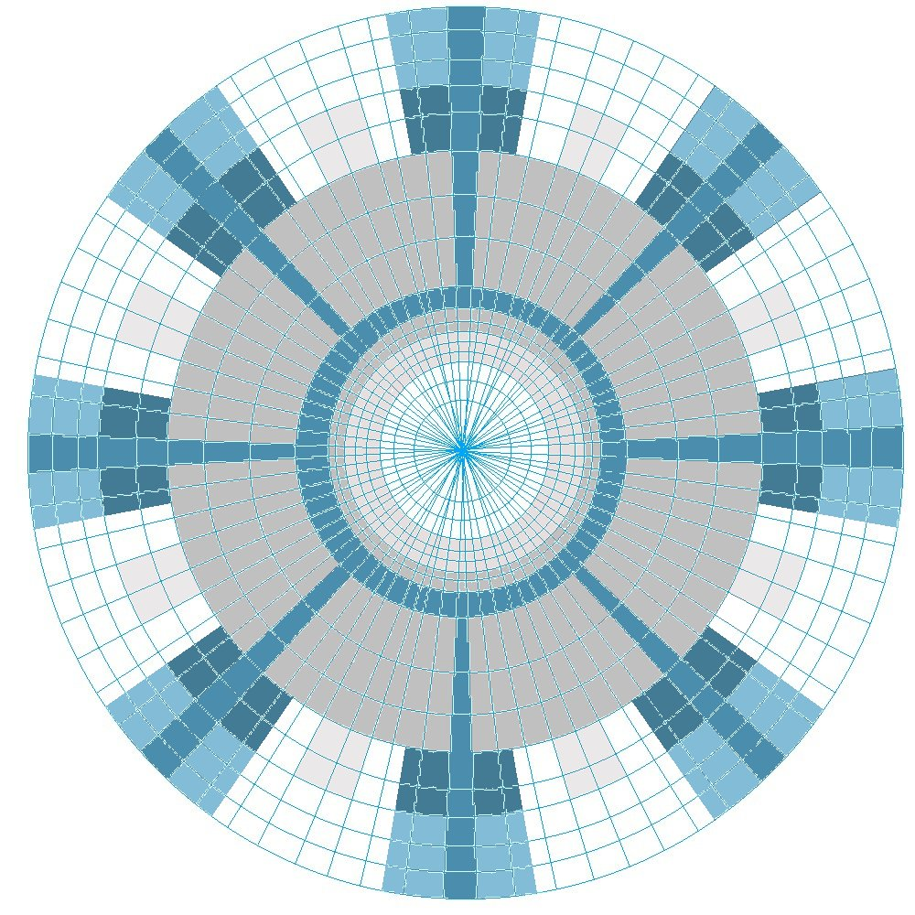
1. __________________________________ 4. __________________________________
2. __________________________________ 5. __________________________________
3. __________________________________ 6. __________________________________

Game Time Ticker |  |  |  |  |  | Light
Melee Rounds (10 per turn) |  | Days (28 per month) |  | Magic Effects Duration and Expirations |  | Type | Radius / Duration
Effect ______________
Duration ____________

Non-Combat Turns (6 per hr) |  | Months (14 per year) |  | Effect ______________  Duration ____________
Hours (24 per day) |  | Years

Clan Worksheet |  |  |  | Obligation |  |  |  |  |  | Marching Order
Clan Name |  |  |  | Nature |  |  | Amount | Due
Seat |  |  |  | Hireling Payments
Race
Align
Family Honor
Social Class |  |  |  | Lodging
Power Base
Hereditary Grudges |  |  |  | Debts
Hereditary Enemies
Hereditary Allies |  |  |  | Other

Unusual Events/Notes

