September 13 & 14, 2003 USBCHA Sanctioned
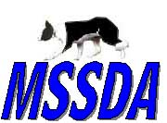

Mid South Stock Dog Association

In Conjunction with: International Goat Days

4351 Babe Howard Blvd.

Millington, TN

Two 1 day Trials

JUDGE: TBA

Classes & Fees...
Novice $15 /run/dog
Pro-Novice $20 /run/dog
Open $25 /run/dog Full course, qualifying class for USBCHA National Open
Nursery $20 /run/dog Full course, no shed, qualifying class for USBCHA National Nursery

Awards… Paybacks in all four classes to top 20% of class

Trial Day | Dog Name | Handler Name | Class | Fee
Sat Sun
Sat Sun
Sat Sun
Sat Sun
Sat Sun
 | Total Fees:
Handler:
Address:
Phone:
Email:

- Mail entries with fees to Bob Urban, 50 Wilberry Way, Moscow, TN. 38057.
- Make checks payable to ‘MSSDA’
- Mailed entries will be taken in the order received
- Entries will be taken on trial day
- Trial will run to a standard if necessary.
- For more information contact Bob Urban at (901) 877-7941 or bovinefarms@yahoo.com

I understand that I am responsible for any cost incurred as a result of damage caused by me or my family or my dog/s to facilities, animals or persons. In the event of personal injury, damage to my property or animals, I will not hold the sponsors of the trial, workers or owners of the property responsible.

Signed ___________________________________ Date _________________________
Accommodations…

Days Inn Millington Suites7763 US Highway 51 N, Millington, TN, 38053
901-872-3335
Super 8
7925 US Highway 51 N, Millington, TN, 38053
901-873-1111
The Best Western Inn
7726 US Highway 51 N, Millington, TN, 38053
901-873-2222
Cascade Motel
6481 US Highway 51 N, Millington, TN, 38053
901-872-7706
Millington Inn
7920 US Highway 51 N, Millington, TN, 38053
901-872-3361

Food Accommodations..

Restaurants and Fast Food establishments are nearby.

Map to the USA Stadium - International Goat Days - 4351 Babe Howard Blvd., Millington, TN
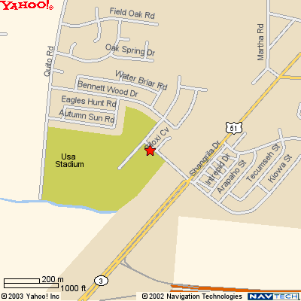

Millington Tennessee is located 12 miles north of Memphis on Hwy 51 North

