April 5 & 6, 2003 USBCHA Sanctioned
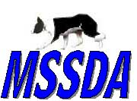

Mid South Stock Dog Association

Trial held at: Double B Boys Ranch

9224 Quito Road

Millington, TN 38053

Two 1 day Trials

JUDGE: TBA

Classes & Fees...
Novice $15 /run/dog
Pro-Novice $20 /run/dog
Open $25 /run/dog Full course, qualifying class for USBCHA National Open
Nursery $20 /run/dog Full course, no shed, qualifying class for USBCHA National Nursery

Awards… Paybacks in all four classes to top 20% of class

Trial Day | Dog Name | Handler Name | Class | Fee
Sat Sun
Sat Sun
Sat Sun
Sat Sun
Sat Sun
 | Total Fees:
Handler:
Address:
Phone:
Email:

- Mail entries with fees to Bob Urban, 50 Wilberry Way, Moscow, TN. 38057.
- Make checks payable to ‘MSSDA’
- Mailed entries will be taken in the order received
- Entries will be taken on trial day
- Trial will run to a standard if necessary.
- For more information contact Bob Urban at (901) 877-7941 or bovinefarms@yahoo.com

I understand that I am responsible for any cost incurred as a result of damage caused by me or my family or my dog/s to facilities, animals or persons. In the event of personal injury, damage to my property or animals, I will not hold the sponsors of the trial, workers or owners of the property responsible.

Signed ___________________________________ Date _________________________
Accommodations…

Days Inn Millington Suites7763 US Highway 51 N, Millington, TN, 38053
901-872-3335
Super 8
7925 US Highway 51 N, Millington, TN, 38053
901-873-1111
The Best Western Inn
7726 US Highway 51 N, Millington, TN, 38053
901-873-2222
Cascade Motel
6481 US Highway 51 N, Millington, TN, 38053
901-872-7706
Millington Inn
7920 US Highway 51 N, Millington, TN, 38053
901-872-3361

Food Accommodations...

Restaurants and Fast Food establishments are nearby.

Map & Directions to the USA Stadium - Double "B" Boys Ranch - 9224 Quito Road - Millington, TN 38053

From Jackson/Nashville going westbound on I-40:
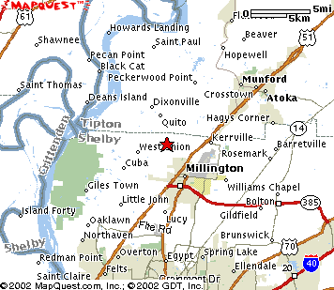
Take Exit 24 following signs toward Highway 385/Millington (This exits at the same place as Exit 25, so watch signs carefully). Stay on Highway 385 (Paul Barrett Parkway) until it ends at Highway 51. Exit off Highway 385 to the right, heading north on Highway 51. Proceed on Highway 51 to the 5th traffic light, which is at Wilkinsville Road. Turn left (Wal-Mart will be on your left). At the first 4-way stop (West Union Road), turn left. Proceed on West Union Road to the first 4-way stop at Quito Road. Turn right (The Hilltop Express convenience store is on the right corner). Proceed on Quito road approximately one mile. The entrance to the Ranch in on the right, directly across from Kerr Road.

Millington Tennessee is located 12 miles north of Memphis on Hwy 51 North

