Publishing to the Web
How-To

Manage your files on geocities.com

Getting started:

- In the URL box in your browser window, type www.geocities.com and press “Enter”  - Type your user ID and password in the appropriate blanks (Note: if you want the computer to remember your password, make sure you check the “Remember my ID and password box”)  - Click on sign in to proceed  - That will take you to the Welcome page  - When you get to the Welcome page, click on file manager, the click on “Open File Manager.” | 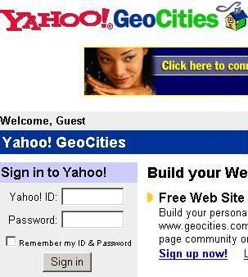

II – Knowing your way around the file manager:

The file manager allows you the opportunity to create new files, edit, rename, or delete existing files. It also allows you to copy or move files from the main directory to a sub directory or from sub directory to another. The following figure illustrates the different buttons and their functions.

Create new file
Copy file
Delete file
Move file to another folder

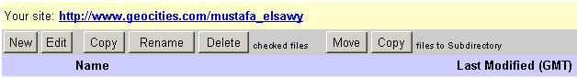
Edit existing file
Rename existing file
Copy file to another folder

Note: make sure the check box next to the file you want to edit, rename, delete, copy or move is checked.

However, the neat thing about geocities is that it has a wonderful feature of EZ upload. This feature enables you to simply browse your local directory, find the files you want to upload and send them to your web space. This feature is available by clicking on the upload files button in your file manager.
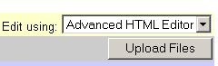

When you click on the “Upload Files” button, it will open a dialogue box like this one in the picture below. You click the “Browse” button next to each box and find the file you want to upload. The default setting lets you upload five files at a time, however, you can increase or decrease this number by selecting another number from the drop down menu below the dialogue box and then clicking the “Display” button. When you choose all the files that you need to upload, click the “Upload Files” button and it will upload them. It might be a good idea to avoid uploading too many files at one time in order to avoid congestion.

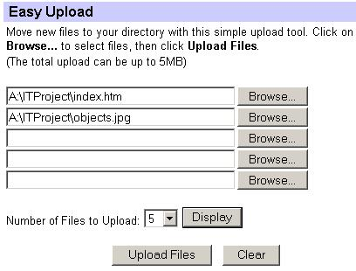
Click here to browse for files on your computer
Click here to change the number of files to upload

When you finish uploading all your files, click the “Refresh File Manager” button.

III- Creating sub directories:

Another neat feature about Geocities is that it allows you to create two levels of sub directories (folders). However, the best way to utilize this feature is to draw the layout/design of your site on paper or using a program like Inspiration first. This step will help you a lot when you start implementing this design. If you are planning on using the six programs, you might want to create a folder for each program. The following is an example of what might be a good layout.

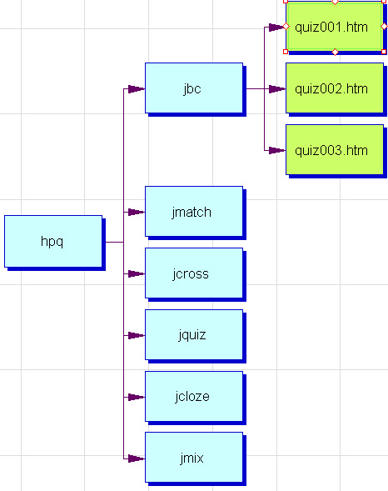
Creating sub directories is very easy. All you have to do is to click the “Create sub Directory” button, give it a name, and choose where you want it to be. For example, you can create a sub directory for Hot Potatoes quizzes and inside that folder, create six sub directories for the different types of quizzes (like the figure above). Just a piece of advice that I’m sure you will appreciate later ☺, avoid capital letters and spaces when naming your folders and files (make your file names as short as you can).

