Creating Web-Based Quizzes with JMatch
- What is JMatch

JMatch is one of six programs that Hot Potatoes include. It can be used to create matching and drag-and-drop exercises

- The JMatch Interface

Since the JMatch icons are very similar to JBC icons, which we already illustrated before, we will only introduce one JMatch icon that JBC does not have. This icon is:

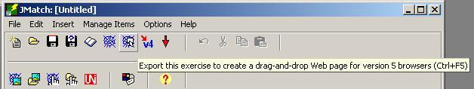

The following picture illustrates the JMatch interface:

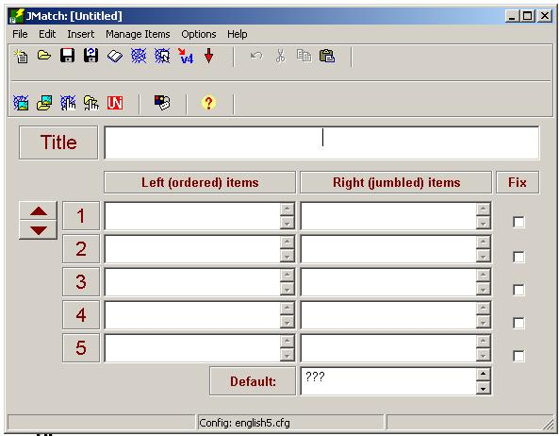
The title of the quiz goes here
Use these arrows to browse between questions

- JBC menus

Since all Hot Potatoes programs share the same menus and output configuration (for the most part), we will only refer too features that are unique for a particular program to avoid repetition.

- Creating Matching Exercises with JMatch

    - Start Hot Potatoes and click on the JMatch potato

    - Type the title of your quiz in the title box

    - Type the items in order in the left column

    - In the right column, right the items corresponding to the ones in the left column (JMatch will shuffle them automatically)

    - Notice that you can use images; not only text using the insert picture feature in JMatch

    - In the box next to the “Default” button, there are three question marks (this is the JMatch default). You may edit that as you like.

    - When you finish all the questions, save your quiz in JMatch format.

    - Export your quiz to the web. The program will prompt you to view it in a browser. Do that and see if you need to make any changes.

- Creating Drag-And-Drop Exercises with JMatch

    - Follow the same steps above until you save your quiz in JMatch format
    - From the file menu, choose “Export to V5 Drag/Drop” option

- Creating Flash cards with JMatch

    - Follow the same steps above until you save your quiz in JMatch format
    - From the file menu, choose “Export to Flash Cards” option

