Creating Web-Based Quizzes with JCloze
- What is JCloze

JCloze is one of six programs that Hot Potatoes include. It can be used to create matching and drag-and-drop exercises

- The JCloze Interface

The following picture illustrates the JCloze interface:

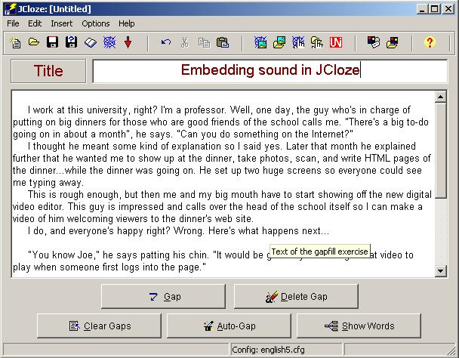
1
2
3
4
5

  - Highlight a word and click on this button to create a gap
  - Place the cursor on a gap (without highlighting) and click on this button to delete it
  - Use this button to clear all the gaps (just like the caption says)
  - When you click this button it will open the dialogue box below. You may enter any number you want and JCloze will gap every nth word in the text.
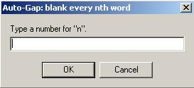

  - When you are done with all the gaps and would like to enter clues or alternative correct answers for each of the gapped words, click on this button. It will open the following dialogue box

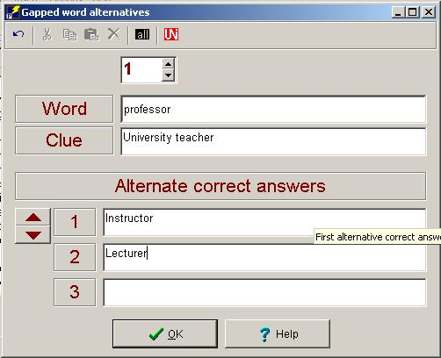
Use these arrows to add more alternative correct answers
Use these arrows to browse between gaps

- Hiding or showing the “Hint” and “Clue” buttons
Some students find it easier to click the hint button and get one letter at a time than to try guessing the words by themselves and this is why some teachers prefer to hide the hint button. Even if you are not planning on hiding the hint button, it is always good to know how to do it just in case. To hide the hint button, uncheck the box next to it under the “Buttons” tab in the output configuration window. The figure below illustrates where that is. Also you may check or uncheck the “Clue” button, depending on whether or not you want the students to see the word clues.

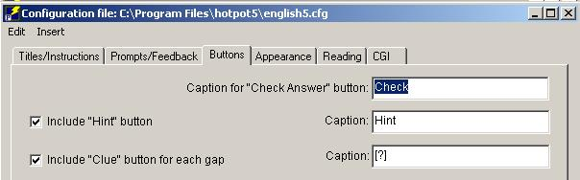
- Including a word list

This option is available under the “Prompts/Feedback” tab in the output configuration window. See the illustration below. As you may have noticed, JCloze gives you the option of making answer-check case-sensitive.

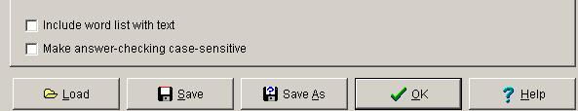

- Creating Cloze Exercises with JCloze

    - Start Hot Potatoes and click on the JBC potato

    - Type the title of your quiz in the title box

    - Type or paste your text in the txt area

    - Make all your gaps or use the auto gap feature

    - When you finish making gaps, adding clues and alternative answers, save your quiz in JCloze format

    - Export your quiz to the web either by clicking “Export to web” under the file menu or using the icon in the toolbar

