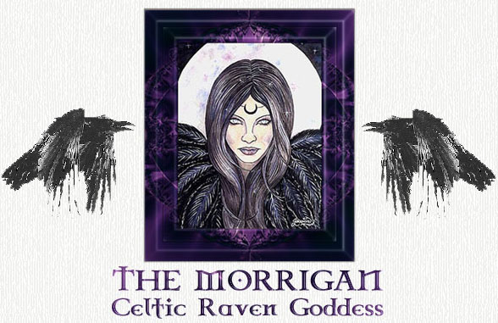

A Celtic goddess of war, strife, and fertility, The Morrigan appeals to me because of her strength and courage. She reminds me of the strong side of the feminine, the courage to do what needs doing and to master fear in battle. She is seen as having multiple faces or aspects: Nemhain or "frenzy"; Badb the vulture; The Washer at the Ford who chooses who will live and who will die in coming battles; Macha, the crone/death aspect; and others. She is associated with ravens, perhaps because of their frequent presence at battlefields and places of death. Ancient Celtic peoples are variously described viewing her as protectress in battles, Valkyrie-like conveyor of heroes to the afterlife, and a source of divination and foresight, with her crows or ravens warning of enemies' approach.
For info: http://www.paganpaths.net

The Morrigan (also known as the Morrigu) was the shape-shifting Celtic Goddess of War, Fate and Death. She also presided over rivers, lakes and fresh water, in addition to being the patroness of revenge, night, magic, prophecy, priestesses and witches.
Her name is interpreted in various forms..."Great Queen," "Phantom Queen" or "Queen of Demons." She was said to hover over battlefields in the form of a raven or hooded crow and frequently foretold or influenced the outcome of the fray. The Morrigan was often depicted as a triune goddess whose other aspects were manifested in the Goddess Badb (meaning "Vulture" or "Venomous") and the Goddess Nemain (meaning "Frenzy" or "Fury"). The Morrigan was one of the Tuatha De Danaan ("People of the Goddess Danu") and she aided in the defeat of the Firbolgs at the First Battle of Magh Tuireadh and the Fomorii at the Second Battle of Mag Tured.
The Celts believed that, as they engaged in warfare, the Morrigan flew shrieking overhead in the form of a raven or carrion crow, summoning a host of slain soldiers to a macabre spectral bane. When the battle had ended, the warriors would leave the field until dawn in order that the Morrigan could claim the trophies of heads, euphemistically known as "the Morrigan's acorn crop."
The origins of the Morrigan appear to be directly linked to the megalithic Cult of the Mothers, who usually appeared as triple goddesses. Her role in Celtic legend is similar to that of the Valkyries in Norse folklore in that both used magic to cast fetters on warriors and made the decision regarding who would live and who would die. The Morrigan is also closely associated with horse symbolism and may, on occasion, have been linked with the equine Goddess, Epona.
Another guise of the Morrigan is that of the "Washer at the Ford," who could usually be found washing the clothes of men about to die in battle. In effect, she is thus choosing those whose lives will be lost in the upcoming conflict. An old English poem entitled "Exodus" also refers to ravens (as previously mentioned, one of the Morrigan's other chosen manifestations) as choosers of the slain.
In one legend concerning the Morrigan, she appears to the hero Cuchulainn (son of the God Lugh) and offers her love to him. When he fails to recognize her and rejects her, the Morrigan is deeply wounded and informs Cuchulainn that she will hinder him while he is in battle. When Cuchulainn finally perishes, she settles on his shoulder in the form of a crow...the hero's misfortune being that he never realized the feminine power of sovereignty that the Morrigan offered to him.
Once Goddess of Strife and Fertility, as well as Battle, modern Pagans view the role of the Morrigan in a somewhat different light from that of the Ancient Celts, but she remains an appropriate deity for strong and independent individuals. Many followers of the Morrigan erect a permanent shrine in her honor, using such items as bowls of brine and blood, the feather of a crow or raven, or even a piece of red cloth to symbolize the Washer at the Ford.
For info: http://www.novareinna.com/guard/morrigan.html

