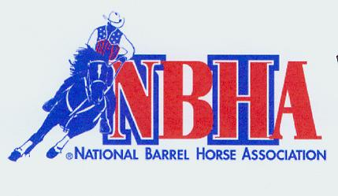

All Exhibitions $4/run
Exhibition Poles Sat 10 am~Sun 8:30 am Entry Fee Added $ PAYBACK
***POLE CLASS STARTS IMMEDIATELY FOLLOWING POLE EXHBITIONS***

1. Open Poles 2D (2 second Split) $10.00 80%
15 minutes open arena when poles are finished then Exhibition barrels.
Class #3 won’t start before Sat 1:00 Sunday 11:30

3. Small fry Barrels $5
10 AND UNDER
4. Warm-Up 4D Barrels $ 15 $ 100 70%
*5. Youth NBHA 3D Barrels $ 15 $ 50 80%
18 & under (full second splits)
*6. Sr. NBHA 3D Barrels $ 12 $ 50 80%
50 & over (full second splits)
*7. Open NBHA 3D Barrels $ 23 $300 80 %
~more than70 entries will run 4D
$4.00 GROUNDS FEE PER HORSE. . ALL DOGS MUST BE ON LEASH
NBHA RULES WILL APPLY TO THE NBHA CLASSES. Violation of dress code results in $15 fine with points and payback withheld until paid
*$3.00 OF EACH ENTRY IN THE 3 NBHA APPROVED CLASSES WILL BE PAID TO NBHA FOR DISTRICT & STATE AWARDS.
~ENTRIES FOR CLASSES WILL CLOSE WHEN THE FIRST HORSE RUNS IN THAT CLASS ~
PRIZE MONEY NOT PICKED UP WITHIN 7 DAYS BECOMES PROPERTY OF SHOW COMMITTEE CONTESTANT’S RESPONBILITY
~Simmons Equestrian Center, NBHA, Sponsors or show committee will not be responsible for accidents or stolen property.~
THANK YOU TO ALL OUR SPONSORS

FOR INFORMATION CALL; JULI 330-352-4941

FOR HELP WITH DIRECTIONS CALL 330-382-9453
Directions: 49053 Fredricktown Clarkson Rd Negley, OH 44441
US-30 E continue onto OH 154 ~ which will become Middle Beaver Rd Turn about 6.5 miles ~ Left onto Greenwood Rd .06miles ~Bear right onto Dutchtown School Rd 0.1 miles ~ bear left onto Clarkson Rd; street becomes Pancake Clarkson Rd (Township Highway 1031) 2 miles ~Continue onto Fredricktown-Clarkson Rd (Township Highway 1032) 2.1miles.
Stalls $15 a day or $35 for the weekend Call ahead for stall rental Juli 330-352-4941 Electric Hook Up $25 for the weekend

