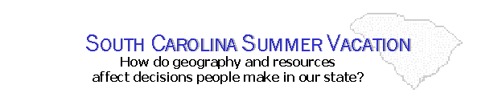
Notes/Activities Sheet
 | Low Country | Midlands | Up Country
Water Sports

Location?

Bodies of Water?

Specific Activities?

Hiking

Location?

Name of Mountains or Trails?

Facilities Nearby?

Animals

Location?

Name of Facility?

Other activities?

History

Location?

Topic?

