MISSION STATEMENT
--The focus of Communities Against Capitalism is to organize on campus in order to educate and inform students as well as our own communities about oppressive systems within our society and to encourage collective activism to ultimately bring about social change.
--We recognize that all forms of oppression and exploitation are interrelated, and that the liberation of one requires the liberation of all.
--We believe that unfettered capitalism, in practice, is one of the major causes of worldwide oppression, violence, exploitation, greed, and environmental degradation because it values economic growth above all else. The kind of progress capitalism necessitates is the main threat to and destroyer of our freedom.
--There are many alternatives to participating in modern capitalist society. We encourage belief systems of all kinds that are anti-capitalist and adhere to the goals of this club. We hope this will broaden our perspective so that we will have a wider range of solutions to offer in dealing with these societal problems.
--Specifically, we want to focus on issues and events of global interest from a leftist perspective utilizing grassroots methods of community outreach. We also want to focus on teaching and implementing alternative views and practices for living, overlooked by mainstream media.
--We want to work together within the community in order to implement ways of living and doing things that are more suitable to the needs of all people on the planet. Instead of simply providing information and ideas for the intellectual, we want to give you ways to take action in your daily life.
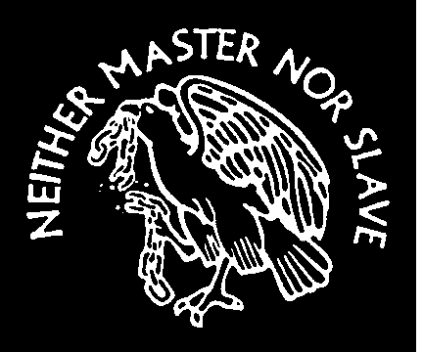
www.geocities.com/no2capitalism
email: no2capitalism@yahoo.com

COMMUNITIES AGAINST CAPITALISM
is an on-campus club that believes in freedom and equality for all beings throughout the world. We believe that the current economic system in power – capitalism – is the major cause of all world-wide crises including but not limited to: poverty, hunger, sickness and disease, environmental degradation, war, terrorism, and racism.

POVERTY AND HUNGER
There are enough resources to feed, clothe, and shelter the entire world’s population. However, due to the capitalist work ethic in the West, most corporate CEOs earn a thousand or a million times more than their lowest paid employees who happen to do all the physical labor. One example is Walmart. Full time employees often still qualify for welfare while the heir to this corporate kingdom is one of the richest men in the world. Most people in the workforce (that includes most people in the world) don’t earn enough wages to buy the products of their labor. This is partly due to the outrageous retail value often added to finished products as well as the incredibly low wages most people receive. This is an unjust economic system because it leaves many people, working full time (often at two jobs), without the basic necessities of life.


ILLNESS AND DISEASE
Because capitalism is focused solely on profits, human health is often overlooked. Tobacco industries make one of the most lethal and addictive products on the market, and yet it remains legal, while every year millions of people die from lung cancer. Epidemics and contagious diseases have dramatically declined in the U.S., yet stress, diet, and degenerative diseases are on the rise. There are more elderly, obese, and psychologically impaired people now than ever before in human history. The real tragedy of this situation though is that the U.S. is THE ONLY Western developed nation that does not have total healthcare for it’s citizens. So each day, right here among you, many people suffer because they can’t afford to see a doctor and get treatment.

ENVIRONMENTAL DEGRADATION
First, capitalists in Europe depleted their natural resources to fuel the factories of the industrial revolution. When their resources were tapped, they didn’t give up. They explored new lands for this purpose, and where they were met with resistance, they slaughtered indigenous people in order to control their lands. So resources from all over the world started being taking up out of the ground, with no concern that it was causing the extinction of species, desertification of land, or toxic pollution. When California became the center of gold and silver mining, they would literally wash away the sides of mountains (because it was more cost effective) causing alarming amounts of water pollution and the complete disruption of the salmon populations – which people depended on for food. Today, corporations that deal with metals and toxins do not usually feel the need to clean up after themselves because it would lower profits.

RACISM
Slavery has existed in many forms throughout much of written history, but until it reached America, it wasn’t a system of oppression based on the concept of race. Why were slaves brought here in the first place? To be used as free labor on cash crops controlled by capitalists. Why did a racial differentiation develop? According to most alternative history books, the white and black slave started out here in similar situations (however nothing compared to the horrors of
the Africans being kidnapped and shipped over). The slaves often rebelled together because of their common struggle and so the whites were given privileges so as to elevate and separate them from their black slave-mates. Capitalism divided people by color and created the concept of race to justify it, in order to keep the slave class and other under privileged people from rebelling and freeing themselves.

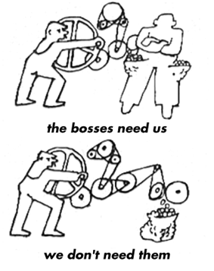

CRIME, WAR AND TERRORISM
Capitalism relies on the concept of private property,
which then has to be protected. Police and military were formed so as to “protect” our property. But capitalism basically guarantees that certain people in society will still be so poor even with a job, they either have to steal food or starve. But stealing threatens the private property owner who then made a law incriminating the thief. The police are in place to protect the property owner from the thief, but thievery is inevitable in a system based on private property that also doesn’t ensure the people are fed.
The irony is that most capitalists became rich by stealing land and resources from indigenous people in the first place. War is just a large-scale version of these scenarios with the military replacing the policeman. Wars are typically fought for religion or resources and often they accompany each other in some way (i.e., manifest destiny).
Terrorism, by definition, is using violence as a means of changing political or social policies that are considered to be wrong in the eyes of the aggressor. Unfortunately, because the hand of capitalism reaches across the globe and destroys lives wherever it goes, some individuals and groups of people feel compelled to act violently because there doesn’t seem to be any other way to make things change. CAC does not condone violence against humans, however one needs to realize that it takes an incredible amount of suffering and pressure on a person’s psyche to enable them to react in such a way. Such actions as bombing buildings, suicide bombings, and hijacking are often the result of the unjust capitalist system’s pressure on society and the individual.

