Pedigree For  Junglebeat Wolly Bear  (JJ) | 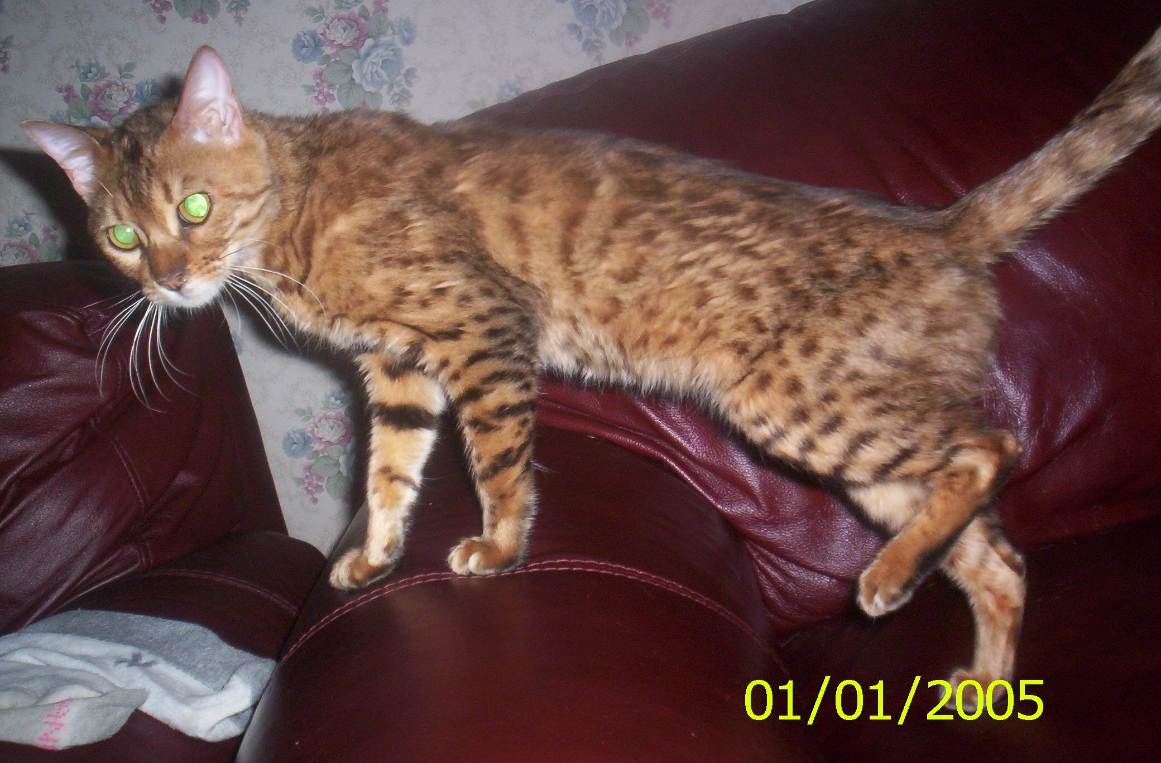

Hapikatz Talon  (TICA SBT 021102) | Oceanwoods Caruso of Junglebeat  (SBT 080399 024) | CH. Millwood Italian Filagree  (SBT 041998 013) | CH. Millwood Firelit Circle  (SBT 032697 009)
Hapikatz Talon  (TICA SBT 021102) | Oceanwoods Caruso of Junglebeat  (SBT 080399 024) | CH. Millwood Italian Filagree  (SBT 041998 013) | GCH. Millwood French Lace  (SBT 042496 005)
Hapikatz Talon  (TICA SBT 021102) | Oceanwoods Caruso of Junglebeat  (SBT 080399 024) | Millwood Willow of Oceanwoods  (SBT 011597 030) | Heritage Shiloh of Millwood  (SBT 051094 001)
Hapikatz Talon  (TICA SBT 021102) | Oceanwoods Caruso of Junglebeat  (SBT 080399 024) | Millwood Willow of Oceanwoods  (SBT 011597 030) | Akerrs Stardust of Millwood  (SBT 012794 001)
Hapikatz Talon  (TICA SBT 021102) | Standin Pat of Hapikatz  (TICA SBT 012700 018) | RW SGC Joykatz Ace Inda Hole  (SBT 071596 004) | Joykatz Bandido Rosatta  (SBT 091294 004)
Hapikatz Talon  (TICA SBT 021102) | Standin Pat of Hapikatz  (TICA SBT 012700 018) | RW SGC Joykatz Ace Inda Hole  (SBT 071596 004) | Episilon Hershey Kisses of Joykatz  (SBT 091294 004)
Hapikatz Talon  (TICA SBT 021102) | Standin Pat of Hapikatz  (TICA SBT 012700 018) | Aluren Sweet Deal of Joykatz  (SBT 040298 027) | Junglebabys Show Me The Money  (SBT 011897 002)
Hapikatz Talon  (TICA SBT 021102) | Standin Pat of Hapikatz  (TICA SBT 012700 018) | Aluren Sweet Deal of Joykatz  (SBT 040298 027) | Aluren Sahara Sands  (SBT 081795 001)
Llandar Cheetara  (SBT 031300 067) | Millwood Llander Braveheart  (UK# CSREF 363127) | CH. Heritage Shiloh of Millwood  (SBT 051094 001) | Heritage Kimo  (SBT 070893 018)
Llandar Cheetara  (SBT 031300 067) | Millwood Llander Braveheart  (UK# CSREF 363127) | CH. Heritage Shiloh of Millwood  (SBT 051094 001) | Heritage Kazuri  (SBT 070893 019)
Llandar Cheetara  (SBT 031300 067) | Millwood Llander Braveheart  (UK# CSREF 363127) | DCH. Millwood Inner Circle  (SBT 022293 002) | Millwood Jokers Wild  (C3T 030891 010)
Llandar Cheetara  (SBT 031300 067) | Millwood Llander Braveheart  (UK# CSREF 363127) | DCH. Millwood Inner Circle  (SBT 022293 002) | Snowbear Clud Nine  (C3T 062089 006)
Llandar Cheetara  (SBT 031300 067) | Llandar Marta Hari  (UK# CSREF 398818) | GCH. Llandar Warrior  (Reg# 1100W98) | Gorgees Llandar Spirit  (CSREF 306464)
Llandar Cheetara  (SBT 031300 067) | Llandar Marta Hari  (UK# CSREF 398818) | GCH. Llandar Warrior  (Reg# 1100W98) | Penneytone Mississippi Llandar  (CSREF 309057)
Llandar Cheetara  (SBT 031300 067) | Llandar Marta Hari  (UK# CSREF 398818) | Millwood Barbie Q  (TICA A2T 082096 001) | Millwood Midas Touch  (SBT 030994 001)
Llandar Cheetara  (SBT 031300 067) | Llandar Marta Hari  (UK# CSREF 398818) | Millwood Barbie Q  (TICA A2T 082096 001) | Johari Shish Kabob of Millwood  (TICA A1T 112894 003)

