IST129 – HTML (I), Project #2

In this project, you will exercise your knowledge of the topics covered in chapters 2 through 5, namely basic tags, text handling, and images.

Before we begin, let me clue you in on the overall content of your web site. Your web site is to be a Mecca for HTML coders (at least within the constraints that I place upon you).

So far, you have a Homepage.com web site with an initial page called “index.htm” (lowercase letters) that looks like the following:

Notice there is no text displayed other than Greg’s Home Page in the title bar of the browser.

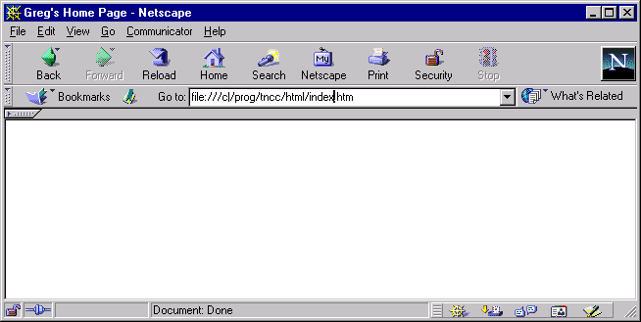
After Project #1
The next step is to flesh out the initial page with some formatted text and graphics such that your page appears as follows:

Welcome to Greg’s Web Site
Is the largest header. The word “Welcome” is blinking and the colors used are: red, blue, green, cyan, purple, black, and brown.

underlined
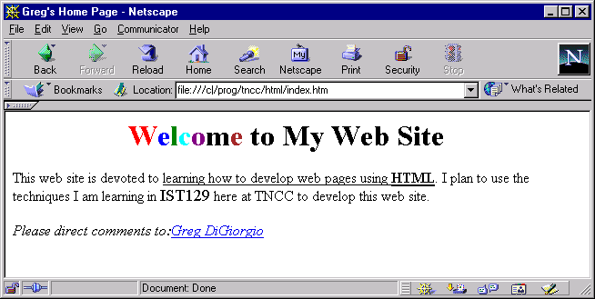
Underlined and bolded.
Use of the <BIG> tag.
After Project #2

The code for the mailto address can be found on page 114 under the <Address> tag discussion.

Tips:

- For HEADER tag usage with the align=CENTER attribute, see page 69
- For use of the <Font> tag for colors on the header, see page 90. The attribute for coloration of text is color. Use the color names I mentioned above. For example, the tag <font color=BLUE>ABC</font> displays:
ABC

- For email address information, see page 114
- For use of the <big> tag, see page 83
- For use of the bold tag, see page 83.
- For use of the underline tag, see page 85
- The blink tag is described on page 85

