Newsgroup Search Exercise

Email-ID First Name Last Name Religious Affiliation Home page URL
sefstrat@aol.com Steve Feder Jewish http://members.aol.com/sefstrat/index.html/sefpage.html
carlginger@aol.com Carl Fiandino?

Email-ID Probable city/state of residence Profession Hobbies
sefstrat@aol.com Rochester, New York Attorney/Musician Tennis, raquetball
carlginger@aol.com

Deja Power Search

Searching for info:
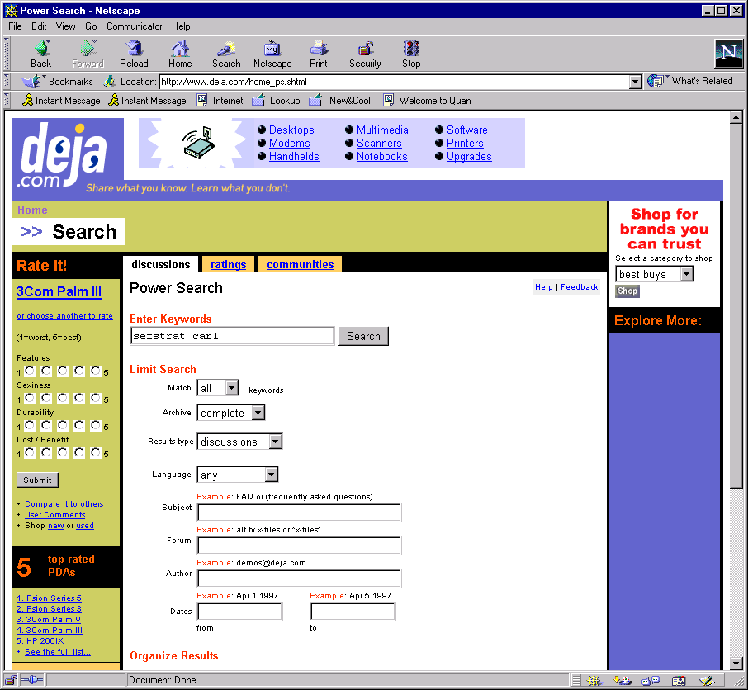

Also use Dogpile to search for “Carlginger” and then “SefStrat”

SefStrat’s AOL Profile
Member Name: Steve
Location: Rochester, NY area
Birthdate: 9/22
Hobbies: racquetball (Team EForce sponsored player), tennis, rollerblading, skiing, listening to and writing music, playing guitar & singing in a cover band, singing and playing solo acoustic guitar, being driven batty by my kids
Occupation: Attorney....and once full-time, now part-time professional musician
Personal Quote: May your eyes kiss the sky...may the breeze kiss your knees..may your feet kiss the grass..and you, my friend...have a nice day!

Carlginger & the WWW Sefstrat and the WWW

http://www.indoorstorm.com/reviews/suhr.htm
http://www.suhrguitars.com/reviewcarlf.htm

http://www.strangecloud.com/indiejournal/equipment/artecc.htm
http://www.guitarsbyleo.com/RESOURCE/sslgspc.txt
http://pages1-ext.prodigy.com/C/A/S/catalogs/gcguestv.htm
http://webm32bc.ntx.net/newyork.htm

Possible Addresses/Phone Numbers
