Sample HTML

Following is a sample of HTML. The picture below is what the user sees. The text that follows is what you code in HTML.
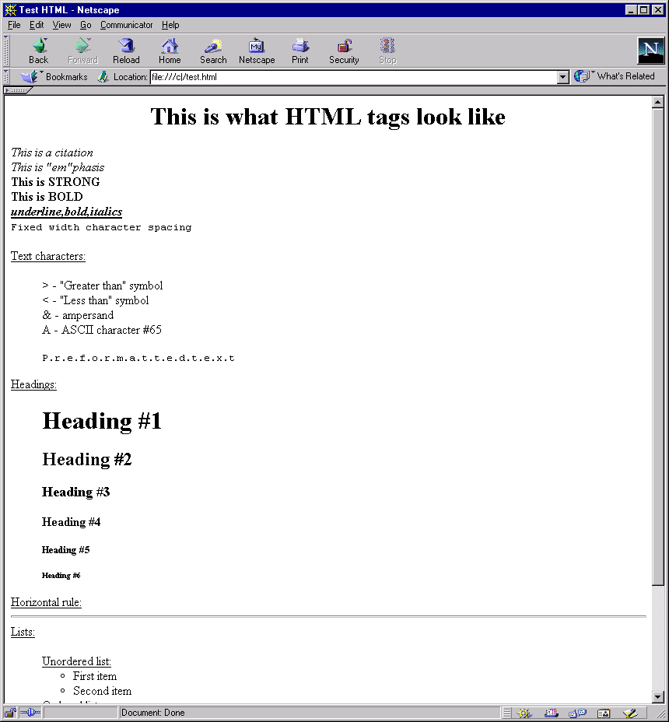
<html>
<!-- Test HTML tags -->
<head>
<title>Test HTML</Title>
</head>
It is interesting to note that, if I accidentally forgot to turn italics off with the </I> tag, Netscape V4.6 turns it off for me whereas MSIEV5 does not. In MSIE, all text that follows would also be in italics.
<body>
<center><h1>This is what HTML tags look like</CENTER></h1>

<cite>This is a citation</cite> <br>
<em>This is "em"phasis</em> <br>
<strong>This is STRONG</strong> <br>
<b>This is BOLD</b> <!-- Same as STRONG --> <br>
<u><b><i>underline,bold,italics</u></b></i> <br>
The use of the unordered list tag <UL> is one way to indent subordinate topics.
<code>Fixed width character spacing</code> <br>
<br>
<u>Text characters:</u>
<UL> <!-- automatic indentation, no bullets -->
&gt - "Greater than" symbol <br>
&lt - "Less than" symbol <br>
&amp - ampersand <br>
&#65 - ASCII character #65 <br>
Turn off auto-indent.
<PRE>P.r.e.f.o.r.m.a.t.t.e.d.t.e.x.t</PRE>
</UL> <!-- end of indentation -->

<u>Headings:</U>
<UL> <!-- automatic indentation, no bullets -->
<H1>Heading #1</H1>
<H2>Heading #2</H2>
<H3>Heading #3</H3>
<H4>Heading #4</H4>
<H5>Heading #5</H5>
<H6>Heading #6</H6>
</UL> <!-- end of indentation -->
<u>Horizontal rule:</u>
<hr>
<u>Lists:</u>
<ul>
<u>Unordered list:</u>
<ul> <!-- Start list -->
<li>First item</li>
<li>Second item</li>
</ul> <!-- end list -->

<u>Ordered list:</u>
<ol>
<li>First item</li>
<li>Second item</li>
</ol>

<u>Definition list:</u>
<ul> <!--- indent the list -->
<dl>
<dt>Title #1</dt>
<dd>Definition for title #1</dd>
<dt>Title #2</dt>
<dd>Definition for title #2</dd>
</dl>
</ul> <!--- end indentation -->
</ul>
</body>
</html>

