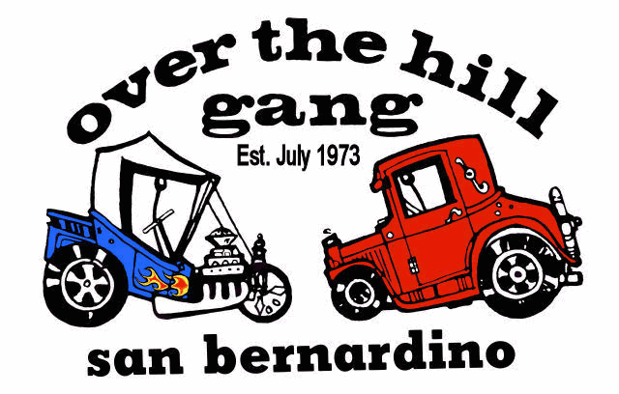
CAR CLUB of the MONTH I The Over The Hill Gang
Over The Hill Gang still running strong
In July 1973, a group of street rodders — led by San Bernardino resident and local upholsterer Tom Pappy Sterkel — decided to form a regional automotive club with few rules and a family-oriented atmosphere.
San Bernardino
The concept soon evolved into a club with three dependent chapters — based in Pomona, San Diego and San Bernardino. Taking notes from the 1969 television movie starring Pat O' Brien and Walter Brennan, Sterkel named the club the "Over the Hill Gang," and subsequently chaired the San Bernardino chapter. Sterkel buddies Craig Lake and John Pickel ran the San Diego chapter.
In Southern California, the street rod scene originally consisted of a few well-organized clubs — among them 1940s Fords, early Fords, Prowlers and many "Lone Wolves." Most activities were organized around

Club rules
- Prospective members
must attend a
minimum of two club
meetings.
- Prospective members
must have an
operational, pre-1948
vehicle at time of
admission to the club.
- Prospective members
must go on at least
one '"run" with the
club.
club-sponsored events; however, if you were not part of that particular club that was hosting the gig, you wouldn't be allowed to participate. Even if a "Lone Wolf attended such an event, he or she often could not participate in team activities such as volleyball, tug-of-war and relay races. This problem was compounded by the strict enrollment requirements enforced by the majority of established clubs — rules that ranged from final club approval on autos prior to entering an event to unnecessarily-high club dues.
Many independent-minded rodders like Sterkel didn't feel like following the regulations, but still wanted to participate in group activities that celebrated the automobile. From this desire, the Over the Hill Gang was born.
GANG
Continued from E2

The first Rendezvous took place in 1990 at Glen Helen Regional Park in Devore with 300 vehicles and about 4,000 visitors enjoying the cars, a concert and a cruise down E Street in San Bernardino.

In 1991, the event moved to the National Orange Show grounds and expanded with the help of the Over the Hill Gang car club.

1992 put the event on the map as a major celebration for nostalgia buffs nationwide. More than 700 vehicles filled downtown San Bernardino streets in celebration of the 66th anniversary of Route 66 "The Mother Road."

Sterkel was also the first person to be inducted into the group's Street Rod Hall of Fame. When he passed away in 1985, the San Bernardino Chapter had fewer than 40 members, and Sterkel couldn't have possibly imagined how big his Gang would become. As of Jan. 2005, the Over the Hill Gang has 276 members in its San Bernardino Chapter. The club has 25 chapters nationwide and three based in Canada.
Sterkel always felt there was a place for a club that could survive by having very few rules and by keeping things simple and fun. Since 1973, the Over the Hill Gang has done just that. The club was instrumental in bringing one of the largest annual automotive gatherings — the Route 66 Rendezvous — to the streets of San Bernardino.
See GANG E7

