Coal

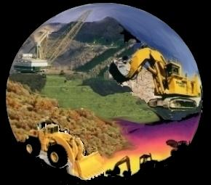
What is coal?

Coal is the remains of trees millions of years old. Australia was covered with swamplands, which means that the trees were covered with mud and water so the trees did not rot. It did not rot because there was too much pressure and that’s what makes coal.

Most people would not think of coal as a fossil but coal is one of Australia’s oldest and most abundant fossils.

How is coal mined?

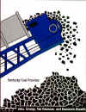
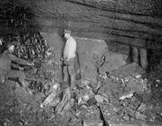
In the olden days coal was mined in under-ground mines. It was very dangerous. There was always a fear that the roof would crumble. The miners had to leave a bit of the coal in the wall, or the roof would get unsteady and collapse. There was also a big danger of methane gas or CO₂ so the workers would take canaries and when the canary would stop singing or die they would know that there is methane gas and the workers would get out of the mine very quickly.

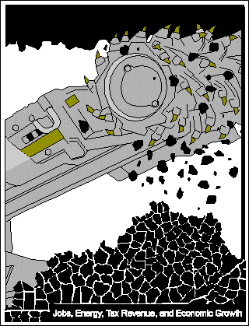
Now in the twenty-first century, technology has changed the way we think. In Australia we have open cut mining. The miners dig a big hole and then they take the coal out not with picks and shovels but with machines.

If the coal is too far below the ground the miners use a giant drill. This drill is like a pencil it has a very sharp point and it is about ten thousand times bigger.

What is the need of coal?
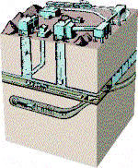
Coal was first used to heat up homes and to cook meals. Now in the 21 century we still use coal but in a different way. We use coal for electricity, to heat water and to make steel. Coal is a very needed source of power in Australia.

Australians don’t only need coal to power things or to heat things we also use it to help our country. You would think how could black coal help our country? It helps because every single year the Australian coal companies get 6 billion dollars alone. That’s a lot of money. The money comes from different buyers all over the world.

Unfortunately for every good there is a bad. Coal is one of the most polluting types of energy when it comes to the green house affects. The burning of coal sends so much Carbon Dioxide into the atmosphere it’s not funny. Though now it is very cheap, in the near future we will be paying, maybe not with money, but with lives….

How is coal used to make electricity?

Coal is made into electricity through a number of steps. The first step is mining the coal. The coal is used to act as a fuel. The coal is used to heat water to make steam to spin a turbine. When the turbine spins a generator turns and the magnetic field of the generator makes electricity.

The end

