Pocketknife Pledge

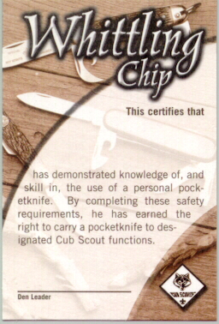
- I understand the reason for safety rules.
- I will treat my pocketknife with the respect due a useful tool.
- I will always close my pocketknife and put it away when I’m not using it.
- I will not use my pocketknife when it might injure someone near me.
- I promise never to throw my pocketknife for any reason.
- I will use my pocketknife in a safe manner at all times.

- Your Cub Scout knife is an important tool. You can do many things with its blades. The cutting blade is the one you will use most of the time. With it you can make shavings and chips and carve all kinds of things.
- You must be very careful and think when you whittle or carve.
- Take good care of your knife. Use it with care so that you don't hurt yourself or spoil what you are carving.
- Know the safety rules for handling a knife.
- A knife is a tool, not a toy.
- Know how to sharpen a knife. A sharp knife is safer because it is less likely to slip and cut you. Keep the blade clean.
- Never carry an open knife in your hand.
- When you are not using a knife, close it and put it away.
- Keep your knife dry.
- When you are using the cutting blade, do not try to make big shavings or chips. Easy does it.
- Close the blade with the palm of your hand.
- A knife should never be used on something that will dull or break it.
- Be careful that you do not cut yourself or any person nearby.
- A knife should never be used to strip the bark from a tree.
- Do not carve your initials into anything that does not belong to you.
Test your knowledge
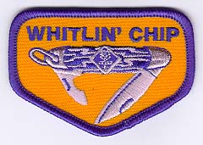
You should close the blade with the palm of your hand
True
False
A knife is just a toy.
True
False
It's okay to keep your knife wet.
True
False
A dull knife is more likely to slip and cut you.
True
False
You should carry your open knife in your pocket.
True
False
Carving your initials into a tree is okay.
True
False
The Pocketknife Pledge (fill in the blanks)
I understand the reason for ________________________________________ rules.
I will treat my pocketknife with the ______________________________ due a useful tool.
I will always ________________________________ my pocketknife and put it away when not in use.
I will not use my pocketknife when it might _______________________ someone near me.
I ______________________________ never to throw my pocketknife for any reason.
I will use my pocketknife in a safe manner at ________________________times.
Signed: (Write your name) _______________________________________________
( Answers: close, respect, injure, promise, all, safety)

