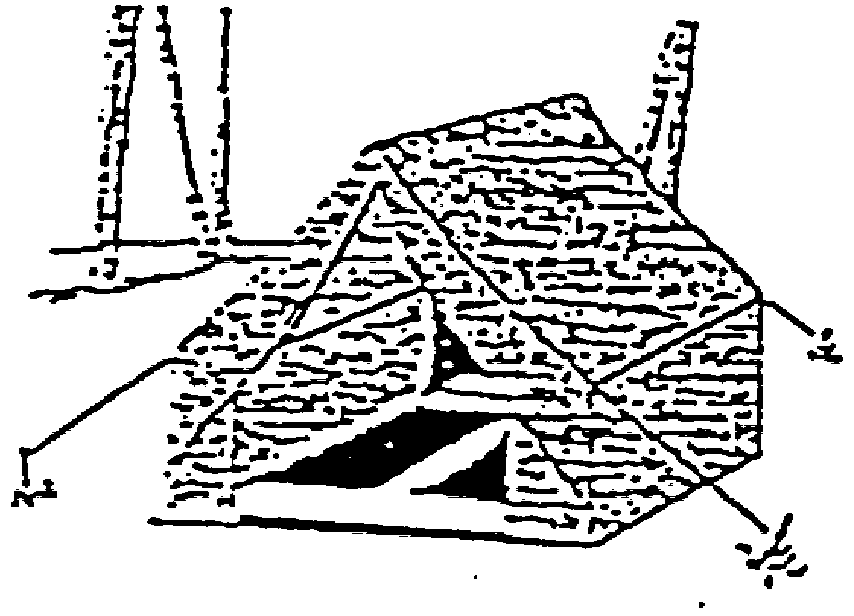
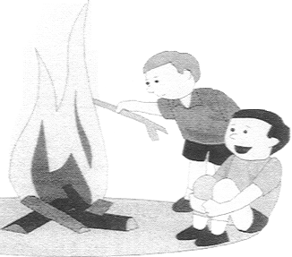Fall '09 “Cub-e-los”

Pack 96 Family Camping Weekend

DETAILS

- Sign-up in advance. Drive up Sat., 10/3 and arrive about at our given time, 8:30AM. It’s an hour or less drive. Parking will be limited so car pool if you can. Arrive after 8:00 AM and as close to 8:30 as possible.

- Our site is Leni Lenape. See attached map.

- Scouts wear your Cub Scout hats and blue Pack 96 “class B” T-shirts so you don’t get your uniform dirty. Bring extra socks, shoes and clothes of different weights. If you don’t have a Pack 96 t-shirt yet, it’s OK.

- A suggested packing list is attached

- Those arriving before 8:00 am will be required to drive through the camp. You will be able to stop at our site and drop your gear. You will then continue through the camp at park at the south end, approximately a 1/2 mile walk. Arrivals after 8:00 am will park in the lots near the entrance to the camp (see map) you will have to carry your gear to the campsite from the parking lot. Be prepared to travel light or bring a wagon, wheelbarrow, hand truck or backpacks. The campsite will be 1/8th mile from the main Parking Lot.

- THOSE ARRIVING ON FRIDAY OR SATURDAY BEFORE 8:00AM WILL BE REQUIRED TO PARK AT THE SOUTH END OF THE CAMP. YOU WILL NOT BE PERMITTED TO RETREIVE YOUR CAR UNTIL AT LEAST 10:30 SUNDAY. IF YOU COME UP FRIDAY NIGHT AND NEED TO LEAVE ON SATURDAY, YOU WILL NEED TO OBTAIN A SPECIAL PARKING PERMIT.

- Suggestion: pack extra stuff separately and leave in your car until needed.

- If you come up on Saturday you are responsible for breakfast (if you get there that early) and lunch (or you can buy hot dogs/hamburgers there). The Pack will provide dinner. The Pack will provide marshmallows and s’mores at the fire and breakfast Sunday morning.

- If you want snacks (chips, trail mix, etc) please bring them. Some drinks will be provided by the Pack and there is running water at the site. Remember no food in tents. There are Bears.

- There is usually a Catholic Mass and a non-denominational service Saturday night around 6:00pm. Times and locations to be announced at the camp.

- NO PETS ALLOWED. WARNING: This is Bear Country. Stay alert.

- DO NOT AT ANY TIME take food into your tent. This attracts Raccoons and Bears.

- You have to pack up Sunday morning after breakfast and evacuate the campsite (time TBA) but you can stay at the reservation until about 11AM.


The theme this time is Carnival. All activities on Saturday, are optional, they typically are open from 9-12 and 1-4, and include the following.

BB Guns in a safe, controlled environment

Boats ($3 charge) Pack 96 will be running this event for part of the day

Archery

Nerf Arrows and cork guns for Tigers and scout siblings

Go-carts

Crafts and demonstrations;

Compass Orienteering;

Fishing Derby (bring all your own equipment and bait)

Scavenger Hunt;

Guided Nature Hike;

Knot tying

Obstacle Course; > Field Sport Games; > Water Rockets

Campfire jokes, skits, stories (prepare some!)

AND MORE…

The Pack will have an opening ceremony/meeting around 8:45 AM at our site and the schedule of activities will be handed out. If you have not yet arrived by this time, we will leave extra schedules, etc. at the campsite.

Each Pack is given one of the activities to run. Please see your den leader or the Pack 96 camping coordinator to help with ours (Boats). See also sign-up poster at our site.

Only Bears and Webelos are allowed to have knives and only if they have earned the whittling chip card (which they can do at Cubelos.) Since knife safety has been an issue in the past we don't let the scouts walk around with knives all weekend and whittle whenever they want. If Bears/Webelos want to whittle at the campsite, they must follow the whittling chip rules and ask permission first.

DO A GOOD DEED: We must bring all garbage home with us.
Please HELP by taking a bag of garbage home with you!

Questions? Contact your Den Leader or

Andy Lesser, 908-253-8333 (home) 908-625-8579 (cell)

Youths should use the “buddy system”. Never go anywhere alone, and when traveling in groups you should always have one other person whose whereabouts you know at all times. If this person disappears tell an adult immediately.

DON’T FORGET: the bathroom is a latrine.
This is camping, not vacationing!!! Be Prepared!!!
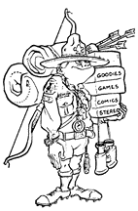
Packing List Suggestions

- This packet, driving directions and a parking permit (which should be provided to you in advance.) Also know the name of our Pack 96 site.

- Wagon or wheelbarrow (if you have a lot of gear) with rope or bungies

- Tent. Ground cloth or tarp (to put under the tent to keep it dry), extra stakes, twine, small hammer and hand broom (to sweep out your tent before packing).

- Sleeping bags. Flat sheets for inside sleeping bags (optional). Pillows.
Foam pad, air mattress or extra blankets to put under sleeping bag (key!) Most of the cold you feel when camping out comes from the ground below. Also, if it is cold, bring an extra blanket to go over your sleeping bag.

- Cub Scout hat and blue Pack 96 T-shirt.

- Warm clothes: sweater, jacket or sweatshirt, and hat. (can leave in car)

- Extra changes of clothes. Extra sneakers, shoes, boots and rain gear.

- Also bring extra plastic bags (such as Shoprite bags) for soiled clothes, etc.

- Folding chairs (or you’ll be sitting on logs).

- Fishing pole, bait and fishing tackle (only if you plan to go fishing.)

- Toiletries: mainly and toothbrush & toothpaste. The Pack supplies liquid soap and paper towels. You can bring bar soap and a washcloth and a towel if you want but there are no showers. It never hurts to bring extra toilet paper…

- Pocketknives OK for adults and scouts with Whittling Chip card. No large knives.

- Flashlights, with extra batteries. A lantern if you have one. The new battery operated lanterns work well and can be brought in to your tent (propane lanterns are not allowed in the tents.) The Pack has several propane lanterns which will be setup around the site to help people see at night.

- PRESCRIPTION MEDICATIONS! Please be sure it is noted on the medical form

- Personal first aid kit if you want. The Pack has a large First Aid kit.

- Some cash (for hot dogs, ice cream and the Trading Post store.)

- Cell phones (fully charged!) They usually work where we’ll be at.

- The Pack supplies stoves, pots, pans, eating utensils, plates, cups and paper towels. SO YOU DON’T NEED TO BRING ANY OF THESE. Some napkins or paper towels for your tent and Kleenex is not a bad idea though.

- There is running water at the site and the Pack also supplies lemonade and iced tea to drink. You may want to bring your own soda, juice boxes, etc.

- If you want extra snacks (chips, trail mix, etc) please bring them.

- Trash receptacles will be available throughout the camping area.

- OPTIONAL: watch, compass, camera, canteen, games & cards -
reading material (if a rainy day), marshmallow skewer (or find a stick). Walkie-talkies. Suntan lotion and insect repellent.

- NO ELECTRONIC DEVICES SUCH AS GAMEBOYS, WALKMANS, ETC ALLOWED AT CUB SCOUT OR BOY SCOUTS CAMPING EVENTS! For obvious reasons. The whole point is to be out in nature and enjoy nature. ALSO NOT ALLOWED: alcohol, illegal drugs, knives in sheaths (pocketknives OK for adults and scouts with Whittling Chip card), and no axes (we will have saws for cutting up firewood.) No liquid fuels. No fireworks.

DIRECTIONS TO CAMP WINNEBAGO

Boy Scout Camp Winnebago, Timberbrook Road,
Marcella (Rockaway Township), Morris County, NJ

From the Bridgewater Area: (About 45 minute drive Northwest)

(1) Take Rt 287 North for about 25 miles to Rt 80 West (see sign for “Exit 41B Delaware Water Gap”). Take the exit on to Route 80 West.

(2) Take Route 80 West for about 6 miles to Exit 37 - Hibernia/Rockaway

(3) At the end of the exit ramp, at the traffic light, turn LEFT (north) onto Green Pond Road (Route 513).

(4) Follow this route for 6.8 miles. When you see the Rockaway Township Fire Dept on the right you are about 1/2 way there. When you pass the Green Pond Golf Course on the left (not a real obvious landmark) you are close.

(5) Just past the sign for “Milepost 52”, you'll see a sign for "Camp Marcella". Turn right (actually bear right) onto Timberbrook Road.

(6) After approximately a mile, continue straight past the NO OUTLET sign, staying on Timberbrook Road (even though the main road goes left).

(7) The road turns in to a dirt road. Keep following it until you see the Winnebago Scout Reservation entrance. Keep going straight.

(8) Park in the parking lot to the left, following the instructions of the attendant, and walk down the road where you would have continued to drive if the gate was not shut. Walk to the site assigned to our pack (the name of which should have been told to you in advance and may be on the parking pass).

(9) The walk to the site is usually about ¼ mile so Be Prepared with backpacks, wheelbarrow, etc, or pack light.

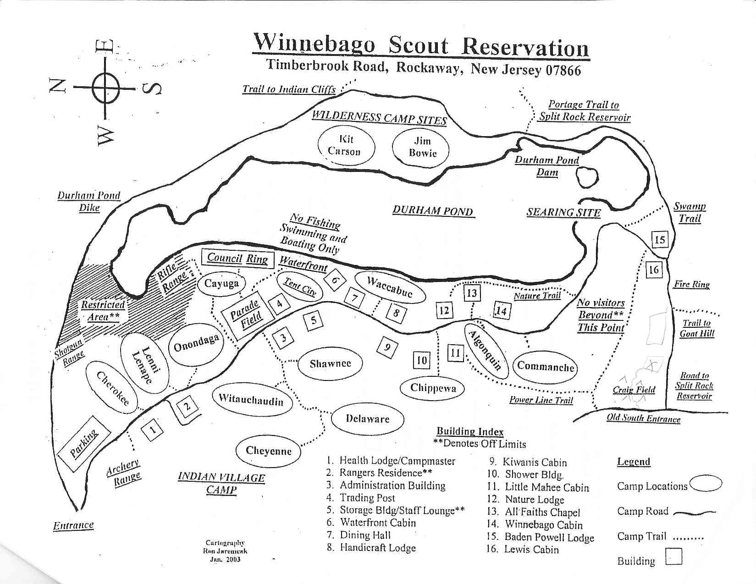
Pack 96 is at this site.

