FOSSILIZED FASHION IN HAWAI'I

Linda B. Arthur,

University of Hawai’i at Manoa
2515 Campus Road, Honolulu, HI 96822
808/956-2234
e-mail LARTHUR@HAWAII.EDU

Abstract
Fossilized fashion, a phenomenon whereby a fashion remains constant long after becoming outmoded, has primarily been found in sectarian societies. Other cases of fossilized fashion have been attributed to a group's separation from mainstream society. However, neither of these explanations is relevant to the case of the holoku, a garment which has become fossilized due to cultural factors.
The holoku has been worn in Hawai'i since the 1820s; since then it has been definitive of Hawaiian ethnicity. A long sleeved, yoked, loose- fitting floor-length dress without a waistline, the holoku today is nearly identical to the original design and is worn primarily for formal occasions. Edwardian style details, popular during the zenith of the Hawaiian kingdom, continue to characterize holoku design. Old Hawai'i came to an end with the overthrow of the monarchy in 1893; the cultural tension from this event has never been resolved, and visual reminders of Old Hawai'i continue to be used to show kinship with the failed monarchy. The holoku is one such reminder.
Associated with Hawai'ian culture, ethnicity and tradition for 175 years, the holoku expresses reverence for Old Hawai'i by steadfastly clinging to the styles popular when the Hawaiian kingdom reigned supreme. The holoku continues to be worn to the present day, virtually unchanged for the past century. As a fossilized fashion, the holoku highlights the importance of cultural factors with regard to understanding fashion change.

Key words: holoku, Hawai'i, fossilized fashion, ethnicity.

The Hawaiian holoku originated in 1820 as an adaptation of an American day gown; in its introduction, the holoku was accompanied by a chemise referred to as the mu'umu'u. First adopted by Hawaiian queens, other Hawaiian women soon wore the holoku. The contemporary holoku is a long formal gown with a train; it is definitive of Hawaiian ethnicity. Both garments continue to be very important in Hawai’i. While the mu'umu'u is regarded by those from outside the islands as Hawaiian dress, the lesser known holoku is more closely associated with Hawaiian ethnicity although it is virtually unknown outside of Hawai’i. Once worn by Hawaiian women as everyday wear, the holoku is now formal wear worn for ritual events related to Hawaiian ethnicity.
In this paper, I discuss the emergence of the holoku in 1820 to its synthesis of design details at the height of the Hawaiian monarchy, to it's contemporary use today. In doing so, I show that the holoku became ethnic Hawaiian dress, reached its zenith in design evolution at the turn of the century and that this turn of the century dress has become fossilized fashion due to cultural factors.

DATA AND METHODS

As part of a larger study on the origins of aloha attire, I conducted historical research from 1993 to 1996. Research began with a review of secondary sources on Hawaiian history and dress. I found only two academic articles (Arthur, 1997; Furer, 1983) and one thesis (Stewart, 1977) and one monograph (Fundaburke, 1965) on Hawaiian clothing and the apparel industry, and several newspaper and magazine articles. The aloha shirt, however, has received much attention as a pop-culture phenomenon and collectible. Notable books on the aloha shirt include those by Steele (1984), Schiffer (1997) and World Photo Press (1997).
Written primary source materials include unpublished nineteenth century traveler's accounts and the diaries and letters of missionaries who arrived in Hawai’i in the early 1800s. These sources yielded data on the origin and later incorporation of the holoku into Hawaiian culture. All letters and diaries written by women were read, and those written by men were randomly selected, as were missionary reports. Unwritten primary source materials included the use of illustrations and photos, and analysis of extant garments. Paintings and other illustrations of early Hawaiians prior to 1860 in addition to photographs of Hawaiian women taken between 1860 and 1960 provided evidence of design evolution.
While a large sample (2035) of photographs was briefly examined, only photos with clearly identifiable garment styles were examined in detail, resulting in a final sample size of 836. Most of the photos were taken between 1870 and 1920; approximately one-third were posed studio portraits. Using content analysis, design and style features were noted along with the date and photographer, if indicated.
Analysis of extant garments included an examination of thirty-two holoku on the island of Oahu. Twenty eight were in the Historic Costume Collection at the University of Hawai’i at Manoa in the Textiles and Clothing Program. Additional gowns were found at the Mission Houses Museum and the Bishop Museum. Dated from 1890 through 1995, these holoku were examined to collect information on both overall style features, and specific design details, such as fabrics, notions, and construction techniques. Provenience for each garment provided additional information as to the socio-historical context. Finally, interviews were conducted with twenty women who wear holoku today; most also participate in the annual Holoku Balls. The vast majority of the information they provided substantiated conclusions drawn from the historical research and examination of photos and historic garments.

FASHION AND THE FOSSILIZATION OF FASHION

Fashion is characterized by constant change in clothing styles; in the latter part of this century style changes occur many times in each year. However, there is a unique form of fashion in which change is severely repressed to the point of virtual stagnation, a process referred to as fashion fossilization. The phenomenon whereby fashion does not change, but remains static over long periods of time has been attributed to religious and sectarian groups (Gordon, 1987; Kefgen & Touchie-Specht, 1986), folk societies and academics (Laver, 1969; Kefgen and Touchie-Specht, 1986), and men employed in high-status professions (Laver, 1969). Fossilized fashion has been explained as a sudden “freezing” of fashion whereby a group continues to wear a style long after it has gone out of style for the general population. This phenomenon has been explained as expressing dignity and high social status (Laver, 1969), or the group’s religious, old-fashioned, sectarian identity (Gordon, 1986). While the connection between fossilized fashion and the visual expression of ethnicity might seem apparent, it has not been addressed in the literature. This paper will show, however, that in Hawai’i, ethnicity is a causal factor leading to the constant use of the holoku for nearly two centuries.

ETHNICITY IN HAWAI'I

Friedman (1992) notes that in the modern world, ethnicity is situated in and on the body which has become a container of identity. As this paper will show, that ethnic identity for women in Hawai'i is visibly manifested in wearing the holoku. Ethnicity in Hawai'i, however, is difficult to understand and many studies have investigated this complex matter. For the purposes of this short paper, however, I will briefly summarize the connections between nationality, ethnicity and pan-ethnic identities in Hawaii, where ethnicity is socio-culturally (not racially) determined. An ethnic group, as Cohen noted, (1974) is a collectivity of people who share normative patterns within a larger population, and interact with people in other collectives within the social system. Ethnicity was defined as the degree of conformity to the shared norms shown by members of the collectivity. It stands to reason then, that a number of ethnic groups in an ethnically diverse social system can develop a pan-ethnic identity, as we find in Hawai'i, where numerous ethnicities have merged into what today is called "local" Hawaiian identity. Some history is pertinent here.
After Western contact, the Hawaiian population was decimated by disease. Due to a shortage of local labor, people from many nations were brought into Hawai'i in the 19th century to work on the plantations. Chinese immigration began in the 1850s, followed by Portuguese in the late 1870s, Japanese in the late 1880s, and Koreans and Filipinos just after the turn of the century (Hawaii State Data Book, 1996). Over time, Hawai'i became characterized by its amicable relations between the many ethnic groups, in part because the various ethnic groups were at approximately the same social status and socialized with each other. Intermarriage between the indigenous Hawaiians and the immigrants led to the extraordinary ethnic diversity seen in Hawai’i today; the rate of inter-ethnic marriage in Hawai’i has tripled in this century to 34% of all marriages (Haas, 1994). As a consequence of immigration and intermarriage, no one ethnic group is in the majority. According to the 1990 Census, the largest ethnic groups are Caucasian (22%), Japanese (20%), Hawaiian and part-Hawaiian (21%), Mixed race non-Hawaiians, (21%), Filipino (10%) and Chinese (5%) (Hawai’i State Data Book, 1996).
The result of this cultural pluralism has been the development of a pan-ethnic identity, which celebrates Hawaiianness as a conglomerate of ethnicities. It is not uncommon, for instance, for a woman born in Hawai'i to identify herself as Japanese-Hawaiian-Caucasian-Chinese or any other combination of the ethnic groups. Due to the perception of ethnic harmony resulting from racial integration, Hawai’i was considered to be an example of ethnic harmony by the Chicago School of sociology in the early part of this century. Robert Park, a notable member of the Chicago School, had taught at the University of Hawai’i, and published an article in 1926 using Hawai’i as a model of what the United States could achieve (Haas, 1994). According to Kirkpatrick (1987) more tolerance does exist in Hawai’i than on the U.S. mainland. The aloha spirit, which maintains that interaction between individuals should occur without reference to ethnic prejudice, is part of the public code of ethnic relationships in Hawai’i (Okamura, 1992).
Although most of the population in Hawai’i has Asian roots, there is little identification with being Asian-American, due to the significance of the pan-ethnic identity (local) identity. Based on the opposition between locals and people considered non-local, such as recent immigrants, the military and tourists, local identity is exclusive, and provides for symbolic boundaries between groups (Okamura, 1992). In Hawai'i, the population is primarily differentiated by the length of time they have been in the islands. Kama'aina means oldtimers, and refers to people who were born in Hawai'i, regardless of the family's national origins. Malihini means newcomers, and refers to those who live in the islands but were not born in Hawaii. A third, and economically important group are the tourists, who are generally kept separate from the local population in tourist areas such as Waikiki, which is separated from the city of Honolulu by a canal. Symbolic boundaries between groups include the use of pidgin language by locals, and the use of dress. A salient symbol is the holoku used only by kama’aina women who wear it to events associated with Hawaiian ethnicity.

ORIGIN OF THE HOLOKU

Prior to the arrival of American Congregationalist missionaries in 1820, the indigenous Hawaiian women wore a pa'u (Allen, 1836; Barnard 1829; Kotzebue, 1821), composed of several thicknesses of kapa (tapa) cloth. Made by felting fibers from the inner bark of the paper mulberry tree, each layer of kapa was about four yards long and two to four feet wide. The pa'u passed several times around the waist and extended from beneath the bust (for royalty) or the waistline (for commoners) to the knee (Kotzebue, 1821; Tyreman and Bennett, 1831; Willis, 1913).
The indigenous Hawaiians illustrated status differences with indigenous dress. For queens, as many as ten layers of kapa were worn, while for commoners, the number of layers was few. Lengths varied according to status as well. On very special occasions, the queens would wear up to 72 yards of tapa at a time; when wound around the body, the thickness of tapa held the arms out in a horizontal position (Holoku, 1907). Although the tapa was the traditional fabric for the pa'u, it could not be cleaned, did not wear well, and even one layer was stiff.
The arrival of western trade goods began with Captain James Cook's visit to the Hawaiian Islands in 1778. As a result of the sandalwood trade beginning in 1810, the Hawaiian royalty (ali'i ) had access to western textiles and apparel, and came to appreciate western textiles as a substitute for kapa (Chamberlain, 1820; Daws, 1974).
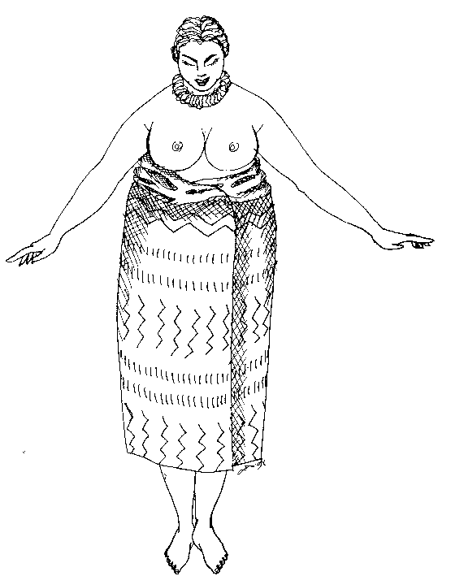
Figure 1: Hawaiian woman in Pa'u. Illustration by Claire Pimentel

The ali’i continued to use clothing, either indigenous or western, to symbolize their upper class position. Travelers noted that the Hawaiians from the upper classes eagerly acquired and wore western clothing and textiles (Kotzebue, 1821; Thurston, 1882); Hawaiians substituted fabrics such as calico for kapa in the pa'u (Anderson, 1854; Arago, 1823).

When the ali'i were notified of the impending arrival of the missionaries (on March 30, 1820) , they dressed for the occasion. The ali’i “met the ship dressed in honour of us with the utmost neatness, in fine English clothes" (Kotzebue, 1821:251-252). In her diary, Lucia Holman noted the European gowns of the Hawaiian queens "were made in the old continental style, with a long, tight waist ", worn over a tapa pa'u and underslip (Lyons, 1963). The missionary women, however, were dressed in the latest fashion; they arrived in dresses in the style of 1819, with a high waist, narrow skirt and long, tight sleeves. The Hawaiian royalty were enchanted and immediately requested that similar dresses be sewn for them. The queens brought out their stores of brocades, silks, and chintz, and missionary wives were pressed into service as seamstresses (Holoku , 1907; McClellan, 1950; Thurston, 1882).
In order to stay in the islands, the missionaries needed the permission of King Liholiho; Queen Dowager Kalakua was to accompany them and demanded a new dress to wear for the critical meeting with the King (Thurston, 1882). She presented the missionary seamstresses with a bolt of white cambric for the construction of her new gown (Holoku, 1907; Lyons, 1963).
Lucy Thurston was one of the preacher's wives who arrived in 1820. She reported that the ali'i had "limbs of giant mould... and weighed 300 pounds or even more " (Thurston, 1882:31). Queen Kalakua was among the most important of the female ali'i, and, from all accounts, was a formidable woman. When she requested a dress like theirs, the missionary women scurried to do her bidding. In order to fit her large size, and to adapt to the hot, humid environment, the mission ladies adapted their high-waisted style for a loose, comfortable fit (Fundaburke, 1965; Holoku, 1907; McClellan, 1950; Thurston, 1882). The missionary women replaced their high waistline with an above-the-bust yoke (Fundaburke, 1965; Furer, 1983). In discussing what would be called the holoku, Lucy Thurston (1882:32) noted that "the dress was made in the fashion of 1819 ". While there are no primary sources to detail the movement of the line from under the bust to a yoke above the bust, several authors (Development of the Holoku, 1950; Fundaburke, 1965; Furer, 1983; Helvenston, 1989; Holoku, 1907; McClellan, 1950) offered explanations such as the following from Lyons (1963:55-56):
The mission ladies realized...their own styles....would be neither becoming nor comfortable to the Polynesian figure... By April 4, a new fashion had been invented.
A full straight skirt had been attached to a yoke, with sleeves resembling the close ones of the day. But the new style, loose and flowing, was better suited to the island climate.
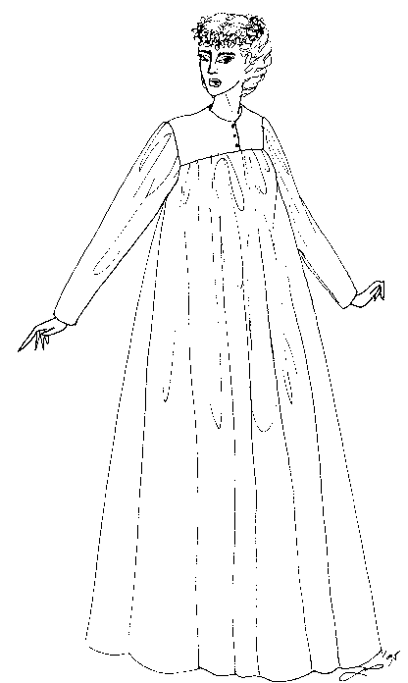
The end result was a basic design which was simply a full, straight skirt attached to a yoke with a high neck and tight sleeves (Anderson, 1865; Arthur, 1997; Helvenston, 1989). When the party of missionaries and Hawaiians arrived for the visit with the King on April 4, 1820, Queen Kalakua made quite a stir with her new dress, and an American lace cap (Thurston, 1882). This style was later referred to as the holoku. Embraced as a new fashion by the ali’i, the adoption of the holoku was overtly encouraged by the Christian missionaries, who were offended by the scanty clothing worn in Hawai’i. Commoners traditionally covered only the genitals, and women wore a short pa'u with the bust exposed; missionaries took offense and would not allow nakedness near the missions (Anderson, 1865; Thurston & Bishop, 1832; Thurston, 1882). As a consequence, the mission wives established women's societies to advance western notions of modesty. By 1829, with 1500 converts, the missionaries insisted that “[converts] must uniformly have a full covering for their person, both at home and abroad" (Thurston, 1882:98).
Figure 2: Early nineteenth century holoku. Illustration by Claire Pimentel

The missionaries and Hawaiians had different motives for covering the body. The main motive of the missionaries was to cover nakedness and uphold the western social conventions of modesty and propriety. According to the missionaries, the Hawaiians used clothing primarily to display status, “rather than as a covering for their deformity” (Missionary Herald, 1832:222). While covering nakedness was essential to the missionaries, Hawaiians considered dress to be optional, depending on rank and the social occasion (Missionary Herald, 1832; Thurston, 1882).
Nevertheless, there was a covert reason that the missionaries insisted on the wearing of holoku; that was that it immediately identified and separated the Hawaiians from the Westerners.

HAWAIIAN ADOPTION OF THE HOLOKu

The diaries of missionary women report that Hawaiian women who had been Christianized adopted the holoku as daily dress by 1822 (Thurston, 1882). However, it took a great deal longer for the holoku to become uniformly associated with Hawaiian women, due to status differences among the indigenous Hawaiian population. The early converts were ali’i, who already had acquired western textiles through trade. When the missionary wives required “modest” dresses to be worn by all women at the missions, they immediately became seamstresses for the early converts, the ali’i. The wives soon found sewing to be an overwhelming job. However, the ali’i were glad to have holoku made for them by the missionary wives, because it reinforced their higher social status. Showing the ethnic transformation associated with the holoku in the 1820s and 1830s, Hawaiian women often wore the pa’u, made of kapa, over the holoku (Arthur, 1997; Bishop, 1887; Furer, 1983).
In the 1830s, the missionary women taught Hawaiians to sew, and soon commoners began to make the holoku of kapa (Bishop, 1887; Furer, 1983), which connected the indigenous Hawaiian textiles to the western design line of the holoku (Fig. 1). Due to the high cost of western textiles, kapa was used by commoners until the late 1830s when they were able to barter for fabric (Bishop, 1887; Missionary Herald, 1833). At this time, Hawaiian men became skilled carpenters and built Western-style houses for missionaries. Hawaiians traded labor and koa wood planking for fabric for their women, who were often involved with the mission and needed dresses (Missionary Herald, 1833)(Fig. 2). Due to the missionaries’ need for housing, and the Hawaiians’ desire to westernize, by 1837 the holoku replaced the pa’u and became the standard dress for Hawaiian women who worked in it, were married in it, and were buried in it (Bishop, 1837; Holoku, 1907; Missionary Herald, 1837). The holoku was the universal dress of all Hawaiian women by the time photographers arrived in Hawaii in 1860 (Fig. 3).

Content analysis of the Hawaiian Women photo collection at the Bishop Museum (dated 1860-1960) indicated that in 1860, all of the Hawaiian women photographed were dressed in holoku. In the entire sample, 90 percent of the dresses worn by Hawaiian women were holoku. Westerners in Hawai’i, however, clung to European and American fashions, in order to aintain ethnic distinctions (Bird, 1882; Thurston, 1882). In her travels through the Hawaiian Islands, Isabella Lucy Bird described the holoku in great detail, praised its beauty, simplicity and comfort. In contrast to the confinement of Western fashion, Bird (1882:150) noted that " if we white women always wore holoku of one shape, we should have fewer gloomy moments".
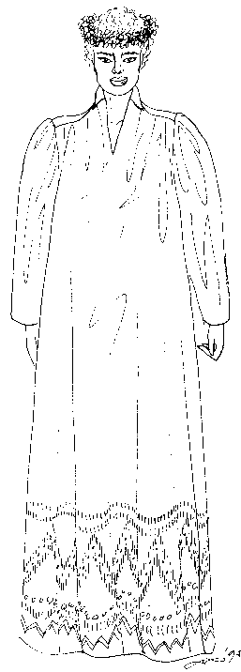 HOLOKu IN THE LATE NINETEENTH CENTURY
Figure 3: Kapa holoku, ca 1835.
Illustration by Claire Pimentel

The ali'i lived and interacted with both westerners and the indigenous Hawaiians; not surprisingly, they dressed according to the occasion. The ali'i wore traditional Hawaiian pa'u of kapa, holoku and western dress. In the latter half of the 19th Century, the ali'i became very involved in European court life and wore European dress for formal and state occasions, such as the coronation of King Kalakaua in 1883. However, they spent most of their time in holoku. A visitor noted that "the ordinary native women had holoku on, many of expensive and rich materials" and was surprised to see that, at the ball later on, the Queen and her retinue changed out of European dress into holoku (Judd, 1975:25).
Commoners wore simply styled holoku for everyday wear, and dressier holoku for special events. In the 1870s, trains were added; the length varied with the formality of the occasion, and the holoku became a formal gown for Hawaiian commoners. While the long sleeves and high necklines persisted for day dresses, lower necklines and short sleeves became acceptable for formal occasions. For all holoku, trains became standard and ruffles and pleating became common decorative elements on late nineteenth entury holoku.
Through the 1870s, the holoku was simply styled but due to the increased influence of European styles, the holoku began to loose some of its fullness. At the same time, Hawaiian women had become more slender. By 1873, the holoku was worn by nearly all Hawaiian women, and was considered “the official dress of the Hawaiian Islands” (Costumes of Hawai’i, 1965), whereas Westerners exclusively wore European fashion (Bird, 1882). The loosely styled holoku, both plain and with assorted trimmings and trains, continued to be the dominant style through the 1880s. Lace, eyelet, ruffles and trims became popular in the 1890s, along with leg-o-mutton sleeves. These Edwardian design details would become extremely popular at the turn of the century, and become immortalized as the late nineteenth century holoku became fossilized fashion in the twentieth century.
Also at the turn of the century, the black holoku was popularized by two famous Hawaiian Queens. In the nineteenth century, Queen Ka’ahumanu wore black holoku exclusively. In her name, a women’s organization devoted to the care of Hawaiian people and preservation of their culture was instituted. Black holoku, hats and gloves have been worn by members of the Ka’ahumanu society since that time, and this practice continues to this day. Following the overthrow of the Hawaiian monarchy in 1893, Queen Liliuokalani wore only black holoku. Although she preferred lilac, Queen Liliuokalani wore black as a symbolic protest for what was considered an illegal overthrow (Goodwin, 1962). Inasmuch as there were no ali’i after the overthrow, the distinction between royalty and commoners disappeared. The holoku continued to represent Hawaiian ethnicity without the connotation of a commoner class. Class and ethnic distinctions became blurred by the turn of the century, due to the influx of various ethnic groups into Hawai’i.

TWENTIETH CENTURY HOLOKu

As it entered it's second century of life, the traditional holoku continued to be worn with little significant change except that white was the predominant color and more detail was added, such as ruffles and tatting. What is significant here is that, even though there was rapid change in western fashions worn in Hawai'i and elsewhere, the change in the holoku was extremely minor and it continued to be worn as an expression of Hawaiianness. These lingerie-style holoku (Fig. 4) were made in cottons such as muslin, batiste and dimity, and had a straighter silhouette than previously. Trains lengthened, and the use of Edwardian details, such as lace, eyelet, pin tucks and ruffles at the sleeves, yokes and hems increased significantly. In 1907, the holoku was described as the Hawaii's reaction to the European tea gown (Holoku, 1907). As a consequence, we see a visual manifestation of Freidman's (1992) assertion that Hawai'i was in the process of developing its own identity in opposition to Western society.
The lingerie style holoku has been memorialized in paintings of "Old Hawai'i" and has enjoyed a revival in contemporary use as we approach the end of this century. The lingerie style holoku was extremely popular in the first part of the twentieth century, which, in Hawai’i was a study in cultural contrasts. Hawaiian style also contrasted with western fashion, which was mass produced, inexpensive and commonly worn for daytime use. White holoku dominated the Hawaiian fashion scene; nonetheless black holoku continued to be favored by many Hawaiian women.
Kathleen Perry (Adams, 1990:B1) remembered, “They had holoku for dressup - the ones with the long trains, and holoku for around the house that had just a little bit of tail.” Leilani and Pua, two of the women interviewed, noted that in the early twentieth century, traditional Hawaiian women began wearing old holoku worn by the women in their families in the nineteenth century. Often, these reproductions were made in styles worn in the mid to late nineteenth century for Holoku Balls.
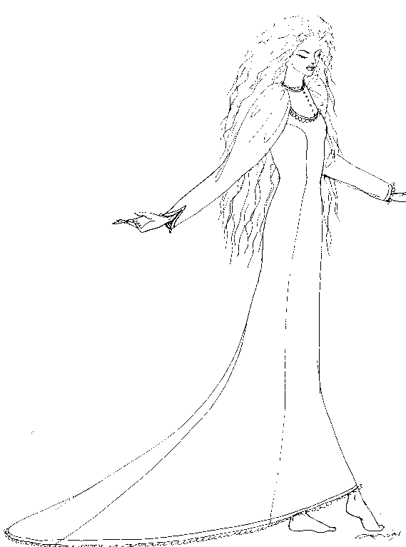
Figure 4: Early twentieth century holoku.
Illustration by Claire Pimentel.
Adams (1990) noted that the holoku was the most popular evening dress for kama’aina women. A similar reverence for Hawaiian history was seen when kama'aina women began making copies of old holoku when they made new gowns (Lytle, 1953). Hawaiian heritage is celebrated today with the wearing of the holoku by kama'aina women in several events honoring Hawaiian heritage, such as May Day events, Aloha Week activities, and in the Holoku Ball, begun in the early part of this century (Khan, 1994; personal communication).
The production of aloha apparel is one of the major industries in Hawai'i. Aloha shirts and mu'umu'u are produced for both tourist and local markets. While anyone may wear the mu'umu'u, the holoku is only worn by kama'aina women and is custom made rather than mass produced. As part of my research, I was invited to attend the Holoku Ball, in which historic holoku are worn in a parade, while all other participants at the ball are in holoku. As a malihini who is neither local nor Asian, however, I was advised to wear a dressy mu'umu'u.
The holoku continued to be a popular gown for the numerous social functions of the late 1940s and 1950s (Adams, 1978). Reverence for the holoku as an elegant garment, reflecting the elegance of a bygone era in Hawaiian history, continued unabated through the 1940s and into the 1950s, evidenced by its ubiquity on the Hawaiian fashion scene (Hussey, 1940). Because holoku were considered formal evening garments by the 1950s, dress fabrics such as lace, velvet, satin and silk were commonly used. Lace became extremely popular in the 1960s, especially for wedding holoku. For Keiko’s wedding in the late 60s, she chose to wear a lace holoku as a form of regional, rather than ethnic identity in order to downplay ethnic differences between the Japanese and Korean members of the families. “We’re so mixed in Hawai’i,” she said, “aloha attire crosses over other ethnicities and shows pride in our Hawaiian heritage.”
Traditional holoku continued to be worn primarily by traditional Hawaiian women, such as members of the Ka’ahumanu society who continued to dress in black holoku for a variety of events. For weddings in the 1970s, holoku design continued the trend to rely on turn of the century designs with high necklines and leg-of-mutton sleeves. “I feel the most Hawaiian when I wear a holoku”, said Moku, “it shows the pride I feel in my Hawaiian heritage.”
Since the 1980s, the holoku has more strongly reflected Hawaii’s past rather than a more contemporary approach to fashion. Design details from the turn of the century, such as white fabrics, from simple cottons to lace, were common in 1980s holoku. In discussing a gown she wore in the mid-1980s, Nani said, “I like wearing the Edwardian kind of holoku, the ones Tutu [grandmother] and my aunties wore at the turn of the century when Hawai’i was in full flower.” Hawaiians became even more retrospective in the 1990s as the state prepared for the centennial anniversary of the overthrow of the Hawaiian monarchy. Focus on Hawaiian culture led to a resurgence of turn-of-the-century holoku designs. Long sleeves and ruffles returned to holoku design in the 1980s. The length of the train denoted the level of formality. For weddings, turn of the century styles, with pin tucks, ruffles, high necklines and leg-o-mutton sleeves were favorites.
The centennial occurred in 1993 and since that time Hawai’i continues to focus on its historical past. Similarities between the early and late twentieth century holoku are rather apparent. In the 1990s, holoku are commonly made of dressy fabrics such as white lace, and have details that were common at the turn of the century. While small details may change, in shape, form and function, the holoku has fossilized. Maile stated that she “wears holoku as a sign of respect for the Hawaiian culture as it was in the past.” Holoku continue to be worn for weddings, graduations, Hawaiian civic affairs such as the Holoku Ball, and to dance the hula. Lianne noted “Its about ethnic togetherness. When my halau dances the hula holoku, we aren’t Japanese, Chinese or Filipinas, -- we’re Hawaiian.” Emphasizing the importance of regional ethnicity to local women, she went on to say, “Its where we are that makes us who we are.”

DISCUSSION

While the holoku was originally an 1820 adaptation of a western-style gown, it was quickly associated with indigenous Hawaiian women, and became the uniform dress of Hawaiian women during the nineteenth century. During that century, the definition of Hawaiian ethnicity changed due to the impact of immigration and intermarriage. In Hawai’i, a pan-ethnic regional identity, referred to as local identity, can supercede other ethnic identities in the local population. In the case presented here, regional identity is expressed visually by kama’aina women who wear the holoku to celebrate their Hawaiian heritage.
Although minor details of the holoku have changed somewhat since 1820, the overall form, and the function of the garment as an expression of Hawaiian ethnicity have not changed. The traditionally loose style of holoku fossilized at the turn of the century, with the design details favored by the Hawaiian monarchy. While it could be argued that the holoku is an invented tradition (following Hobsbawm), I would note that the tradition has evolved over time to represent exactly what it was intended to -- that is to define Hawaiian women as ethnically separate from the white missionary women who introduced western-styled garments to Hawai'i. The continual wearing of this turn of the century garment indicates that fossilized fashion can occur due to cultural factors. The continued use of the holoku by kamai'ina women may be a cultural statement not unlike the historic function of the hula, which Sahlins (1994) states continues to express (after two centuries of western domination) a defense of the old Hawaiian order, of Hawaiiana. Similarly, reverence for Hawaiian culture continues to be expressed visually by local women who wear the holoku to express their local ethnicity, a pan-ethnic Hawaiianness, rather than a genetic connection to Asian ethnic groups. The use of this Hawaiian garment is a unifying symbol of the aloha spirit. As long as the holoku is associated with Hawaiian tradition, it will continue to be worn as a symbol of the wearer's commitment to Hawaiian culture.

REFERENCES

Adams W. (1978), Fashioning a tour of the past, Honolulu Star Bulletin, July 12: G 1;
Adams W. (1990), Holoku history, Honolulu Advertiser, March 14: B1;
Allen A. (1850), Dr. White's Travels and Oregon Adventures, Ithaka, NY, Press of Andrus,
Gauntlet and Co. (Original work published 1836);
Anderson M. (1865), Scenes in the Hawaiian Islands and California, Boston, American Tract
Society;
Anderson N. (1854), A Voyage Around the World with the Swedish Frigate Eugenie, \Groningen, J. B. Wolters;
Arago J. (1823), Narrative of a Voyage Around the World 1817-1820, London, Treuttel and Wurtz;
Arthur L. (1997), Cultural authentication refined: The case of the Hawaiian Holoku, Clothing and Textiles Research Journal, 15, 129-139;
Barnard C. (1829), Voyage Around the World, London, J. Lindon Printers;
Bird I. (1882), Six Months in the Sandwich Islands, New York, G. P. Putnam;
Bishop S. (1887), Jubilee Celebration 1837-1887, The Forbes Notes, Unpublished manuscripts, Mission Houses Museum, Honolulu, HI;
Chamberlain M. (1820), Letter to James Patton, Unpublished manuscripts, Mission Houses Museum, Honolulu, HI;
Cohen A. (1974), The lesson of ethnicity, Urban Ethnicity, London, Tavistock;
Costumes of Hawai’i (1965), Unpublished booklet for Hawaiian Arts, 152, University
of Hawai’i;
Daws G. (1974), Shoal of Time: A History of the Hawaiian Islands, Honolulu, University of Hawaii Press;
Development of the Holoku, (1950), Paradise of the Pacific (61), May, 12-13;
Fundaburke E. (1965), The Garment Manufacturing Industry of Hawai’i, Honolulu, Economic Research Center;
Friedman J. (1992), The Past in the Future: History and the Politics of Identity, American Anthropologist, 94 (4), 837-859;
Furer G. (1983), Designs of Hawaiian wear, Proceedings of the Association of College Professors of Textiles and Clothing, 13-20;
Goodwin R. (1962), Those elegant years, Paradise of the Pacific, 74, 106-123;
Gordon B. (1987), Fossilized fashion: Dress as a symbol of a separate, work-oriented identity, Dress, 13, 49-59;
Haas M. (1994), Explaining ethnic harmony: Hawaii’s multicultural ethos, Paper presented at the American Sociological Association annual meeting, Los Angeles, CA.
Hawaii State Data Book, 1996, Online research, table 1.24;
Helvenson S. (1989), The much maligned Mother Hubbard: A study of unfashionable dress, Proceedings of the Association of College Professors of Textiles and Clothing, 39;
Holoku -- Origin and Evolution, (1907), Picturesque Honolulu, Honolulu, Hawaiian
Gazette, 44-5;
Hussey W. (1940), Holoku: Hawaii's glamour gown, Honolulu Advertiser Magazine, Section
1;
Judd W. (1975), Palaces and Forts of the Hawaiian Kingdom, Palo Alto, Pacific Books;
Kefgen M., Touchie-Specht P. (1986), Glossary, Individuality in Clothing Selection and Personal Appearance, New York, Macmillan;
Kirkpatrick J. (1987), Ethnic antagonism and innovation in Hawaii, J. Boucher, D. Landis and K. Clark, (Eds.), Ethnic Conflict: International Perspectives, 298-316, Newbuy Park, Sage;
Kotzebue O. (1821), Kotezebue's Voyage of Discovery 1815-1818, London, Longman, Thirst, Rees, Orme and Brown;
Laver J. (1969), Modesty in Dress, Boston, Houghton Mifflin;
Lyons B. (1963), The first holoku, Hawaii Historical Review, 54-56;
Lytle D. (1952), Regal holokus recall Polynesian history, Honolulu Advertiser, 1-5;
McClellan E. (1950), Holoku and mu'umu'u, Forecast Magazine, Honolulu, Outrigger Canoe Club, 12;
Missionary Herald (1832), Extracts from the Joint Letters of the Hilo Mission, Hilo, HI,
Lyman House Memorial Museum, 222;
Missionary Herald (1833), Extracts from the Joint Letters of the Hilo Mission, Hilo, HI,
Lyman House Memorial Museum;
Okamura J. (1992), Why there are no Asian Americans in Hawai’i: The continuing significance of local identity, Paper presented at the National Conference of the Association of Asian American Studies, San Jose, CA;
Sahlins M. (1994), Goodbye to Tristes Tropes: Ethnography in the Context of Modern World History, Robert Borofsky (ed.), Assessing Cultural Anthropology, McGraw Hill, 377-395;
Schiffer N. (1997), Hawaiian Shirt Designs, Atglen, PA, Schiffer Publications;
Steele T. (1984), The Hawaiian shirt, its art and history, New York, Abbeville Press;
Stewart G. (1977), Ancient Hawaiian dress and the influence of European dress on it,1778- 1820, Unpublished Master’s thesis, University of Hawai’i;
Thurston A., Bishop, A. (1832), Difficulty of introducing purity of morals among a barbarous people, Missionary Herald, 28, 220-221;
Thurston L. (1882), Life and Times of Mrs. Lucy G. Thurston, Wife of Rev. Asa Thurston, Pioneer Missionary to the Sandwich Islands, Ann Arbor, MI, S.C. Andrews;
Tyreman D., Bennett G. (1831), Journal of Voyages and Travel, London Fredrick Westley and A.H. Davis;
Wills F. (1913), The story of the holoku, Mid Pacific Magazine, 465-7;
World Photo Press, (1997), Master Book of Hawaiian Shirt, Tokyo, Japan, World Photo
Press.

ENDNOTES ?The two largest collections of primary and secondary sources on Hawaiian history are on the island of Oahu. The University of Hawai’i at Manoa has a large collection of primary materials in the Hawaiian Costume Collection and in the Hawaiian /Pacific Collection at Hamilton Library. The other large collection is at the Mission Houses Museum, in the Hawaiian Mission Children’s Society Library. Further research into unpublished typescript letters and diaries was conducted at the Lyman Mission House Memorial Museum on the island of Hawai’i.
The largest photograph collections on early Hawaiian history are at the Bishop Museum (750,000 photos) and the Hawaiian State Archives (100,000 photos), both on Oahu, and on the island of Hawai’i at the Lyman Mission House Memorial Museum (14,000 photos).
The most useful photos were taken by Ray Jerome Baker and are housed at the Bishop Museum. A photographer who arrived in Hawaii in 1908, Baker had an ethnographic approach, and made documenting Hawaiian culture in situ his life’s work. Consequently, his photos show the people in their villages and houses on all the islands, rather than only in studios.
Pseudonyms are used for quotes in this manuscript, due to the promise of anonymity to women who were interviewed. Much of the information on twentieth century design evolution came from these interviews.

