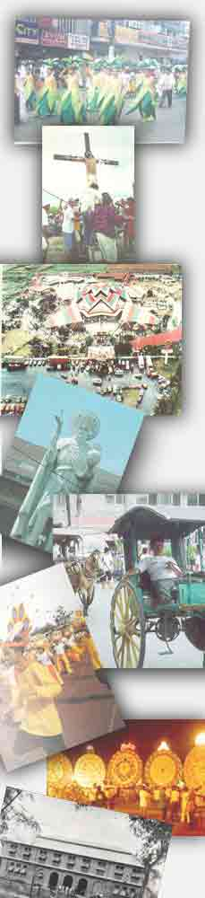
PHS CLASS’65
GRAND REUNION 2005
Preliminary Program

Pre-Reunion Tours

Wednesday, 28 December 2005

0900-1100 Registration/Credentialing
(Partyland)

1100-1400 Foundation Scholars/Donors
Meeting (Partyland)

1700-2200 Home/Host Hospitality Evening

Thursday, 29 December 2005

0700-1500 Alumni Group Tour

1800-2200 Registration/Credentialing
(Paskuhan Village)

1800-2200 Foundation Project Exhibits
(Paskuhan Village)

1800-2400 Fellowship Night
(Paskuhan Village)

Friday, 30 December 2005

0700-0800 Interfaith Service (PHS Grounds)

0800-1000 City Motorcade (Starts at PHS Blvd)

1630-2200 Grand Reunion Dinner Dance
(Fortune Restaurant)

Fellowship Tours 
(Ticketed Event)

 Post Reunion Tours 
(Arranged with Tour Operators)
Fab@40!

