Gases

and their

Behaviors

Okon Koko Ekpo

Miami-Dade Community College

Kendall Campus

Table of Contents

The Physical Behavior of Matter in the Gaseous State…………………….…... 4
The Kinetic Theory of Matter……………………………………………………… 4
The pressure exerted by gases……………………………………………………... 6

A Brief Description of Gas Laws, Equations,
and Concepts Governing the Behavior of Gases ………………………………. 6
Boyle's Law ……………………………………………………………………….. 6
Charles' Law...……………………………………………………………………... 6
The Pressure Law………………………………………………………………….. 6
The General Gas Equation……………………………………………………….… 6
The Ideal Gas Equation…………………………………………………………….. 7
Avogadro's Principle……………………………………………………………….. 7
Dalton's Law of Partial Pressures………………………………………………….. 7
Graham's Law of Diffusion………………………………………………………… 8
The Concept of Molar Volume…………………………………………………….. 8
Standard Temperature and Pressure (STP)……………………………………….... 8

Further Explanations on the Gas Laws and Equations………………………... 8
Boyle's Law………………………………………………………………………... 8
Mathematical representations of Boyle's Law……………………………………... 9
Graphical and diagrammatical representations of Boyle's law…………………….. 10
How the Kinetic Theory of Gases explains Boyle's Law………………………….. 11
Charles' Law………………………………………………………………………. 12
Mathematical Representations of Charles' Law……………………………………. 12
Graphical and Diagrammatical Representations of Charles' Law…………………. 13
How the Kinetic Theory of Gases explains Charles' Law…………………………. 14
The Pressure Law……………………………………………………………….… 15
Mathematical Representations of the Pressure Law……………………………….. 15
A diagrammatical representation of the Pressure Law…………………………….. 15
How the Kinetic Theory of Gases explains the Pressure Law……………………... 16
The General Gas Equation………………………………………………………... 17
The mathematical representation of the General Gas Equation………………….… 17
The Ideal Gas equation……………………………………………………………. 17
The mathematical representation of the Ideal Gas Equation………………………. 17
Modifications of the Ideal Gas Equation…………………………………………... 17
The Concept of Diffusion…………………………………………………………. 19
A Definition of Diffusion ………………………………………………………….. 19
Factors that affect the rate of diffusion of a gas……………………………………. 19
Graham's Law of Diffusion………………………………………………………… 19
Mathematical representations of Graham's Law of Diffusion………………………20

Preface

Basically, this handout contains simple and straightforward explanations on important gas laws such as: Boyle’s Law, Charles’ Law, the Pressure Law, and Graham’s Law of diffusion. It also contain explanations on some of the important concepts that govern the physical behavior of gases when they are subjected to certain conditions within a closed system.

Originally, it was just a simple handout that I prepared for my friends in a CHM 1045 Lecture class, which I was also a part of.

The original version was only on explaining gas laws, equations, and concepts like: Boyle's Law, Charles' Law, the Pressure law, the General Gas equation, the Ideal Gas equation, Avogadro's principle, Dalton's Law of partial pressures, the Molar Gas concept, and the concept of Standard Temperature and Pressure. It did not contain some of the diagrams and additional explanations that I have included in this particular version.

Later on, I decided to make some changes to the original version and then add other concepts and better diagrams to it, so that some of my explanations will be clearer.

Some of these modifications were: the addition of better diagrams and graphs for the explanation of Boyle’s, Charles' and the Pressure Laws; the inclusion of the Kinetic Theory of Matter in the handout for further explanations on the gas laws; and the inclusion of the concept of diffusion.

At this point, I would like to seize this opportunity to express my sincere appreciation to Dr. Ana Ciereszko, my Chemistry Instructor in the "Bridges to the Future Program" for her spending her valuable time in editing this piece of information; I will also like to thank you, its reader, for paying your undivided attention while studying with it.

If there is any misspelling or misrepresentation of any information in this pamphlet that might lead to your misinterpretation or misunderstanding of any of my explanations please do not hesitate to let me know. You can email me at ELmeuko@aol.com, if you have any questions, comments, or suggestions.

The online version of this handout can also be accessed through the Internet at www.expage.com/gases or at www.megaone.com/chemistry/gases.htm

Thank you for your attention. I hope this handout will be of help to you in your studies.

Okon Koko Ekpo
Miami-Dade Community College, North Campus.

The Physical Behavior of Matter in the Gaseous State
In a gas, the molecules have much more kinetic energy than those in the liquid and solid states. The cohesive forces (the forces that bind the gas molecules together) in a gas are negligible (very small and insignificant). This is why the molecules are free to move about in all directions and at great speed, but only within the walls of the container.

Matter in the gaseous state has no definite shape; it occupies the whole volume of the container because it is able to move to every part of the container; and since the molecules are relatively far apart from one another, they can be easily compressed.

Matter in the gaseous state has characteristics that are different from that in the solid and liquid states. As such, the behavior of gases should be expected to be different from that of solids. These behaviors were investigated by many of the early scientists such as Boyle, Charles, Graham, and Dalton. Their important findings and discoveries were named after them.

Before I go into explaining these different laws, let me give you a brief theory upon which the physical behaviors of these gases are based. This theory is known as the Kinetic Theory of Gases. It describes the behavior of an Ideal or Perfect gas.

It states the following (the theorem is the sentences in italics):

- Gas molecules move randomly in straight lines, colliding with one another, and also with the walls of their container. The individual speeds of the gas molecules differ widely and are constantly changing. The collision of the gas molecules on the walls of the container results in the gas pressure exerted on this container.

- The collisions of the gas molecules with one another and with the walls of their container are perfectly elastic.
Before I proceed, let me explain what is meant by a perfectly elastic collision:
A collision between two bodies or particles is said to be perfectly elastic when a particle collides with another particle such that the sum of the kinetic energies of the two bodies or particles before the collision is exactly the same as the sum of the kinetic energies of the two bodies or particles after the collision.
One of the particles may lose its kinetic energy during the collision, but this energy will in turn be gained by the other particle so that the sum of the kinetic energy of the two particles remains the same after the collision.
To make the picture clearer, let us take a look at a hypothetical example of a perfectly elastic collision:
Let’s consider two particles, Particle A and Particle B:
Particle A has a kinetic energy of 50 Joules and Particle B has a kinetic energy of 50 Joules. Particle A collides head-on with Particle B; after the collision, it is observed that Particle A is now moving with a kinetic energy of 85 Joules, while Particle B is moving with a kinetic energy of 15 Joules.

This collision is perfectly elastic. Notice that though there is a change in the individual kinetic energies of these two particles, the sum of the kinetic energies of these two particles is still 100 Joules.
On the other hand, if the collision were to be inelastic, the sum of the kinetic energies of the two particles after the collision would have been lower.
Inelastic collisions occur because some of the kinetic energies of the bodies or particles involved in the collision is converted into other forms of energies like sound or heat energy.

Let’s get back to the Kinetic Theory of Gases: When two gas molecules collide, the collision is perfectly elastic. Their individual kinetic energies may change; one molecule may move faster while the other slows down, but the sum of their kinetic energies will remain the same. When these molecules collide with the walls of their container, they also rebound like elastic balls, without any loss of kinetic energy.

- The actual volume occupied by the gas molecules themselves is negligible (small and insignificant) when compared to the volume of their container.
Let us take a look at an analogy so that you can have a better picture of this part of the theorem:
Let us consider a small room containing 50 butterflies.
Let the butterflies represent the gas molecules and let the room represent the container of the gas.
Imagine the butterflies flying all over the entire room such that you can see a butterfly at every part of the room at any instant; just like how the molecules of the gas are spread all over the container in which they are. After a while, the 50 butterflies decide to cluster at one spot in the room for their “evening prayers.” If we really want to compare the actual volume occupied by the butterflies themselves to the volume of the room in which they are, their volume will be very small and insignificant. This is how the volume occupied by the molecules of the gas is, when compared to the volume of the container in which they are.

- The cohesive forces (the forces that bind the gas molecules together) between the gas molecules are negligible (very small and insignificant).

- The temperature of a gas is a measure of the average kinetic energy of the gas molecules. As the temperature of the gas increases, the average kinetic energy of the gas molecules also increases.

In the above theory, certain assumptions have to be made in order to simplify the description of the physical behavior of gases in a closed system. Real gases, however, show certain deviations from that of the Ideal or Perfect gas as given in The Kinetic Theory of Matter.

Pressure Exerted by Gases
The molecules of gases contained in a vessel move randomly at high speeds, often colliding with one another and with the walls of their container. Each time a gas molecule hits or collides with the wall of their container, it exerts a small force on it. Since the gas molecules are very numerous and are evenly distributed within the container, their continued collision with the walls of the container exerts a force on the walls of this container. The force that the gas exerts per unit area on the walls of container is known as the gas pressure. This force is constant for every unit area of the walls of the container within which the gas is enclosed.
Gas pressures are commonly measured in atmospheres (atm) or in mmHg. The S.I unit in which pressure is measured is the Pascal (N/m²).

Different laws and equations have been formulated based on the behavioral changes that are associated with gases, when they are subjected to certain conditions. Some of these laws include:

♦ Boyle’s Law: This is a law that expresses the relationship between the volume of a
gas and its pressure when,
• Its absolute temperature and
• Its amount (in moles) remain unchanged.
Basically, it shows how the volume of a gas increases or reduces as its pressure is being decreased or increased.

♦ Charles’ Law: This is a law expressing the relationship between the volume of a gas and its absolute temperature when,
• Its pressure and
• Its amount (in moles) remain constant.
Basically, it shows how the volume of a gas increases or reduces, as its absolute temperature is being raised or lowered.

♦ Pressure Law: This is a law expressing the correlation (relationship) between the pressure of a gas and its absolute temperature when,
• its volume and
• its amount (in moles) remain unchanged.
Basically, it shows how the pressure of a gas increases or reduces, as its absolute temperature is being raised or lowered.

♦ The General Gas Equation: As the name implies, it is not a theorem or a law as the other laws that I have mentioned above; it is a mathematical equation formed from the combination of the above-mentioned laws (Boyle’s, Charles’, and the Pressure Laws).
It shows the interdependence or relationship between
• the pressure
• volume
• and absolute temperature of a gas
when the amount of the gas (in moles) is fixed.

♦ The Ideal Gas Equation: This is also a mathematical equation based on the relationship between the pressure, the volume, the absolute temperature, and the amount of a gas (in moles). Since nothing is considered fixed, all the four properties are taken into consideration in the writing of the formula (mathematical equation).

These Properties include:
• The Pressure of the gas.
• Its Volume
• Its absolute temperature
• and its amount (in moles).

There are also other laws that are equally important in the study of the behavior of gases. Some of them are:

♦Avogadro’s Principle: According to this principle, equal volumes of all gases under identical conditions of temperature and pressure, contain equal number of molecules.
This implies that, if there are 2 million molecules of oxygen in a 10-liter container at a pressure of 5 atmospheres, when the temperature is 300 K, there must also be exactly 2 million molecules of carbon dioxide (another gas) in another 10-liter container that has exactly 5 atmospheres of pressure, and at a temperature of 300 K (the same conditions of temperature and pressure). This principle holds true for all gases.

♦ Dalton’s Law of Partial Pressures: This law states that if there is a mixture of gases, which do not react chemically together, then the total pressure exerted by the mixture is a sum of the partial pressures exerted by the individual gases making up the mixture.
According to this law, the total pressure exerted by a mixture of gases is the sum of the pressures that each individual gas would exert if it were confined alone within a volume occupied by the mixture.

For example, if a gas is collected over water, it is likely that this gas will be saturated with water vapor. The pressure that is exerted is the combined partial pressures from the gas itself, and that of the water vapor. The effective pressure of the dry gas will have to be calculated by subtracting the saturation vapor pressure of water at that temperature from the total gas pressure of the mixture of the gas itself and water vapor.

Another example of this phenomenon is illustrated when a container is filled up with air (air is a mixture of nitrogen, oxygen, carbon dioxide and other gases). The pressure exerted on the walls of the container is the sum of the partial pressures exerted by each of the gases that are present in air.

Mathematically, Dalton’s Law of Partial Pressure is represented as follows:
P_{total} = P_{A} + P_{B} + P_{C} + P_{D} . . . .

On the last page,
• P_{total} represents the total gas pressure from all the gases making up the mixture.
• P_{A}, P_{B}, P_{C,} and P_{D} represents the partial pressures exerted separately by the individual gases A, B, C, and D that make up the mixture.

♦Graham's Law of Diffusion:
This is a gas law that expresses the relationship between
• the rate of diffusion of a gas and
• its density when
• Its temperature and
• Its pressure remains constant.
Basically, it shows how the rate of diffusion of gases decrease as their densities increase.

The Concept of Molar Volume:

The molar volume of a gas is the volume occupied by one mole of that gas at standard temperature and pressure, and this volume is numerically equal to 22.41 liters (dm³ ). This is true for any gas.

At standard temperature and pressure (commonly abbreviated as STP )

• The value of the temperature is 0°C (273 K) and
• The pressure is at 1 atmosphere (760 mmHg or 1.01 x 10⁵ Nm⁻² [pascals] ).

So, this implies that at STP, 71.0g of chlorine gas (one mole of chlorine molecules) will occupy a volume of 22.41 liters.
Similarly, 44.0g of carbon dioxide (one mole of carbon dioxide molecules) will also occupy a volume of 22.41 liters at standard temperature and pressure.

Further Explanations on the Gas Laws and Equations

Let’s begin with Boyle’s Law:

Boyle’s Law states that the volume of a given mass of a gas is inversely proportional to its pressure provided that its temperature remains unchanged.

If one measurement say V is said to be inversely proportional to another measurement P, this implies that when P increases, V decreases; and when P decreases, V is going to increase. To make the picture a little clearer, let’s put two things into consideration:
• The number of people in a particular household.
• The period of time it takes them to finish, completely, one hundred boxes of cereal in that house.
If each person can finish a box of cereal in a day, going by this rate, you can see that as the number of people living in the house increases, the period of time that it takes for the one hundred boxes of cereal in the house to finish decreases. This means that the number of people in the house is inversely proportional to the period of time it takes them to finish the boxes of cereal.

According to Boyle’s Law, the volume of a gas decreases as the pressure applied to it increases; if its pressure is decreased, its volume will increase. Of course, this will happen only if its absolute temperature and its amount (in moles) remain unchanged.

Mathematically, Boyle’s Law is expressed as follows:

P ∝ 1
V
P = k

V

P•V = k (k is a mathematical constant)

Therefore, P₁V₁ = P₂V₂

In the equation above, • P₁ represents the initial pressure of the gas.
• P₂ represents the final pressure of the gas.
• V₁ represents the initial volume of the gas.
• V₂ represents the final volume of the gas.

Note that if two measurements, say A and B, are inversely proportional to each other, their product at the initial conditions will always be equal to their product at the final conditions. This is why the mathematical relationship between the pressure of a gas and its volume in Boyle’s Law is expressed the way it is.

Also, if a graph of A against B is plotted, the graph will be a curve approaching the vertical and horizontal axes of the graph, but not touching them.

However, if the graph of A against 1/B, or the graph of B against 1/A is plotted, the graph will look like a straight line and not a curve.

This is why, in Boyle’s Law, when the graph of P (the pressure of the gas) is plotted against V (the volume of the gas) the graph forms a curve approaching the horizontal and vertical axes. However, when P (the pressure of the gas) is plotted against 1/V (the reciprocal of the volume of the gas) the graph forms a straight line instead.

Examples of these graphs are shown on the next page. Notice that in the first graph, the pressure of the gas is plotted against its volume; and the graph is a curve approaching the vertical and horizontal axes but not touching them.

In the second graph, the pressure of the gas is plotted against the reciprocal of its volume; and the graph is a straight line pointing away from the origin of the graph; if the volume of the gas was plotted against the reciprocal of its pressure, a similar graph will be obtained.
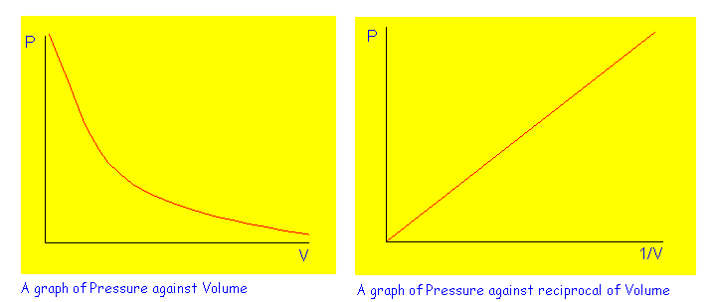

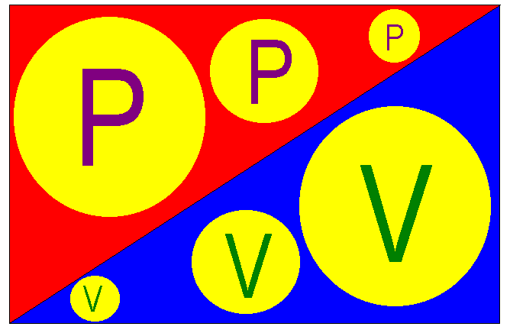Below is a diagrammatical representation of Boyle’s Law. I hope it will help you to remember the explanations that I have made.

The diagram shows how the volume of a gas varies with its pressure:
• The volume is small where the pressure is large.
• The volume is large where the pressure is small.

How the Kinetic Theory of Gases explains Boyle’s Law

If the volume of a container is reduced while the temperature and the amount of the gas remains unchanged, the total surface area of the walls of the container on which the gas particles are colliding will also be reduced.

Since the amount of the gas (in moles) and its temperature still remains the same, the number of collisions that the gas molecules are making with the walls of the container will remain the same too. Therefore, the force that the gas molecules are exerting on the container will not change. However, since the total surface area inside the container has been reduced by reducing the volume of the container, the ratio of the force exerted on the walls of the container by the gas molecules to the total surface area inside the container will increase, therefore resulting in an increase in the gas pressure. Pressure is a ratio of force to surface area.
Pressure = Force exerted
Surface Area
This is why the pressure of a gas increases when its volume is reduced at constant temperature.

Let’s now take a look at Charles’ Law:
Charles’ Law states that the volume of a given mass of gas is directly proportional to its absolute temperature, provided that its temperature remains unchanged.
If one value say V is directly proportional to another value T, this implies that as T increases, V is going to increase; and as T decreases, V is going to decrease.

Let’s take a look at an analogy: take the following two things into consideration:
• The quantity of pizza in a large bowl.
• The amount of time it takes someone to finish the pizza in the bowl.
Consider an employee of a "pizza-eating agency" that can finish twelve slices of pizza in one minute. If this guy is assigned a pizza-eating job, going by his pizza-eating ability, one can observe that as the quantity of pizza in the bowl is increased, the time that it takes the pizza-eating wizard to finish his job increases. If the quantity of pizza in the bowl is reduced, the time he uses in finishing the pizza will also reduce. This implies that the time used by the pizza-eating wizard to complete his job is directly proportional to the amount of pizza he is being assigned to eat.
According to Charles’ Law, the volume of a gas increases as its absolute temperature is being raised, if its absolute temperature is being lowered, its volume will consequently decrease. Again, this can only happen if the pressure of the gas and its amount (in moles) remain unchanged.

Mathematically, Charles’ Law is expressed as shown below:

V ∝ T
V = k•T

V = k (k is a mathematical constant)

T

Therefore,
V₁ ₌ V₂
T₁ T₂

In the equation above,
•V₁ represents the initial volume of the gas.
•V₂ represents the final volume of the gas.
•T₁ represents the initial absolute temperature of the gas.
•T₂ represents the final absolute temperature of the gas.

Note that whenever two quantities, say A and B, are directly proportional to each other, the ratio of A to B, at the initial condition will always be equal to the ratio of A to B at the final condition. This is why the mathematical relationship between the volume of a gas and its absolute temperature in Charles’ Law is written the way it is.

Also, if a graph of A versus B is plotted, this graph will be a straight line pointing away from the origin of the graph. This why the graphical representation of Charles’ Law is a straight line pointing away from the origin of the graph.

Below is an example of the graph of the volume of a gas plotted against its temperature at constant pressure and amount (in moles). Notice that the graph is a straight line pointing away from the origin with a positive gradient (slope).

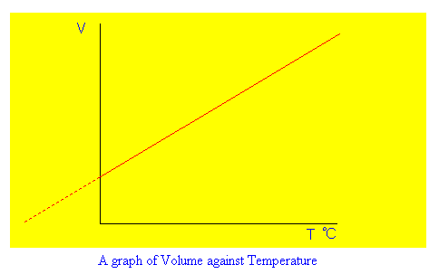
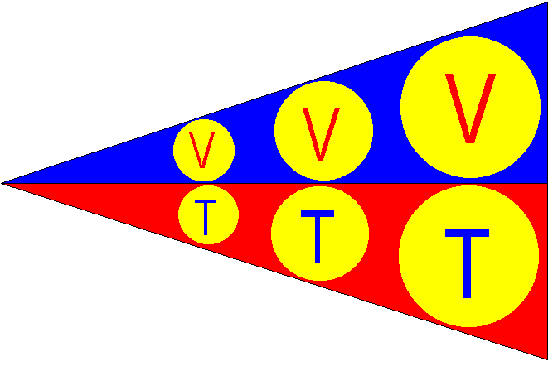
Here is a diagrammatical representation of Charles’ Law.

The diagram shows how the volume of the gas varies with its absolute temperature:
• The volume of the gas is small, when its absolute temperature is low.
• The volume of the gas is large, when its absolute temperature is high.

How the Kinetic Theory of Gases explains Charles’ Law

Let’s consider a given mass of a gas confined within a vessel with a movable piston. If the gas is heated, the temperature of the gas will rise and the gas molecules will acquire more kinetic energy, move faster and collide more often with the walls of the container, thereby increasing the pressure that they exert on the walls of their container.

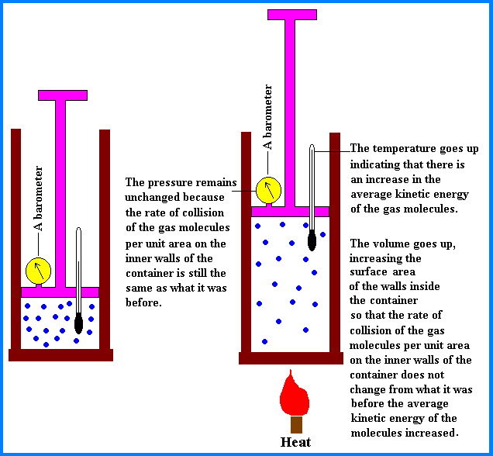

In order to maintain the same number of collisions per unit area of the container (i.e. to maintain the same pressure), the surface area on which the gas molecules are colliding has to be increased. Therefore, the piston moves up, and the volume of the gas increases.

This is why the volume of a gas increases when its temperature is raised at constant pressure.
The Pressure Law:
The Pressure Law states that the pressure of a given mass of a gas is directly proportional to its absolute temperature provided its volume remains constant.

According to the Pressure Law, if the absolute temperature of a gas is raised, its pressure is going to increase; if its absolute temperature is reduced, its pressure is going to be reduced. Again, this can only take place if its volume and amount (in moles) remains constant.

Mathematically, this relationship between the pressure of the gas and its absolute temperature in the Pressure Law is represented as follows:

P ∝ T
P = k•T
P = k (k is a mathematical constant)

T
Therefore,
P₁ = P₂
T₁ T₂

In the equation above,
•P₁ represents the initial pressure of the gas.
•P₂ represents the final pressure of the gas.
•T₁ represents the initial absolute temperature of the gas.
•T₂ represents the final absolute temperature of the gas.

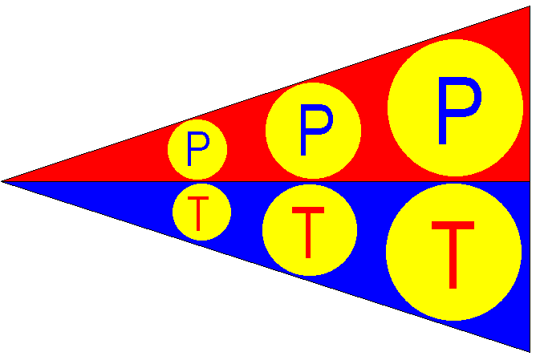
Here is a diagrammatical representation of the Pressure law:

The diagram on the last page shows how the pressure of a gas varies with its absolute temperature:

• The pressure of the gas is low when its absolute temperature is low.
• The pressure of the gas is high when its absolute temperature is high.

How the Kinetic Theory of Gases explains the Pressure Law

Consider a given mass of a gas that is confined within a vessel with an immovable piston. If heat is being supplied to the gas, the temperature of the gas will rise and this will result in an increase in the average kinetic energy of the gas molecules. Therefore, the gas particles will move faster and collide more often with the walls of the container, consequently increasing the force that is being exerted in the walls of the container.

Since the volume of the container cannot be changed, the ratio of the force exerted by the gas molecules on the walls of the container to the surface area of the inner walls of the container will increase, therefore resulting in an increase in the gas pressure.

This is why the pressure of a gas increases as its temperature is being raised at constant volume.

♦ The General Gas Equation: As I have mentioned earlier, this is simply a combination of Boyle’s Law, Charles’ Law, and the Pressure Law. In the general gas equation, everything except the amount of the gas, is taken into consideration. The amount of the gas is not considered because it is assumed to be fixed.

This is how the General Gas Equation is represented:
P₁V₁ = P₂V₂
T₁ T₂

P_{1,} V_{1,} and T₁ represents the initial pressure, the volume, and the absolute temperature of the gas respectively.
P₂, V₂, and T₂ represents the final pressure, the volume, and the absolute temperature of the gas respectively.

♦ The Ideal Gas Equation: Here, all the four properties of the gas (its pressure, its volume, its absolute temperature, and its amount [in moles]) are taken into consideration. Here is how the equation is represented:

P•V = n•R•T
In the equation,
•P represents the pressure of the gas.
•V represents the volume of the gas.
•n represents the number of moles of the gas
•R is a constant of proportionality known as the molar gas constant.
•T represents the absolute temperature of the gas.

In the ideal gas equation, certain restrictions also apply. For example, the value of R (the molar gas constant) depends on the temperature and pressure conditions at which the measurements are taken and also on the unit in which the pressure is measured.
Also, when using this equation for calculations, ensure that
• The volume of the gas is in liters or dm³.
• The amount of the gas is in moles.
• The temperature of the gas is in Kelvin.
• The Units of R corresponds with the units of the volume and pressure used in the calculations. For instance, if the units of the pressure and volume are in mmHg and cm³ respectively, the unit of R must also contain mmHg and cm³.

Certain modifications can be made to the Ideal gas equation based on the following factors:

1. The relationship between
- The number of moles of the gas, n
- The mass of the gas in grams, g
- The molecular weight of the gas, M

n = g / M

2. The relationship between
(a) The density of the gas, d
(b) The volume of the gas, V
- The mass of the gas in grams, g

g = d • V

From the Ideal Gas Equation,

P•V = n•R•T

Since n = g/M

Therefore, the ideal gas equation can be rewritten in the form shown below:

P•V = g•R•T ……………………………………………..Equation 1
M
However, g = d•V

So

P•V = d•V•R•T
M
Therefore, the ideal gas equation can also be written as

P = d•R•T ……………………………………………. Equation 2
M

(Since the volume, V cancels out because it appears on both sides of the equation).

Equations 1 and 2 can be employed as modifications of the Ideal gas equation to solve problems involving parameters (such as density and molecular mass) that are not included in the Ideal gas equation (PV = nRT)

In calculations involving Boyle’s Law, Charles’ Law, the Pressure Law, the General Gas Equation, and the Ideal Gas Equation always ensure that the unit of temperature is in the Kelvin Scale, otherwise the answers that you will have from your calculations will be incorrect.

When you are given any calculation involving the use of these gas laws, take a close look at the parameters that are available in the question(s) (they may be given directly or indirectly). The gas law or equation that you will use depends solely on the parameters that are available in the question, and also on what you are asked to look for.

Diffusion
Diffusion is the movement of molecules from regions where they are more concentrated (occurring in larger amounts per unit volume) to regions where they are less concentrated (occurring in fewer amounts per unit volume).

Diffusion is a natural phenomenon that we experience in our everyday lives. For example, if a bottle of perfume or cologne is opened at one end of a room, within a few seconds, another person at the other end of the room will be able to smell the scent of the cologne.
What happens is this:
In the bottle of the cologne, the molecules of the cologne vapor are very concentrated; so, when the cap of the cologne bottle is removed, these molecules migrate from the cologne bottle (where they are more concentrated) to other parts of the room (where they are less concentrated). This is why someone at another end of the room is able to smell the scent of the cologne, though the person is not close to the bottle of cologne.

The Rate of Diffusion:
The rate of diffusion of a gas is the ratio of quantity of the gas that diffuses to the time it takes the gas to complete this diffusion.
The rate of diffusion of a gas can be expressed in any of the following units:

1. grams/second or in grams/minute.
2. moles/second or in moles/minute.
3. liters/second or in liters/minute.
It can also be expressed in any other unit that expresses the ratio of the quantity of the gas to its time of diffusion such as lbs./hour or gallons/day.

The rate of diffusion of a gas depends on its density. It also depends on the molecular weight of the gas, since the density of the gas increases as its molecular weight increases. The relationship between the rate of diffusion of a gas and its density was first discovered in 1833 by an English chemist named Graham.

He carried out experiments using gases with different densities. He found out that a less dense gas would diffuse through a medium much faster than a gas that is denser. At the end of his experiments, he came out with this statement, which we now know as Graham’s Law of Diffusion:

Graham’s Law of Diffusion states that the rate of diffusion of a gas is inversely proportional to the square root of its density provided that its temperature and pressure remains unchanged.

Mathematically, this relationship between the rate of diffusion of a gas and the square root of its density is expressed as follows:

R ∝ 1
√d
R = k
√d

If the rates of diffusion of two gases, A and B are compared, the ratio of their rates of diffusion will be equal the ratio of the reciprocals of the square roots of their densities. This statement is expressed mathematically as follows:

R_{A} = √d_{B}
R_{B} √d_{A}

In the above expression,
R_{A} represents the rate of diffusion of gas A d_{A} represents the density of gas A
R_{B} represents the rate of diffusion of gas B d_{B} represents the density of gas B

Certain modifications can be made to this law. These modifications are made depending on the relationship between the rate of diffusion of a gas and its time of diffusion; and also on the relationship between the density of the gas and its molecular weight.

The density (d) of a gas increases as its molecular weight (M) increases; and

The rate of diffusion (R) of a gas increases as its time of diffusion (t) decreases.

Since the density of the gas increases as its molecular weight increases, the density of the gas can be replaced with its molecular weight in Graham’s Law. In addition, since the rate of diffusion of the gas increases as its time of diffusion decreases, the rate of diffusion of the gas can be replaced with the inverse (reciprocal) of the time of diffusion in Graham’s Law.

Mathematically, the above statements can be summarized as shown below:

R_{A} ₌₌ t _{B}
R_{B} t _{A}

√d_{A ==} √M_{A}
√d_{B} √M_{B}

On the last page,
R_{A} represents the rate of diffusion of gas A
R_{B} represents the rate of diffusion of gas B
t _{A} represents the time of diffusion of gas A
t _{B} represents the time of diffusion of gas B
d_{A} represents the density of gas A
d_{B} represents the density of gas B
M_{A} represents the molecular weight of gas A
M_{B} represents the molecular weight of gas B

The relationship between these eight quantities is shown below:

R_{A} ₌₌ t _{B} ₌₌ √d_{B ==} √M_{B}
R_{B} t _{A} √d_{A} √M_{A}

From here, we can have other formulas by rearranging these relationships.
Some of these rearrangements are given below:
1. R_{A ==} √M_{B}
R_{B} √M_{A}

2. R_{A ==} √d_{B}
R_{B} √d_{A}

3. t _{B} ₌₌ √d_{B}
t _{A} √d_{A}

4. t _{B} ₌₌ √M_{B}
t _{A} √M_{A}

