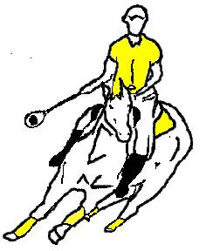
Liscombe Park Tournament

25th and 26th June 2005

To be held at Elsage Farm, on the B488, Cheddington, Buckinghamshire – about 10mins from the old grounds at Liscombe Park!
Location of grounds – please ignore the star! Grounds are on the B488 between Cheddington and Ivinghoe
Map
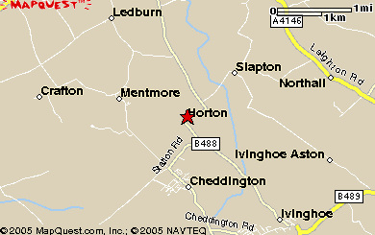
Give us a call if you get lost!
Larraine 07754535366
Sarah Gall – 07717068280
Nigel Smith – 07795416161

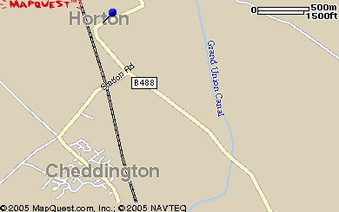
Exact location of grounds – coming from Ivinghoe(south) the grounds are on the left after the cannel bridge.
Coming from Horton (north) grounds are on the right past the turning to Cheddington.

Directions: From the M25
Take junction 20 (A41 Aylesbury) from the M25 take directions for Aylesbury, Tring. Carry on the dual carriageway when you see signs for Tring, please ignore them, you need to take the second lot of signs for Tring / Dunstable – B488 / B489 Come off the slip road for the B488 and take a right turn at the roundabout. Follow signs to Ivinghoe B488. Stay on this road, you will pass traffic controlled cannel bridges. When you reach Ivinghoe take the sign right (opposite the church) to Cheddington, Horton, Mentmore – this is still part of the B488. You will have to go over another traffic controlled cannel bridge and then the grounds will be on your left. If you get to Horton you have gone too far!!

Liscombe Park Tournament

SCHEDULE – Saturday 25th - Sunday 26th June 2005

BRIEFING TIME: Saturday at 9.00 a.m. for all players and umpires.

START TIME: Saturday at 10.00 a.m. / Sunday at 9.00 a.m.

PADDOCKS: DIY electric fencing only. No stables are available.

CATERING: A mobile caterer will be on site all day Saturday and Sunday. There are a number of restaurants and take aways and a supermarket in Leighton Buzzard – 10 min drive away.

FACILITIES: There will be toilet and shower facilities on site also a horse wash down site. Bouncy castle for children all day Saturday and Sunday.

FEED / HAY: If you require feed, hay or any supplements to be provided for you when you arrive at the tournament please contact Sarah Gall on 01442 842422 one week before.

PHOTOGRAPHER: There will be a photographer on site all day Saturday and Sunday. If you would like team photos organised please call Sarah Gall on 01442 842422 one week before to book.

ENTERTAINMENT: Disco and Bouncy Castle for Saturday evening with a licensed bar. The bar is also open Fri, Sat and Sunday evening.

FARRIER: In attendance all weekend.

PARAMEDICS: There will be Paramedic cover during tournament play.

RULES: International Rules will apply.

UKPA or PONY CLUB
MEMBERSHIP: Entries can only be accepted for fully paid up members of the UKPA or PONY CLUB. Riding hats must comply with the UKPA standard and be suitably tagged

HORSE WELFARE: A horse welfare officer will be on site. The officer will be given full discretion to withdraw horses from the tournament if deemed unfit to play. There will be a veterinary surgeon on call. All horses and ponies would be expected to be vaccinated for flu and tetanus

DOGS: Dogs on lead at all times.

TOURNAMENT: The tournament will be played in teams of 6 players each. Teams entered will be placed in divisions dependent upon their collective grade total.
Liscombe Park will try our best to place players without a team into a team so they can play in the tournament – please call Nigel Smith about spare players on 07795416161

GRADING: Players will be graded by the UKPA.

CLASSES: Primary Junior
Junior
A,B,C & D division

DUTY TEAM ROTA: Every Section must provide 1 goal judge, a scorer/timekeeper, and a ball for each match played.

ENTRY FEES: £35 per senior player. £25 per junior player (must be 16 or under on 1 Jan 2005). Entries received after the closing date (17th June) may be accepted but will require an additional fee of £10 per player to cover administrative costs.
Liscombe Park will only accept entry fees from 1 cheque per club from their club representative. e.g. one cheque from each club, not a cheque from each individual player. The entry fees will need to be accompanied by the Team Section Entry forms for all Teams playing and the Total Fees Form. It is each club’s responsibility to collect payment from all their players and send a total cheque to Liscombe Park for this tournament. If any club has any difficulties with this please contact the LPPC Finance officer – Larraine Chappell on 07754535366.

Any player that has not paid their entry fees in full will have to result in their whole team not being allowed to play on the pitch throughout the tournament.

DECLARATION: A representative from each club must sign the declaration on the attached entry form agreeing that the Section entered agrees to be bound by the rules and conditions of the Tournament. This will include the Section’s agreement to abide by the ‘duty team’ rota and to behave responsibly and safely at all times.

