Medieval Tournament
Hosted by the Northern Region
27th & 28th August 2005

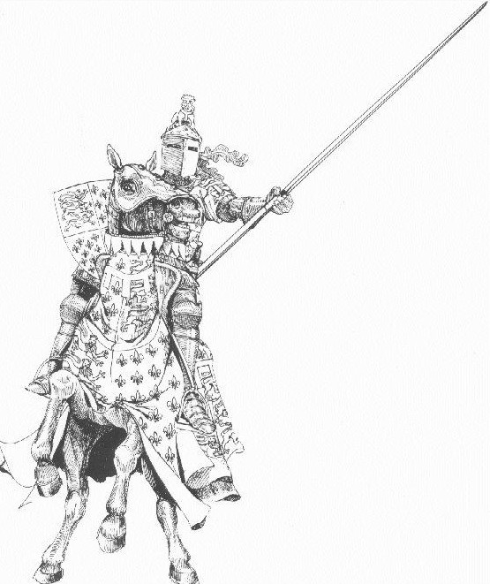 | 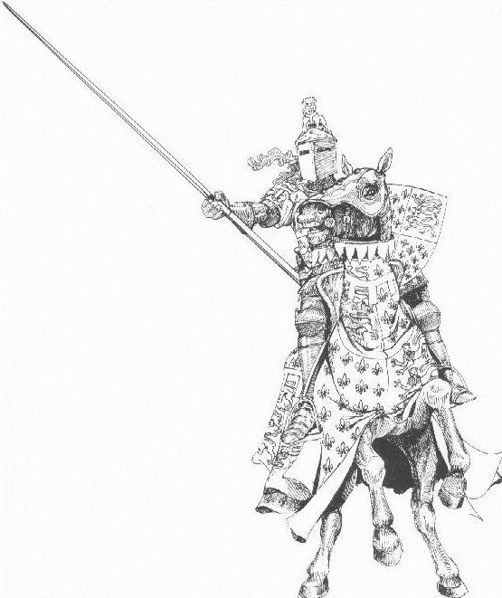

Including first test Series

United KingdomV
Zimbabwe

Open Mixed and Intermediate (Under 21)

MEDIEVAL TOURNAMENT 27th/28th August, 2005

Briefing at 07.45 am and play starts at 8am PROMPT start, Saturday and Sunday

Please ensure your teams, goal judges, timekeepers, scorers & umpires arrive at the field in order to START THE GAMES ON TIME (complete with a polocrosse ball!).

Any change to listed umpires MUST be agreed with the Tournament Umpire Chris Schaefer

ALL GAMES 6x5 minute (Yes…. FIVE minute) chukkas.

Tournament Rules Medieval Tournament 27th /28th August 2005:

Supplementary Rules and Penalties

- This is a Turnaround Tournament and each player in a section must play in a different position; 1, 2 and 3 for the duration of one chukka of each game. The sequence of positions played is at the discretion of the captain of the section/side.

  - At the beginning of each chukka the captain of the section/side shall nominate to the Field Marshall the playing position of each player of the section; 1,2 and 3. No player is allowed, for that game, to play in the same position for more than one chukka.

The International rule for ‘substitution of a horse or player’ does not apply; the substitute player/horse must play in the position of the player they are replacing. The captain is not allowed to re-organise the section by moving players between positions during a chukka.

In the event of the section being reduced to two players during a game then the captain can re-organise the section to allow any two positions to be played. The Field Marshall shall record these positions for that chukka; the players’ positions must then be changed between chukkas.

Penalty: The highest graded player of the section/side shall not be allowed to play in the first chukka of the next game. If all games have been completed by that section/side then the last scoring points awarded to that section/side for a game shall be reduced to zero for that game.

- Umpires are required to be on time so that games may start promptly:

- Any section/side not having their nominated umpire at the appointed pitch for the published time for the game they are due to umpire will be penalised. Only if they are advised by the tournament organizer in writing of another time does this rule not apply.

Penalty: The person nominated as umpire who was late will not be allowed to play in the first chukka of their next game. In the event that all games have been completed by the person the last scoring points awarded to their section/side they played for, will be reduced to zero for that game.

Should the person umpiring not be playing in a section/side, the penalty shall be applied to the highest handicap player in the section/side that nominated them at their next game. If all games have been completed by that section/side then the last

- Definition of highest graded player, if there are two players of equal grade:

In the event of a section having its highest graded player as a choice between two players, the Field Marshall will nominated one player as ‘Heads’ and the other ‘Tails’. The Field Marshall shall then toss a coin and which ever side of the coin shows upwards, ‘heads’ or ‘tails’ the player nominated to that value will be the player to whom the penalty is applied.

The Tournament Arbitration Committee will define the formulae for selecting the nominated ‘penalty’ player if all players in a section are of the same grade.

TEAMS (4 divisions)

King Arthur’s Allstars

Uncle Pete’s Elite
2 Blokes & A Blonde
Centaur Knights
Gringolet (Sir Gawain’s Horse)
Bel Joeor (Sir Tristan’s Horse)

Lancelot’s Laugh-a-Lots

Pegasus Croome Comics
Liscombe Garters
Pegasus Croome Battleaxes
The Black Death!

Merlin’s Magicians

Liscombe Knights
Team Orgy
Be-Headers
Liscombe Jousters

Guinevere’s Ghouls

The Black Knights
Pegasus Croome Minstrels
The Three Musketeers
A-Team

Team Lists

The Black Knights  Alex Edwards Claudia Richardson A N OTHER | Pegasus Croome Minstrels  Sam Farmer  Ashley Robbins  Luke Bater
The Three Musketeers  Will Halcrow  John Whitehead Lewis Parr | A-Team  Helen Grundy  Lucy Winyard  Steph Metcalfe
Team Orgy  Jack Williams  Jack Woolley  Josh Woolley | Be-Headers  Toni Marsh  Ally Hibberd  Oli Harwood
Liscombe Jousters  Nigel Smith  Sammy Rowden  Marc Goddard | Liscombe Knights  Ashley Biggin  Cheryl Chappell  Dean Chappell
Pegasus Croome Comics  Bob Taylor  Ben Taylor  Kitty Taylor | Liscombe Garters  Caroline Biggin  Tom Bowden-Eyre  Saskia Gall
Pegasus Croome Battleaxes  Simon Twidberry  Lucy Cayley  Amy Proctor-Nicholls | The Black Death!  Hannah Oliver-Bryne  James Oliver-Byrne  A N OTHER
Uncle Pete’s Elite  Uncle Pete  Chris Chennells  Caroline Kelly | 2 Blokes & A Blonde  Liam Taylor  Shaun Taylor  Zara Hunt
Centaur Knights  Matthew Hale  Emily Newbrook  Vickie Metcalfe | Gringolet  Claudia Richardson  Kim Downey  Becky Robison
Bel Joeor
Alex Richardson
Ed Gall
Bryony Cross

ORDER OF PLAY SATURDAY 27th August

TIME | TEAMS | UMPIRES
8am | Uncle Petes Elite V 2 Blokes & A Blonde  XXXXXXXXXXXXXXXXXXX | Matt Hale  & Joel Sics
8.45 | Liscombe Knights V Team Orgy  A-Team V The Black Knights | Emma Halcrow  & Nigel Smith
9.30 | Centaur Knights V Gringolet  Liscombe Garters V P.C.Battleaxes | Bob Taylor  & Shaun Taylor
10.15 | Be-Headers V Liscombe Jousters  P.C.Minstrels V Three Musketeers | Ashley Biggin  & Joel Sics
11.00 | Uncle Petes Elite V Bel Joeor  XXXXXXXXXXXXXXXXXXXXX | Naomi Pearce  & Charlotte Nicholls
11.45 | 2 Blokes & A Blonde V Centaur Knights  P.C.Comics V Liscombe Garters | Charlie Wright-Roberts  & Becky Robison
12.30 | Liscombe Knights V Be-Headers  A-Team V P.C.Minstrels | Dom Northmore  & Uncle Pete
1.15 | Team Orgy V Liscombe Jousters  The Black Knights V Three Musketeers | Chris Chennells  & Liam Taylor
2.00 | Gringolet V Bel Joeor  P.C.Battleaxes V The Black Death! | Ashley Biggin  & Vickie Metcalfe
3.00 | TEST MATCH U.K. V Zimbabwe  Under 21’s
5.00 | TEST MATCH U.K V Zimbabwe  OPEN

ORDER OF PLAY SUNDAY 28th August

 | TIME | TEAMS |  |  |  | UMPIRES
 | 8.00am | Centaur Knights V Bel Joeor  Liscombe Garters V The Black Death! |  |  |  | Chris Chennells  & Ashley Biggin
 | 8.45 | Gringolet V 2 Blokes & A Blonde  P.C.Battleaxes V P.C.Comics |  |  |  | Uncle Pete  & Naomi Pearce
 | 9.30 | Liscombe Knights V Liscombe Jousters  A-Team V Three Musketeers |  |  |  | Charlie Wright-Roberts  & Charlotte Nicholls
 | 10.15 | Uncle Petes Elite V Centaur Knights  XXXXXXXXXXXXXXXXXX |  |  |  | Liam Taylor  & Dom Northmore
 | 11.00 | Team Orgy V Be-Headers  The Black Knights V P.C.Minstrels |  |  |  | Becky Robison  & Vickie Metcalfe
 | 11.45 | 2 Blokes & A Blonde V Bel Joeor  P.C.Comics V The Black Death! |  |  |  | Nigel Smith  & Emma Halcrow
 | 12.30 | Uncle Petes Elite V Gringolet  XXXXXXXXXXXXXXXXXXXXX |  |  |  | Matt Hale  & Joel Sics
 | 1.30 | TEST MATCH U.K. V Zimbabwe  Under 21’s
 | 3.30 | TEST MATCH U.K. V Zimbabwe  OPEN
UKPA |  |  |  |  | Zimbabwe
Country’s Squads |  |  | 4 players to be |  | selected for each |  | Test match
President |  |  | Dave Brookes |  | Richard Mostert
 |  |  |  |  | Gary Dodd |  | Umpire
Open Mixed
Ladies (from) |  |  | Club |  | Ladies
Shelley King (Capt) |  |  | Highlanders |  | Margot Worswick (Capt)
Debbie Harris |  |  | Welsh Dragons |  | Arlene Crook
Sharon Kennedy |  |  | Kent Target |  | Nicola Mannix
Rachel Johnson |  |  | Highlanders |  | Ashley Panter
Jessica Shearing |  |  | Welsh Dragons
Sarah Simkin |  |  | Celyn
Lizzie Wright-Roberts |  |  | Welsh Dragons
Men (from) |  |  |  |  | Men
Jason Burbidge (Capt) |  |  | Arden |  | Shannon Burbidge (Capt)
Martin Brookes |  |  | Highlanders |  | Andrew Baker
Guy Robertson |  |  | Highlanders |  | Howard Baker
Simon Shearing |  |  | Welsh Dragons |  | Philip Whaley
Tom Simkin |  |  | Celyn
Coaches |  |  | Greg Sargeant |  | Jon Baker
 |  |  |  |  | Barry Burbidge
Managers |  |  | Dawn Goodfellow |  | Kevin & Julia Fisher
Under 21s
Ladies (from) |  |  |  |  | Ladies
Sophie Lodder (Capt) |  |  | Arden |  | Audra Dixon (Capt)
Imogen Johnson |  |  | Pennine |  | Frances Dodd
Charlotte Pykett |  |  | Welsh Dragons |  | Jaime Haasbroek
Rebecca Shearing |  |  | Welsh Dragons |  | Ursula Shaw
Lucy Shell |  |  | Highlanders
Osha Williams |  |  | Welsh Dragons
Men (from) |  |  |  |  | Men
James Robertson (Capt) |  |  | Highlanders |  | Bradley Clark (Capt)
Alex Bull |  |  | Arden |  | Michael Krynauw
Dan Duhig |  |  | Arden |  | Ross Shand
Jonathan Keen |  |  | Arden |  | Danie Swan
Sam Sics |  |  | Pennine
Tom Wigglesworth |  |  | Pennine
Coach |  |  | Andrew Schaefer
Manager |  |  | Brenda Begley

Saturday 27th August 2005 - Score Sheets and players lists | 
Intermediate (U21s) ….15.00 Open Mixed ….17.00
UKPA Ladies | Zimbabwe | UKPA Ladies | Zimbabwe
1………………………… | 1……………………… | 1………………………… | 1………………………
2………………………… | 2……………………… | 2………………………… | 2………………………
3………………………… | 3……………………… | 3………………………… | 3………………………
Impact………………… | Impact……………… | Impact………………… | Impact………………
UKPA Men | Zimbabwe Men | UKPA Men | Zimbabwe Men
1………………………… | 1……………………… | 1………………………… | 1………………………
2………………………… | 2……………………… | 2………………………… | 2………………………
3………………………… | 3……………………… | 3………………………… | 3………………………
Impact……………… | Impact……………… | Impact……………… | Impact………………

Intermediate 15.00
UKPA | Chukka  Total | Running  Total | Zimbabwe | Chukka  Total | Running  Total
1st. |  |  | 1st.
2nd. |  |  | 2nd.
3rd |  |  | 3rd
4th |  |  | 4th
5th |  |  | 5th
6th |  |  | 6th
7th |  |  | 7th
8th |  |  | 8th
Total |  |  | Total

Open Mixed 17.00
UKPA | Chukka  Total | Running  Total | Zimbabwe | Chukka  Total |  | Running  Total
1st. |  |  | 1st.
2nd. |  |  | 2nd.
3rd |  |  | 3rd
4th |  |  | 4th
5th |  |  | 5th
6th |  |  | 6th
7th |  |  | 7th
8th |  |  | 8th
Total |  |  | Total
Sunday 28th August 2005 - Score Sheets and players lists
Intermediate (U21s) ….13.30 Open Mixed ….15.30
UKPA Ladies | Zimbabwe | UKPA Ladies | Zimbabwe
1………………………… | 1……………………… | 1………………………… | 1………………………
2………………………… | 2……………………… | 2………………………… | 2………………………
3………………………… | 3……………………… | 3………………………… | 3………………………
Impact………………… | Impact……………… | Impact………………… | Impact………………
UKPA Men | Zimbabwe Men | UKPA Men | Zimbabwe Men
1………………………… | 1……………………… | 1………………………… | 1………………………
2………………………… | 2……………………… | 2………………………… | 2………………………
3………………………… | 3……………………… | 3………………………… | 3………………………
Impact……………… | Impact……………… | Impact……………… | Impact………………

Intermediate 13.30
UKPA | Chukka  Total | Running  Total | Zimbabwe | Chukka  Total | Running  Total
1st. |  |  | 1st.
2nd. |  |  | 2nd.
3rd |  |  | 3rd
4th |  |  | 4th
5th |  |  | 5th
6th |  |  | 6th
7th |  |  | 7th
8th |  |  | 8th
Total |  |  | Total

Open Mixed 15.30
UKPA | Chukka  Total | Running  Total | Zimbabwe | Chukka  Total | Running  Total
1st. |  |  | 1st.
2nd. |  |  | 2nd.
3rd |  |  | 3rd
4th |  |  | 4th
5th |  |  | 5th
6th |  |  | 6th
7th |  |  | 7th
8th |  |  | 8th
Total |  |  | Total

