PERCY HUNT PONY CLUB

POLOCROSSE TRAINING WEEKEND AND REGIONAL TOURNAMENT

7TH AND 8TH MAY 2005

To be held at

Doxford Fann,Chathi1l., Alnwick, Northumberland, NE67 5DY.

Organiser: Helen Robison 01665713263
Camp Manager: Sarah Shell 01665 579348
Safety Co-ordinator: Jo Young 01665 604033

The weekend is open to all interested members and beginners and novice players will
be especially welcome.
All members will receive mounted and dismounted instruction throughout the
weekend and will have the opportunity to compete in chukkas in their ability group on
Sunday.
The aim of the weekend is to improve riding and playing skills, to find out more about
the game, to learn some tactics and have fun! (A limited number of spare sticks are
available; please ring organiser if you wish to reserve one)

The cost of the weekend will be £40.00 per member (includes paramedic cover on the
Saturday and Sunday and fork supper on Saturday night);

Please arrive after 5pm on Friday 7th May or by 9:30am on Saturday 8th May to be
ready for tack inspection at l0am. (All ponies will be expected to have 4 over reach
boots and either bandages and fibregee or approved boots) The weekend will end on
the Sunday aftemoon after the toumament and a mounted presentation.

Camping and toilets will be available adjacent to the playing area with drinking water
close by. The weekend is self-catering but 2-course fork supper can be provided if
pre-ordered on application form for Saturday evening.

Ponies/horses staying overnight should be penned in electric fenced pen in accordance
with the polocrosse rulebook. Ponies/horses must be trained to electric pens before
they come and will need a New Zealand rug.. Alternatively stabling may be available on site and can be arranged by telephoning the camp manager, £10 per night.

Please return the application form by Sunday 1st May. If you have any queries
whatsoever do not hesitate to contact either Helen Robison or Sarah Shell.

Polocrosse is a dangerous sport and all reasonable precautioliis have been taken when organising this event.
Neither the organiser, agents nor any person acting on behalf of the Percy Pony Club
accept any responsibility for injury, loss or damage to person, anima1 or property
howsoever caused throughout this event.

Application for POLOCROSSE TRAINING WEEKEND to be held at Doxford Farn,
Chathill, Alnwick, Northumberland, NE67 5DY on Saturday 7th and Sunday 8th May 2005.

Please return to Helen Robison, 29 High Street, Amble, Morpeth,
Northumberland NE65 OLE.

Pony Club Branch .

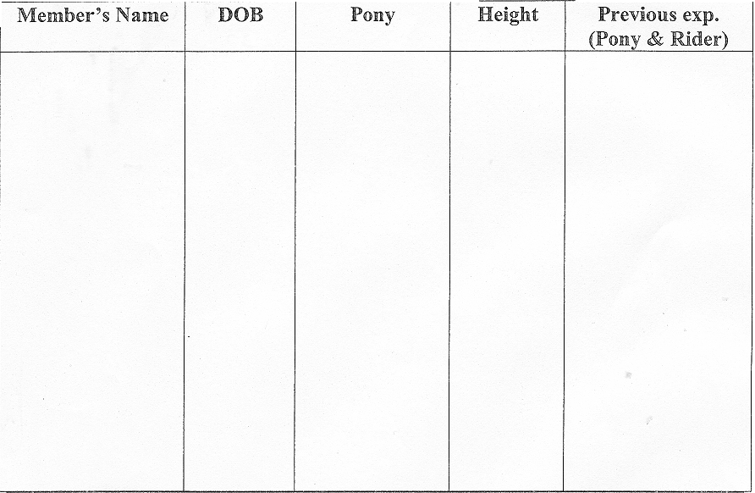

PLEASE NAME SUPERVISING ADULT WHO WILL BE RESPONSIBLE
FOR MEMBERS AND THEIR PONIES THROUGHOUT THE WEEKEND
AND PARTICULARLY DURING SATURDAY NIGHT.

ETA Friday evening/Saturday morning (delete as appropriate)

Please state how many Fork Suppers required -- cost£5.00 per person:………………….

£40.00 per pony club member (including supper):………………

Total enclosed:……………………………

Please make cheques payable to Percy Hunt Pony Club)

SIGNED ………………………………………… (DC)
DIRECTIONS

TRAVELLING NORTH

By-pass Alnwick on the AI.
5 miles north of Alnwick take the right turn onto the B6347 - Seahouses.
Follow B6347 for approximately 2 miles and take a left - Doxford Farm..
Alternatively, follow the brown and white signs for Doxford Country
Crafts.

TRAVELLING SOUTH

By-pass Belford on the AI.
4 miles south you come to a Dual Carriageway.
Continue to the end of the dual carriageway, and for a further 1 mile
south.,
Take a left turn onto B6347 - Seahouses.
Follow B6347 for approximately 2 miles and take a left - Doxford Farm.
Alternatively, follow the brown and white signs for Doxford Country
Crafts.

