UNITED KINGDOM POLOCROSSE ASSOCIATION
NATIONALS 2006 - RESULTS

A Division
CHAMPIONS Highlander Warriors
Runners-up Arden

BEST NO.1 Brian Davidge [Higlander]
BEST NO.2 Hamish Michael [Arden]
BEST NO.3 Guy Robertson [Highlander]
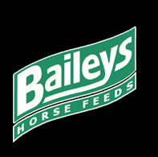
Best Horse/Rider Combination Brian Davidge & Bullitt
BEST HORSE Bullitt
Prizes Sponsored by: Denne’s Western Store, Leighton Buzzard
Best Horse/Rider Combination sponsored by Baileys Horsefeeds.

A Plate
Winners Highlander Outlaws
Runners-up Pennine

Best No.1 Joel Sics [Pennine]
Best No.2 Elliot Gloyn [Pennine]
Best No.3 Lucy Shell [Highlander]
Best Horse/Rider Combination Lucy Shell & Maud
Best Horse Estrella [Sam Sics, Pennine]
Best Horse/Rider Combination sponsored by Baileys Horsefeeds.

B Division
Winners Welsh Dragons
Runners-up Pennine

Best No.1 Charlotte Pykett [Welsh Dragons]
Best No.2 Vicky Metcalfe [Pennine]
Best No.3 Charlie Wright-Roberts [Welsh Dragons]
Best Horse/Rider Combination Charlotte Pykett & Smartie Lee
Best Horse Smartie Lee
Best Horse/Rider Combination sponsored by Baileys Horsefeeds.

B Plate
Winners Welsh Dragons 2
Runners-up Kent Target
Best No.1 Lewis Parr [Welsh Dragons]
Best No.2 Amy Johannsen [Welsh Dragons]
Best No.3 Charlotte Nicholls [Welsh Dragons]
Best Horse/Rider Combination Charlotte Zygmunt & Donna Lee [Welsh Dragons]
Best Horse Donna Lee
Best Horse/Rider Combination sponsored by Baileys Horsefeeds.

C Division
Winners Celyn 1 [Young Tarts]
Runners-up Celyn 2 [Old Farts]
Best No.1 Mike Pearce [Celyn 2]
Best No.2 Rosie Pearce [Celyn 2]
Best No.3 Ffion Tomos [Celyn 1]
Best Horse/Rider Combination Ffion Tomos & Time Out
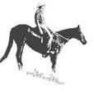
Best Horse Time Out
Prizes sponsored by Australian Stock Horse [Jason and Penny Webb]
Best Horse/Rider Combination sponsored by Baileys Horsefeeds.

C Plate
Winners Pennine
Runners-up Arden
Best No.1 Ed Gall [Pennine]
Best No.2 Meg Hibberd [Pennine]
Best No.3 Laura Newell [Arden]
Best Horse/Rider Combination Ed Gall & Miloko
Best Horse Miloko
Best Horse/Rider Combination sponsored by Baileys Horsefeeds.

D Division
Winners Western Phoenix Indians
Runners-up Liscombe Park
Best No.1 Nick Foley [Western Phoenix Indians]
Best No.2 Nina Wiggan [Liscombe Park]
Best No.3 Alice Humphrey [Western Phoenix Cowboys]
Best Horse/Rider Combination Nick Foley & Beanie
Best Horse Kaz
Best Horse/Rider Combination sponsored by Baileys Horsefeeds.

Junior Division
Winners Kent Target
Runners-up Celyn
Best No.1 Oli Harwood [Kent Target]
Best No.2 Rosie Miller [Celyn]
Best No.3 Hazel Wilson [Kent Target]
Best Horse/Rider Combination Oli Harwood
Best Horse Simon Amor’s pony
Best Horse/Rider Combination sponsored by Baileys Horsefeeds.

Primary Junior Division
Winners Arden
Runners-up Centaur
3rd place Kent Target
Best No.1 Ashleigh Burbidge [Arden]
Best No.2 Lucinda Cornforth [Arden]
Best No.3 Chloe Stuart [Kent Target]
Best Horse/Rider Combination Charlie Jones [Centaur]
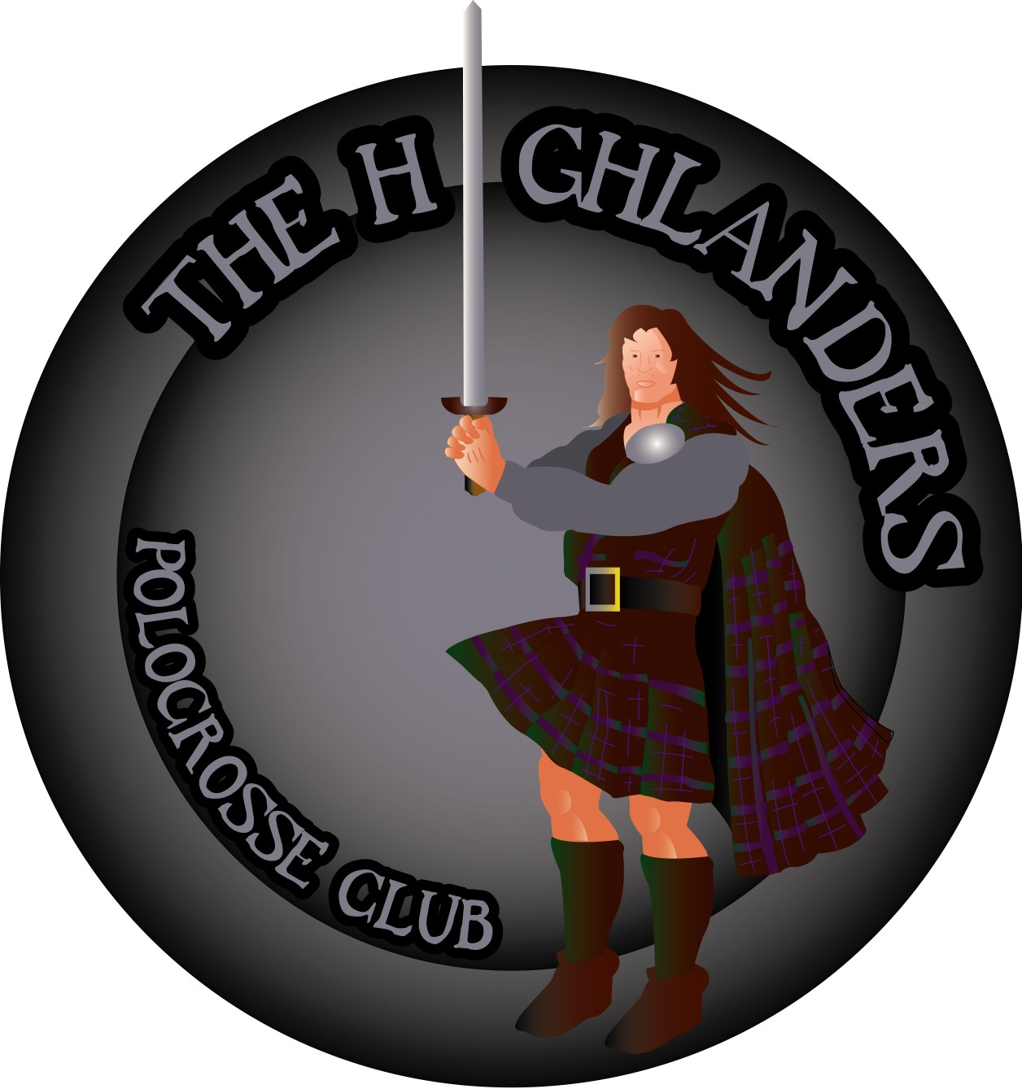
Best Horse Chloe Stuart’s horse ‘Ted’

Prizes sponsored by Highlander Polocrosse Club
Best Horse/Rider Combination sponsored by Baileys Horsefeeds.

Best Mare of the Tournament
Papoose - Sarah Peaker [Northern Lions]
Sponsored by Australian Stock Horse [Jason and Penny Webb]

