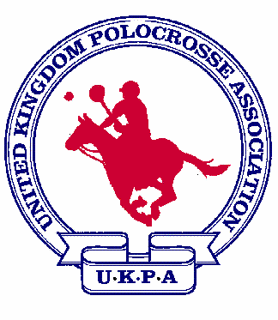 UKPA Squads 2004-5 in alphabetical order

Juniors  - Luke Bater  - Sophie Brocks  - Bryony Cross  - Sam Farmer  - Edward Gall  - Oscar Harding  - Alice Hibberd  - Rhianydd Lee Jones  - Annemieke Mitchell  - Lewis Parr  - Amy Proctor Nicholls  - Claudia Richardson  - Rebecca Robeson  - Ben Taylor  - Jon Whitehead  - Jack Williams  - Josh Woolley  1st reserve  Stephanie Metcalfe | Under 21 males  - Alex Bull  - Daniel Duhig  - Jonathan Keen  - Mathew Richardson  - James Robertson  - Sam Sics  - Will Waterer  - Tom Wigglesworth  - Charlie Wright-Roberts  1st reserve  James Davidson  2nd reserve  Joel Sics | Under 21 females  - Nerys Cross  - Imogen Johnson  - Sophie Lodder  - Rosie Palmer  - Charlotte Pykette  - Tessa Newton  - Rebecca Shearing  - Annie Waterer  - Osha Williams  1st reserve  Lucy Shell  2nd reserve  Jenny Palmer | Mens  - Martin Brookes  - Jason Burbidge  - Grant Hayes  - Wayne Henning  - Chris James  - Guy Robertson  - Simon Shearing  - Tom Simkin  - George Wilson Fitzgerald  Colorado team  1.MartinBrookes  2. Jason Burbidge  3. Wayne Henning  4. James Robertson  5. Guy Robertson  6. Simon Shearing  7. Tom Simkin | Ladies  - Debbie Harris  - Rachel Johnson  - Sharon Kennedy  - Shelley King  - Jemma Murray  - Jessica Shearing  - Sarah Simkin  - Kim Stevens  - Lizzie Wright-Roberts

