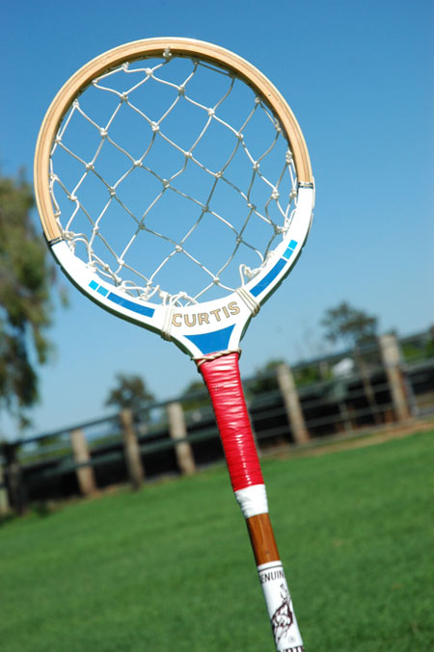
- Mamma Mia theme (70’s)
Tricks, sticks and ball competition.

Are you a wiz with your stick?
Good with a ball?

If you want to take part in this racket and ball competition please speak to . . . .

TOM KITCHEN-DUNN
- Fancy dress optional
- Karaoke
- DJ

- All entry money collected helps support our club
- Any entries welcome
Could you be the next Grand National winner??

If you think you’re man enough, there will be a jockey simulation machine.
Test your riding skills to the limit!!

Also see our slave flyer for assistance
with looking after your horses at
the weekend.

