Rustlers Polocrosse Extravaganza!
At Easingwold, nr York.

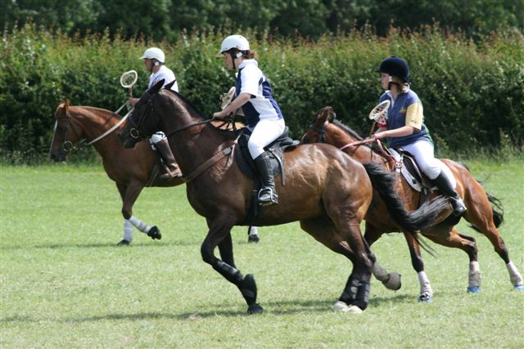

Two day camp - Tues 26th/ Weds 27th May
One day Tournament - Thursday 28th May

Training with some of the best coaches in the UK, including Jason Webb, just back from the Quadrangular series in Australia.
Jason, of Risebridge Stock horses will also be demonstrating his unique method of horsemanship with his legendary stallion Diesel.

Young and problem horses are invited for a clinic with Jason.

Live Music & Hog Roast on Wednesday Evening

For further information contact Christine Stansfield
Email: christine@polocrosseacademy-yorkshire.com

Tel: 01944 738714

Mbl: 07800 649599
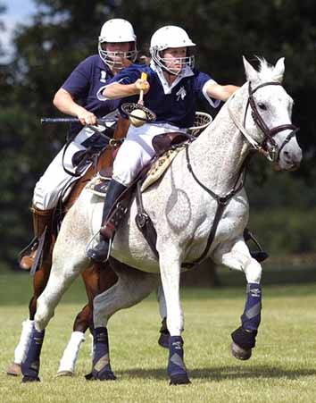


www.polocrosseacademy-yorkshire.com

