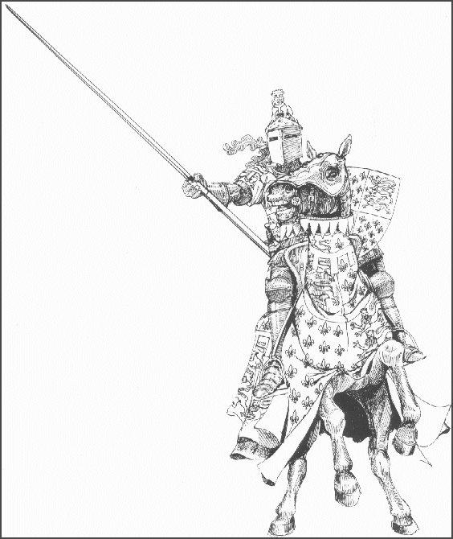
Medieval Tournament at Stonehall

Catering arrangements

Food and drinks will be available over the weekend at the following times

Merlin’s Amazing Butties
Saturday and Sunday –
8.00 a.m. to 2.00 p.m. (approx)
and for an hour between the
two Test games
Serving a selection of hot sandwiches,
and hot and cold drinks
All food and drink will be very
reasonably priced!

Pimms Tent
Saturday and Sunday 1.00pm until 5.30 pm

Bar at the clubhouse
Friday 7pm – 11pm
Saturday and Sunday 3.30pm – 4.30pm
(between the two Test games)
Sunday 7pm – 11pm

Medieval Banquet, by ticket only.
Saturday 7.30pm – 11.30pm
Serving Mead
A three course meal, see menu
There will be a bar.

