Newton’s Universal Law of Gravitation

Excerpted from (with additions by P. Perry) : Isaac Newton, Michael Fowler, Physics Dept., U.Va.
Let us turn to the central topic of the Principia, the universality of the gravitational force. The legend is that Newton saw an apple fall in his garden in Lincolnshire, thought of it in terms of an attractive gravitational force towards the earth, and realized the same force might extend as far as the moon. He was familiar with Galileo's work on projectiles, and suggested that the moon's motion in orbit could be understood as a natural extension of that theory. To see what is meant by this, consider a gun shooting a projectile horizontally from a very high mountain, and imagine using more and more powder in successive shots to drive the projectile faster and faster.
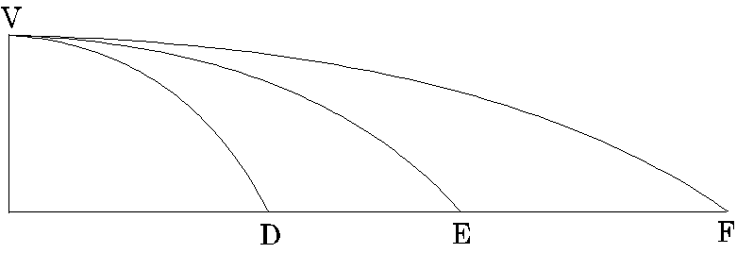
The parabolic paths would become flatter and flatter, and, if we imagine that the mountain is so high that air resistance can be ignored, and the gun is sufficiently powerful, eventually the point of landing is so far away that we must consider the curvature of the earth in finding where it lands.
In fact, the real situation is more dramatic---the earth's curvature may mean the projectile never lands at all. This was envisioned by Newton in the Principia. The following diagram is from his later popularization, A Treatise of the System of the World, written in the 1680's:
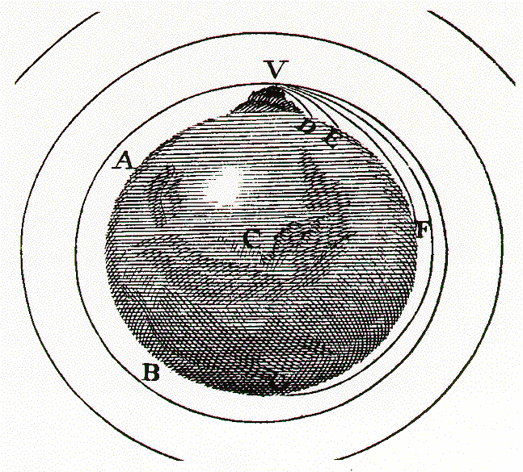
The mountaintop at V is supposed to be above the earth's atmosphere, and for a suitable initial speed, the projectile orbits the earth in a circular path. Visit this applet.
http://galileoandeinstein.physics.virginia.edu/more_stuff/Applets/newt/newtmtn.html
Summary of data and conversion factors to be used in this packet:

- average radius of Earth = 6,378,132,1 m
- mean distance from Moon to Earth = 384, 467 km
- period of Moon’s orbit = 27.32166 days
- 1 meter = 3.2808399 feet
- 1 mile = 5280 feet
- Using the applet, determine the initial velocity in mph that a cannonball must be fired at to put it in a circular orbit. Convert this velocity to m/s.

- How far (in m) does a projectile fall during the first second?

- How far (in m) along Earth’s surface would you have to travel before the surface would fall away below a truly flat horizontal line by the amount in #2? Use the diagram below to help you. (Hint – Use the right triangle to find θ in radians. Remember that an angle in radians is the ratio between the arc length and the radius).
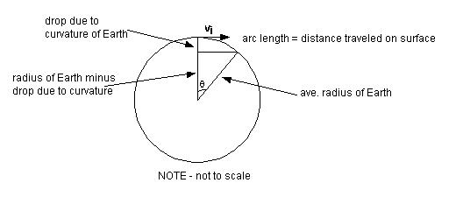

- Given your answers to #2 & #3, with what initial horizontal velocity must you fire a cannonball from the mountain top so that its downward fall would be just matched by the earth's surface falling away, and it would never hit the ground? How does this compare to the value you obtained from the simulation in #1?

This is just the motion, familiar to us now, of a satellite in a low orbit, which travels at about 8,000 meters (five miles) a second, or 18,000 miles per hour. (Actually, Newton drew this mountain impossibly high, no doubt for clarity of illustration. A satellite launched horizontally from the top would be far above the usual shuttle orbit, and go considerably more slowly than 18,000 miles per hour.)
Newton realized that the moon's circular path around the earth could be caused in this way by the same gravitational force that would hold such a cannonball in low orbit, in other words, the same force that causes bodies to fall.
To think about this idea, let us consider the moon's motion, beginning at some particular instant, as deviating downwards from some initial "horizontal" line, just as for the cannonball shot horizontally from a high mountain. The first obvious question is: does the moon fall five meters below the horizontal line, that is, towards the earth, in the first second? This was not difficult for Newton to check, because the path of the moon was precisely known by this time. The moon's orbit is approximately a circle of radius about 384,000 kilometers (240,000 miles), which it goes around in a month (to be more precise, in 27.3 days), so the distance covered in one second is, conveniently, very close to one kilometer.
- Using the same geometry you used in #3 for the cannonball around Earth, find how far (in m) the Moon drops below a horizontal line of flight in one second. Make sure your calculator is in radians. Your answer will be VERY tiny, so do not round. Use a graphing calculator and keep all digits until the end.
How many radians does the moon go in 1 second? This is θ.

Drop due to curvature of orbit = [(radius of Moon’s orbit) - (radius of Moon’s orbit)(cosθ)]

- The "natural acceleration" of the moon towards the earth, measured by how far it falls below straight line motion in one second, is less than that of a cannonball here on earth by the ratio of the drop distance on Earth to the drop distance of the Moon. Find this ratio.

What can be the significance of this much smaller rate of fall? Newton's answer was that the natural acceleration of the moon was much smaller than that of the cannonball because they were both caused by a force---a gravitational attraction towards the earth, and that the gravitational force became weaker on going away from the earth.
In fact, the figures we have given about the moon's orbit enable us to compute how fast the gravitational attraction dies away with distance.
- The cannonball (or Newton’s apple) is at the Earth’s surface relatively speaking. How many times further away from the center of Earth is the moon?

- Show how putting these two facts together (from #6 and #7), led Newton to his famous inverse square law: the force of gravitational attraction between two bodies decreases with increasing distance between them as the inverse of the square of that distance.

- The acceleration due to gravity on Earth is 9.80 m/s². A satellite orbiting above Earth’s equator with an orbital radius of 6.6 Earth radii.
  - What is the satellite’s centripetal acceleration? (Apply Newton’s inverse square law).

  - How fast is the satellite traveling?

  - What is the period of its orbit in days?

  - Why do you think this kind of satellite is called “geosynchronous” or “geostationary”?

