Vector Operations

Vector Addition

The easiest way to learn how vector addition works is to look at it graphically. There are two equivalent ways to add vectors graphically: the head-to-tail method and the parallelogram method. Both will get you to the same result, but one or the other is more convenient depending on the circumstances.

Head-to-Tail Method

We can add any two vectors, A and B, by placing the tail of B so that it meets the tip of A. The sum, A + B, is the vector from the tail of A to the tip of B.

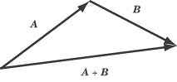

Note that you’ll get the same vector if you place the tip of B against the tail of A. In other words, A + B and B + A are equivalent.

Parallelogram Method

To add A and B using the parallelogram method, place the tail of B so that it meets the tail of A. Take these two vectors to be the first two adjacent sides of a parallelogram, and draw in the remaining two sides. The vector sum, A + B, extends from the tails of A and B across the diagonal to the opposite corner of the parallelogram. If the vectors are perpendicular and unequal in magnitude, the parallelogram will be a rectangle. If the vectors are perpendicular and equal in magnitude, the parallelogram will be a square.

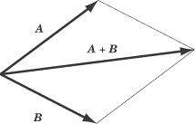
Vector Subtraction

---You probably know that subtraction is the same thing as adding a negative: 8 – 5 is the same thing as 8 + (–5). The easiest way to think about vector subtraction is in terms of adding a negative vector. What’s a negative vector? It’s the same vector as its positive counterpart, only pointing in the opposite direction.

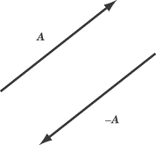

A – B, then, is the same thing as A + (–B). For instance, let’s take the two vectors A and B:

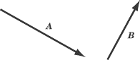

To subtract B from A, take a vector of the same magnitude as B, but pointing in the opposite direction, and add that vector to A, using either the tip-to-tail method or the parallelogram method.

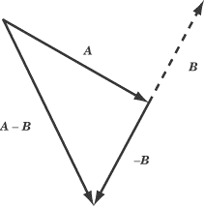

Graphical Vector Addition
Adding two vectors A and B graphically can be visualized like two successive walks, with the vector sum being the vector distance from the beginning to the end point. Representing the vectors by arrows drawn to scale, the beginning of vector B is placed at the end of vector A. The vector sum R can be drawn as the vector from the beginning to the end point.

Example of Vector Components
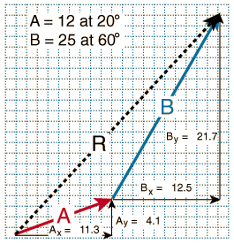
Finding the components of vectors for vector addition involves forming a right triangle from each vector and using the standard triangle trigonometry.

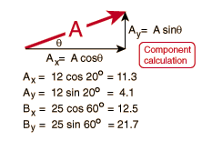
Adding Vectors by Components
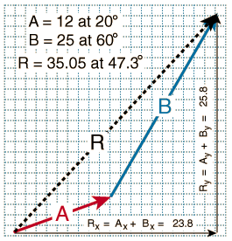
After finding the components of vectors A and B and combining them to find the components of the resultant, R, the magnitude and direction of R can by found by

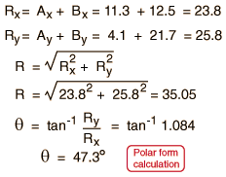

Adding Two Vectors Using the Laws of Cosines and Sines

Note from the geometry that the angle between vectors A and B
(∠ R) is 140º.

From the Law of Cosines:
R² = A² + B² – 2ABcos(∠R)
(∠R is the angle opposite side R)

R² = (12) ² + (25) ² – 2(12)(25)cos140º
R² = 1228.5 and R = 35.05

Now find the angle between A and R (∠B) – this angle is opposite side B.

From the Law of Sines:
(sin ∠R)/R = (sin <B)/B

(sin 140 º)/35.05 – (sin ∠B)/25
sin ∠B = 0.4585 so ∠B = 27.3 º

and the angle from the positive x-axis is 27.3 º + 20 º = 47.3 º

