HEAD TRAUMA IN PEDIATRIC POPULATION

Babies are in great risk to suffer some kind of accident while they grows and begins to crawl, stand up, run, play, etc. and they need to explore them new world; the child can not recognize dangers and thus, they needs attention and care from adults because an adequate care is the best way to prevent or reduce child injuries. Hence adequate personal (teachers, medics, nurses, etc.) must take the job to teach this prevention of injuries, using key points as use of restraint systems inside car, protection gear for the games (helmets, knee guards, others), aware about dangers (as hot objects, deep in a pool), management of toxic substances and chemicals, and so forth, adding the teach of those basic first aids to all population.
Falls are the first cause of pediatric injuries in the U.S., follow by motor vehicle collisions and bicycle injuries, sports injuries and those produced by fire weapons and stab wounds are less common.

Anatomical and physiological differences
If we analyze a little child, we can find some differences between adults individuals concern anatomic and physiological aspects. One of this differences is the head, they have more prominent occiput (this get the adult form among 10 years old), thereby cause neck flexion when the child lay supine and it can occlude the unprotected airway.
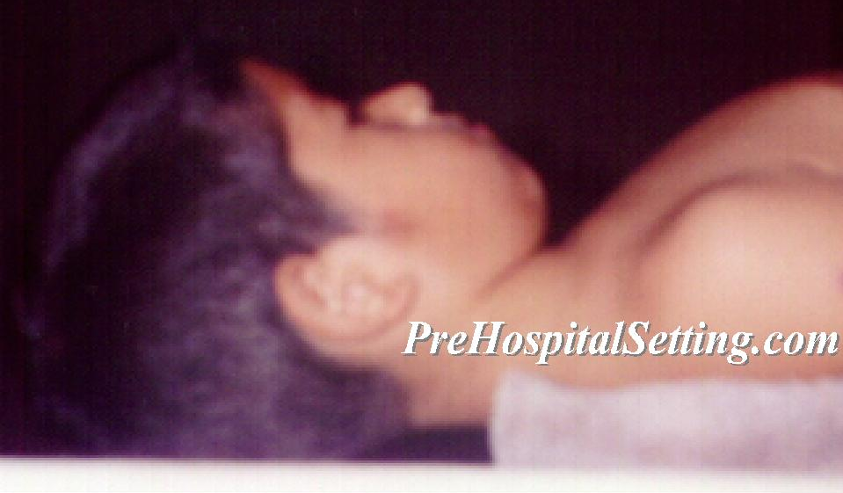
Head is proportionally bigger in children
Sutures and fontanelle are open and they get close between first and second year of life. The child’s head lose more heat and they have poor ability for termoregulation and homeostasis when are stressed. The Brain is more elastic and thus, more resistant to impacts.
Mouth and nose are littler and the tongue is proportionally bigger respects the oral cavity, adenoids are larger and the larynx are more cephalic that we can find in adults, and it have a conic Shape, with a strait structure in the cricoid ring, just below vocal cords; this is important because when perform a enotracheal intubation the cricoid cartilage make a natural sealing and so, endotracheal tubes without cuff are needed for little children.
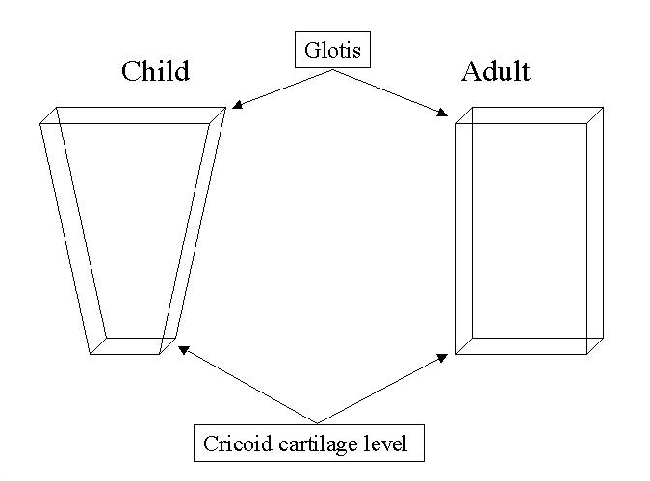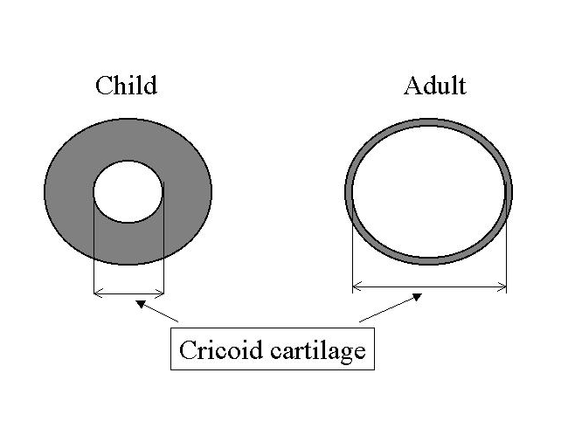
Larynx in children have a conic shape opposite in adults whom have a cylindrical shape larynx. This is the reason why in child narrowest structure isn’t that you are seeing when perform a laringoscopic procedure.
The epiglottis is littler, closer and soft, with “U” or “Ω” (omega) shape, and it cover more space in airway for the acute angle with the trachea. Cartilage leak of firmness and lower airway are undeveloped.
The larynx is littler in child than adult, placed more anterior and is more difficult to visualize. toddler’s trachea is shorter 5 cm approximately, and grown up to 7 cm approximately, therefore in a intubation of the trachea we can invade the right mainstem bronchi, producing hipoxia and/or perforation.
The neck is short, with poor musculature and more cartilaginous, furthermore it support a great mass (the head) and bear impact forces better than adults, likewise column is very elastic and the little size difficult the evaluation of the trachea or vessels.
Children have highly elastic chest walls and they not give support to lungs creating a paradoxical respiration (intercostal and sternal retractions) during expansion of lungs. Tidal volume depends of diaphragmatic function. When the diaphragmatic movement is limited by pressure from above (lung hyperinflation) or from below (gastric distention), breathing is compromised because they can not compensate.
Skeleton is not completely calcified, and is very elastic, contains growth centers. This is the reason why we can find organ damage internally without fractures in a injured child.

Kinematics
The little size of children implies that forces produced by trauma hit a little surface and the energy transmitted cause organic damage instead localized damage. Although trauma could appear insignificant it can produce prolonged incapacity, either cerebral, organic or psychological. Inappropriate care in the immediate posttraumatic period may affect survive rate and the consequences in the subsequent years being probably the most important topic. Therefore the traumatized children must receive expert treatment in the field, during transport and in the hospital because the final results depends from the first “golden hour”.
Motor vehicle accidents causing great amount of deaths, includes children older than 6 years old in United States.
Injuries are product from forces transmitted to tissues exeding them tolerance caused by velocity or compression.
In a car crash, occurs several collisions: first impact happens when vehicle hits another object. Second happens when the individual hits the internal structure of the vehicle, and this can minimize by adequate restraints. Third collision occurs when internal organs impacts internal surfaces or shearing. A fourth collision can happen when others objects or even others unrestrained individuals (usually children) hit with others passengers and increasing injuries in both.
Spinal trauma (cervical and lumbar spine) is very common in restrain persons, but injuries in head, face, chest, abdomen and extremities can be diminished.
Air bags, it can save lives, but it can be detrimental or yet mortals in those infants carried in car seats placed in the front seat. Posterior seat is safer for them, restrained appropriately.
When a child is struck by a car, the child face the vehicle. Children are shorter than adults and strikes, depends on height, it can be the thigh or the hip. Second impact occurs almost simultaneously and hit the chest while the head hit the front or the hood of the car, then the injury mechanism can vary concern the child’s height, he can be ejected, fall to the ground, spin in the hood or get below from the car.
Additionally, with increase of recreational and sports activities, the injuries and mortality increase because they are expose to other risk such as drowning, head trauma, fractures, etc.
Talking about death and incapacity, the end result about children care is determinate by the quality on care given to the child in the first moments follow the accident. Same as adults, three causes are responsible from immediate death: Hipoxia, Central Nervous System Damage and Massive Hemorrhage.

Assessment
Head trauma in children can be since slight, moderated, severe or fatal, and is the first cause of death in pediatric population. Isolated head trauma is caused normally by falls, nonetheless main causes of cerebral damage in little children are non accidental and we must be aware for signs of abuse or neglect for avoid continuous and future injuries. Death risk in children produced by head injury is low if they are no comatose when arrive to the hospital, likewise, children have a better recuperation as adults suffer from head injury, except those children below from 3 years old.
Although recent research concern cerebral injury suggest less mortality beside adults, children have the worst prognostic.
Children with intracraneal injury frequently are present with depressed level of consciouness or they can suffer a time from unconsciouness which sometimes is not informed (or ignored) to prehospital provider. Lose of consciouness is a important data for suspect central nervous system damage.
Primary brain injuries (produced by the trauma) can be separate in two categories: focal and diffuse. Secondary brain injury are produced by hipoxia and hipoperfusion
Infant’s brain have great amount of water and is not completely evolved by myelin, thus is more susceptible for diffuse injury. Cerebral functions and reflexes are present, but cortical functions as memory and fine motor coordination have not completely developed and sometimes can not be evaluated after 6 months old or bigger.
Focal injuries are about 50 % of head trauma and includes intracraneal bleedings and contusions.
Scalp wounds needs immediate control of bleeding, because it can lead in hipovolemia and shock. If it can not be controlling may need to localize the exactly site of bleeding and to claw but this is only realized in the hospital.
Linear fractures may or not accompanying a brain injury; if great trauma is suspected computerized axial tomography is the elective procedure and indications are altered level of consciouness, seizures, continuous vomit and tension of fontanelle. When find some of signs listed above transfer as soon as possible. Depressed fractures or compounds and penetrating injuries in head generally implies brain tissue injury and are consider critical. Basilar fractures shows characteristic signs as retroauricular echimosis, periorbital echimosis which can be late or we can find hemotimpanum, otorrhea, rinorrea o cerebrospinal fluid come out from nose, or ears.
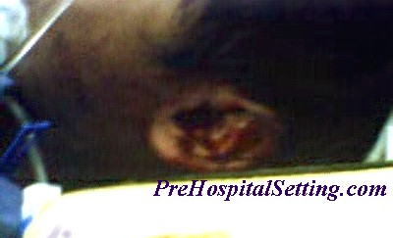
Otorrhagea in a child who fall from 3 m of height landed on his head.
Epidural hemorrhage is rare in children and usually is result of trauma in middle meningeal artery, as a result it shows fast and progressive loss of consciousness, classic triad can be: concussion, lucid interval and neurological deterioration; it can be result from fracture. If hemorrhage is localized posterior we can find nape rigidity, cerebelosus signs, vomiting and progressive lost of consciousness.
Subdural hemorrhage is more frequent as epidural and affects mainly to young children. Symptoms is slow, without specific clinical data but we can find vomit, irritability and hypertermia. Sometimes signs are present in subacute or chronic phases as generalized or focal seizures.
Diffuse brain injury includes concussion and diffuse axonal injury, it can occur by tissue shearing caused by deceleration forces. This injuries commonly are result of falls and car collisions, and shows fast, profound and prolonged lost of consciousness and probably increase of intracranial pressure.
Cerebral concussion is a transitory neuronal disjunction induced by trauma, producing confusion and lost of consciousness. The damage implies hemorrhagic zones with or without local swelling; other neurological signs and symptoms depends on injury site.
Focal and diffuse injuries can produce Increase of Intracraneal Pressure what can leak on herniation. As intracraneal pressure increases, the temporal lobe is dislodged down the fibrous tissue separating brain portions. Brain stem compression can produce altered in breathing, blood pressure, slowing of pulse and heart rate and hemiparesia, pupilar changes when third cranial nerve are compressed, which produce dilatation in the side of the expansion mass.
Signs of increase of intracraneal pressure can be subtle and includes depressed level of consciousness, persistent irritability or inconsolable crying. Children with head trauma sometimes present emesis and rarely is a sign of increase of intracraneal pressure, but persistent vomit require specialist examination. Young children can be pale, diaphoretic and lethargic immediately follow the trauma. Obvious signals as vital signs changes main Cushing’s triad (hypertension, bradicardia, respiratory changes), temperature instability, posture (decorticating, decerebration)and as revised above: pupil changes. Toddler with open fontanelle and movile sutures support better a increase of intracranial pressure. Signs about expansion mass can keep occult until decompesation occurs. In children lucid interval subsequent to neurological deterioration is more frequently with brain edema and increase on intracraneal pressure
Likewise all signs and symptoms above mentioned, brain damage can appear without initially show signals and the only indicative can be the suspect about injury mechanism, therefore a detailed evaluation by specialist is important
Secondary Cerebral Injury is caused by hipoxia and/or hipoperfusion producing edema. As any organ, brain needs perfusion, the body have the ability to regulate the blood flow but it can be deteriorated by the trauma and flow can fall while intracraneal pressure increase. This is the reason why the body increases the blood pressure in Cushing’s response to avoid leak of blood flow until this compensation is loosen. Hipoxia can be consider when the SaO₂ fall to 90. When hipoxia increases. Cell damage occur by edema.
TREATAMENT
Early interventions in a injury children is crucial for increase survive. Although the initial damage can be fatal, injury is released by ischemia. Those children in coma can get recuperation if brain hipoxia is avoided. Initial survey includes injury mechanism, general trauma protocol and level of consciousness add to the well known ABCDE, and secondary survey.
A: Airway and cervical spine control
Respiratory secretions, vomit, blood, or any strange body can obstruct the airway. Suction must be performed for get free the airway; flexible plastic cannulas suction thin secretions inside the mouth, nasopharinx or endotracheal tube. Rigid cannulas such as tonsil tips are used to remove thick and relatively bigger secretions such clothes. An important complication concern suction is vagal stimulation, which can result in fall of heart rate thus, is important to keep monitored heart rate while aspiration are performed. Suction must no exceed 5 seconds every time and patient can be assisted with oxygen either each aspiration.
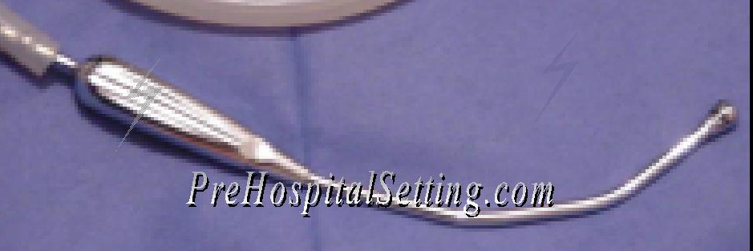
Tonsil tip suction cannula
In a unconsciousness patient the tongue can obstruct the airway by the displacement to hypopharinx. The head injury children must be maintained on neutral position for protect and avoid more injury to cervical spine, and we can perform the jaw trust maneuver or shin lift (with neutral position). High injury in the cervical spine (C4 and superior) can produce apnea by the diaphragm’s inervation compromised. Cervical spine must be inmovilized with a semi rigid cervical collar, is very important to use an appropriate size for every child, if cervical collar of adequate size is not available we can use towel or blankets around the neck. lateral movement is restricted by place head immobilizers or rolls of blankets or towels on the sides of the head and tape. Soft cervical collars are not useful because do not support appropriately the spine.

Semi rigid Cervical collar for children
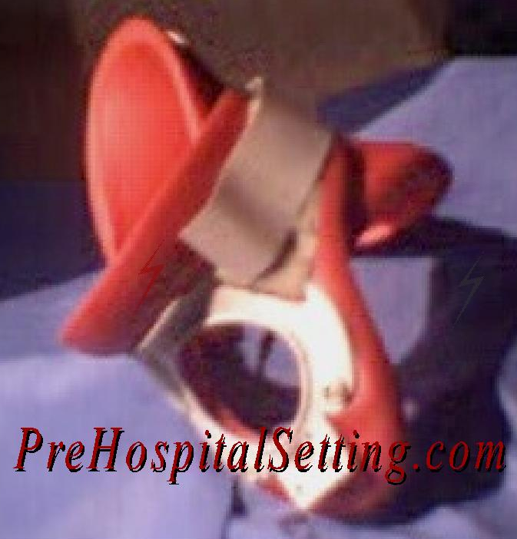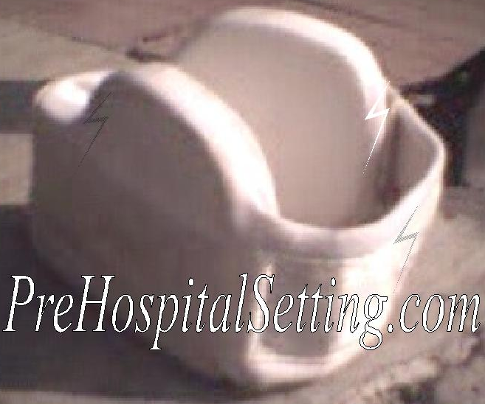
Left: Semi rigid Cervical collar; Right: soft collar (not recommended)

For get control of airway, oropharingeal airway (OPA) can be used which separate the tongue from the posterior wall of the pharynx. It can not be used in children with gag reflex. OPA’s size range from 4 a 10 cm in length (000 to 4). Size is determined by placing the OPA on the side from the face, on the corner of the mouth to the angle of the jaw. It must be placed depressing the tongue on the floor of the mouth.
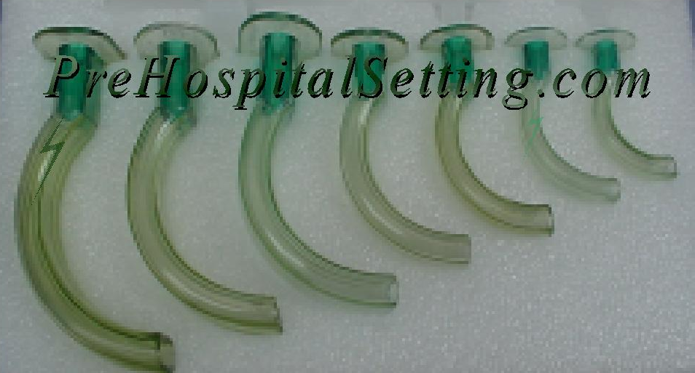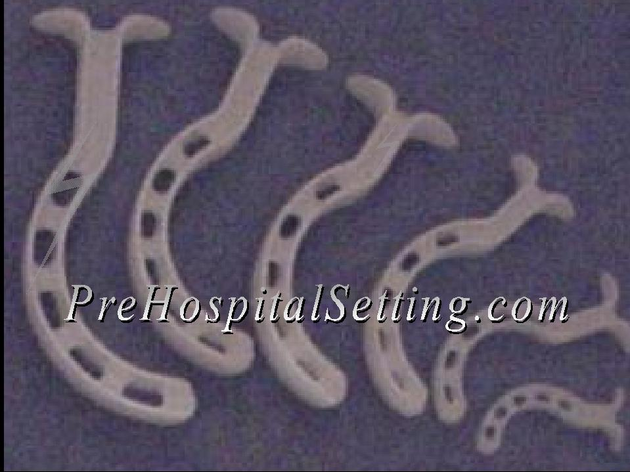
Oropharyngeal airways; left: guedel; right: bermann.
Endotracheal intubation is an excellent alternative for airway control, which isolate the trachea preventing the gastric distention and bronchoaspiration. Endotracheal tubes must be sterile, be transparent and contain a 15 mm standard connection for fix with the ventilator, Murphy’s eye, present in some tubes, is for diminished the total obstruction of the tube if it occurs, cuffed tubes only have utilization in children above 8 years old.
For get the appropriate internal diameter of the tube in children above 1 year this formulas can be used:
$\text{ID}=\frac{\text{age}(y)}{4}+4$ $\text{ID}=\frac{\left(\text{16}+\text{age}(y)\right)}{4}$
ID is the internal diameter. French diameter results from multiplying the internal diameter by 4. In a newborn and premature, 3.0 or 3.5 mm (12 ó 14 Fr) tubes are used but premature children can need smaller tubes as 2.0 or 2.5 mm and in children of 1 year old 4.0 (16 Fr) tube is recommended, likewise, this formulas are not exactly and is recommended have tubes of bigger mid number and litter mid number while the procedure is performed.
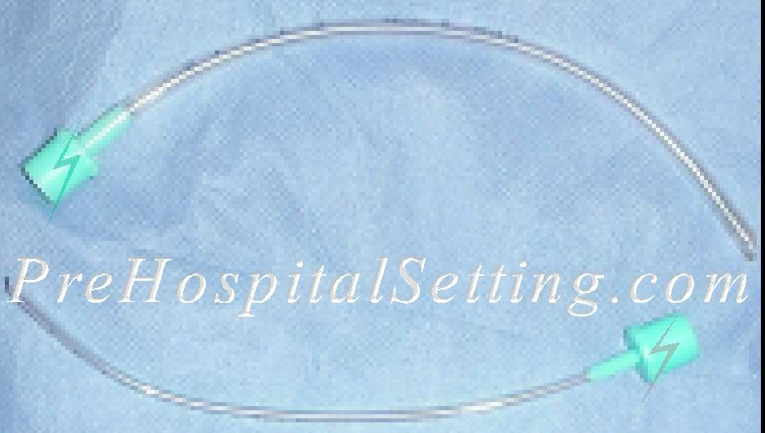
Endotracheal tubes for children
Endotracheal tube insertion can be made under direct vision using a laryngoscope or performing a digital intubation, and would made controlling the cervical spine. Digital intubation is safer in infants without theet add to the shorter distance of the larynx. Blind nasotracheal intubation is not recommended because children have an closer angle in the posterior nasopharinx, and cause penetration of the basal skull.

Rapid Sequence Intubation
Children with head trauma are in risk to develop increase on intracraneal pressure and sometimes they have significant pain. hipoxia, hipovolemia or the head injury it self can deteriorate the behavior and children may be combative making airway management more difficult. Rapid sequence intubation can help to control and protect the airway and diminished increase on blood pressure and thus, diminished intracraneal pressure. A drug of choice for anesthetizing children with head trauma and increase of intracraneal pressure is Thiopental. Thiopental is a barbiturate that depress the central nervous system and is used to produce anesthesia. The main advantage of this drug is the protective effect it provides to brain because it attenuates the response to intracranial pressure to intubation, reduces cerebral blood flow, cerebral metabolic rate and acts as a free radical scavenger to decrease damage done by toxic metabolites in the injured brain. The major disadvantage is that acts as a myocardial depressant and may lower the blood pressure. Other medication inside rapid sequence intubation is Lidocaine. Lidocaine can be administered before intubation to provide local airway anesthesia and to blunt the intracraneal pressure response to intubation.

Alternative devices
Laryngeal mask airway (LMA) is an alternative device for get control in the airway, this device is placed exactly in front of the glottis and the cuff is inflated for secure position; at level of the lips, this device needs to secures such as a endotracheal tube and is necessary to place another device (OPA, roll of gauze) for avoid bite of the tube and obstructs the tube and ventilation become compromised. LMA’s sizes run in 7 sizes, size 1 for newborns below from 5 kg to size 5 for adults >70 kg. Other devices are available as light stylet; esophageal obturator airway or combitube are not use in children.
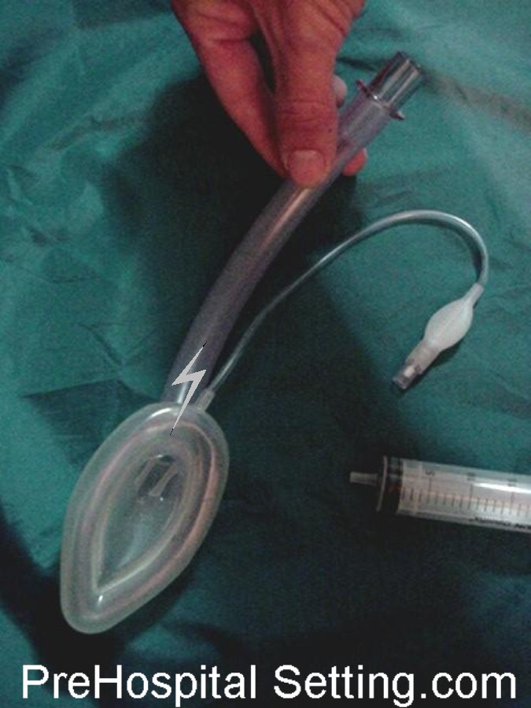
Laryngeal mask airway
Cricotirotomy by needle is an alternative for control of the airway. Usually for this maneuver a 18 cath (above needle) or littler is used attached to syringe with 1cc of saline solution. Needle. This alternative is used when other methods fail to control the airway and can maintain the airway for 30 to 45 minutes because exist a leak of expiration and C0₂ is accumulated. This technique can be used with a manual ventilator attached to the catheter with a standard 15 mm adapter of a DI 3mm tube.
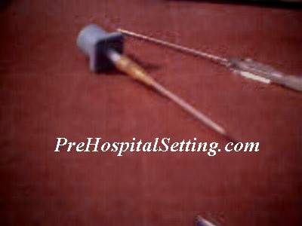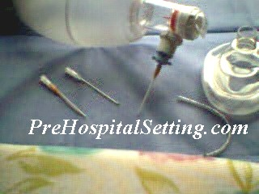
Manual ventilator attached to standard 3 mm tube DI adapter placed inside a cath

B: Ventilation and oxygenation
Children with evidence or suspect of increase on intracraneal pressure should be hyperventilated preferably with endotracheal tube. If endotracheal intubation are not available, personal of emergency medical services must be expert on ventilation in children with non secure airway. Hyperventilation may reduce the intracranial pressure associated with excessive cerebral blood flow if cerebral carbon dioxide vascular reactivity is preserved. Extreme hyperventilation probably should be avoided, since it may reduce cerebral blood flow to levels associated with ischemia.
AGE | Breaths per minute
0-6 weeks | 30 - 50
7weeks – 1 year | 20 - 30
1 – 2 years | 20 - 30
2 – 6 years | 20 – 30
6 – 13 years | 12 –20 – 30

Tidal volume is calculated multiplying the weight per 10 cc or 15 cc. This way a 15 kg child will need 150 cc calculated at (10)(kg) or 225 cc calculated at (15)(kg)
Gastric distention must be avoided because it can produce regurgitation and gastric content aspiration and avoid an adequate ventilation by elevation of diaphragm limiting the expansion while inspiration. Gastric distention can be diminished with Sellick maneuver (cricoid pressure) while positive pressure is delivery. This maneuver must be realized by a second rescuer using one fingertip in infants and the thumb and index finger in children. Excessive pressure must be avoid because larynx cartilage is less developed and airway can be easily obstructed. Pressure is suspended once intubation was realized.
Chest movement must be evaluated for presence and quality and search for intercostal or sternal retractions or nasal fluttering. In toddlers, the lung sounds can be transmitted across the chest and sometimes the sound in a damaged lung is produced by the opposite side of the torax and is harder to assess. Sometimes tone change is less common than intensity tone.

C: Circulation and fluids
Scalp injuries can lose a great amount of blood. In children, head injury can lead on hypotension. Always must be aware for hipovolemia in children with head bleeding and begin fluids early.
Normal volume in a child is about (80 cc)(kg). For fluid restoration must be given crystalloid in bolus of (20 cc)(kg). If children do not respond at 2 bolus, blood replace are necessary. Hypovolemic children may need up (50 - 60 cc)(kg) of crystalloid and for volume lost greater than 25 % 3 to 1 rule can be need. Head must be elevated around 20 a 30º for help to venous return.
Children’s weight can be find with this formulas:

3 to 12 months: (months)(0.5) + 4.5
1 to 5 years: (years)(2) + 8.5
6 to 12 years: (years)(3) + 3

Primary response to hipovolemia in children is tachycardia, nonetheless to evaluate heart rate alone can laid on mistakes about child’s condition because increase in heart rate are result from stress, pain and fear and not only by leak from fluid. Bradycardia is a common dysritmya in serious injured infants.

AGE | Beats per minute
0-6 weeks | 120 – 160
7weeks – 1 year | 80 – 140
1 – 2 years | 80 – 130
2 – 6 years | 80 – 120
6 – 13 years | 60 – 80 – 100

The children shows hypotension when lose about 25 % of volume. As the children’s volume is less than adults, little bleeding is significant and is associated generally with drop in the cardiac output. Children maintain the blood pressure with compensatory mechanisms as vasoconstriction, inotropism and tachycardia.

Blood pressure is an important sign and is necessary to use adequate size equipment. Systolic blood pressure (SBP) can get multiplying 80 plus the double of the age (years), diastolic blood pressure (DBP) is 2/3 of SBP.

$$\begin{aligned}\text{SBP}=\text{80}+\left(2×\text{age}(\text{years})\right) \\ \text{DBP}=23\text{TAS}\end{aligned}$$

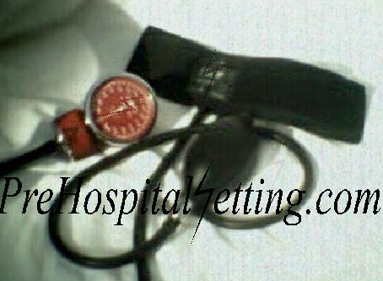
Infant blood pressure cuff for blood pressure measure

There are some devices to help to perform quick assessment about height, weight and some medications and equipment for different ages in children. Some of this devices are the “Broselow tape” and the “pedi-wheel” which can be helpful for pediatric care


Broselow tape

D: Disability
Level of consciousness can vary in children. Young children may can not capable for interact with strange people and thus they may not cooperate with assessment. Quick neurological exam can be made with mnemonic AVPU.

A | Child is ALERT, responds to all kind of stimuli
V | Child responds to VERBAL stimuli or talk him/her loud
P | Child responds to PAIN, when painful stimuli is applyed the child respond and then become depressed. Sometimes only reefer too much pain but is not capable to interact appropriately
U | Child is UNCONSCIOUS, they do not respond to any kind of stimuli and is unnecessary to keep applying painful stimuli
Mnemonic AVPU
Glasgow coma scale was developed in 1974 for adult, in children can be reliable but in infant and young children GCS modified is used:

Eye response | 4 | Spontaneous
Eye response | 3 | To verbal stimuli
Eye response | 2 | To pain
Eye response | 1 | No response
Motor response | 6 | Moves spontaneously and purposefully
Motor response | 5 | Withdraws to touch
Motor response | 4 | Withdraws to pain
Motor response | 3 | Abnormal Flexion to pain (decorticating)
Motor response | 2 | Abnormal Extension to pain (decerebration)
Motor response | 1 | No response
Verbal response | 5 | Coos and babbles
Verbal response | 4 | Irritable Cries
Verbal response | 3 | Cries to pain
Verbal response | 2 | Moans, Grunts
Verbal response | 1 | No response
Pediatric coma scale for children

“Pediatric Trauma Score” is used for get a quick assessment of child’s condition and triage for Pediatric trauma center:

 | +2 | +1 | -1
Age | Child / adolescent > 20 Kg | Toddler 11 – 20 Kg | Infant < 10 Kg
Airway | Self-Maintained | Non maintained, oro or nasopharyngeal airway needed | Controlled by endotracheal tube, LMA, Cricotirotomy
Level of consciousness | Alert | Confuse  Lost of consciousness | Coma  Unconsciousness
Systolic blood pressure | >90 mm Hg  PULSE PRESENT AT WRIST | 51-90 mm Hg  COROTID /FEMORAL PULSE PRESENT | <50 mm Hg  WITHOUT PERCEPTIBLE PULSE
Fractures | Fractures Non apparent and without suspect. | Close Fracture anywhere | Multiples fractures or single open fracture
Coetaneous | No visible injuries | Contusion, abrasion, laceration < 7cm and not affect to fascia | Lost of tissue.  Gun or stab wound
Pediatric Trauma Score

If pediatric trauma score is ≤ 8 transfer to pediatric trauma center.
Pupilar contraction is produced by response to light (II and III cranial nerve).
Absent response in pupilar reflex is product from interruption in any site of the nerve (as III cranial nerve compression by edema), another reason for absent or poor response are ocular surgery, blindness by sickness or drugs. Miotic pupils after head injury show lose from simpatic tone product of brain stem injury.
Ocular movements assess the brain stem, if this movements are normal and spontaneous III, IV and VI cranial nerves are intact.
Seizures in the posttraumatic period are more frequent in children than adults and are not related with epilepsy, but it increase metabolism in the brain. They affect motor and sense activity, behavior and autonomic function. Posttraumatic seizures is more common in children as adults but are not associated with epilepsy. Seizures increase metabolic needs on a injury brain.

E: Expose
Is important to expose the child for assess and detect all injuries and bleeding sites. Infants can not to shiver for get warm and they need to use fat and thus, energy. They can become hypothermic easily and exposition must be perform inside a warm environment (as ambulance) for help to maintain the temperature at 36 to 37ºC.
Core temperature under normal values can protect the cerebrum of edema and is not necessary to elevate quickly, nonetheless, cold can complicate the child’s condition and resuscitation. On the other hand, hypertermia increases the cerebral flow and increases the intracraneal pressure, so decrease in temperature is very important.

Battered / abused children
Non accidental trauma is one of main causes of important head trauma in children younger than 1 year. This injuries are result from concussions or aggressive shake made for adults. Injuries produced by “shaken baby syndrome” are result from shaking an infant held by the arms or trunk or forcefully striking an infant’s head against a surface. Deceleration produced injuries as coup contra coup type. Although there is not evident signals one third of children die and another third survive show some kind of disability such as blindness or some degree of mental retardation.
Shaken baby syndrome is find in battered infants and is common to find echimosis at level of shoulders, arms chest or include rib fractures because the baby is taken from this zones for the shake. Echimosis at different level of healing is find when child has suffer previous trauma. Some infants can develop increase of intracranial pressure.
Falls from little height as 2 or 3 stairs do not produce important intracraneal injuries. Another signals show infant mistreatment are injuries or fractures in different stages of healing and incongruent history about injuries.

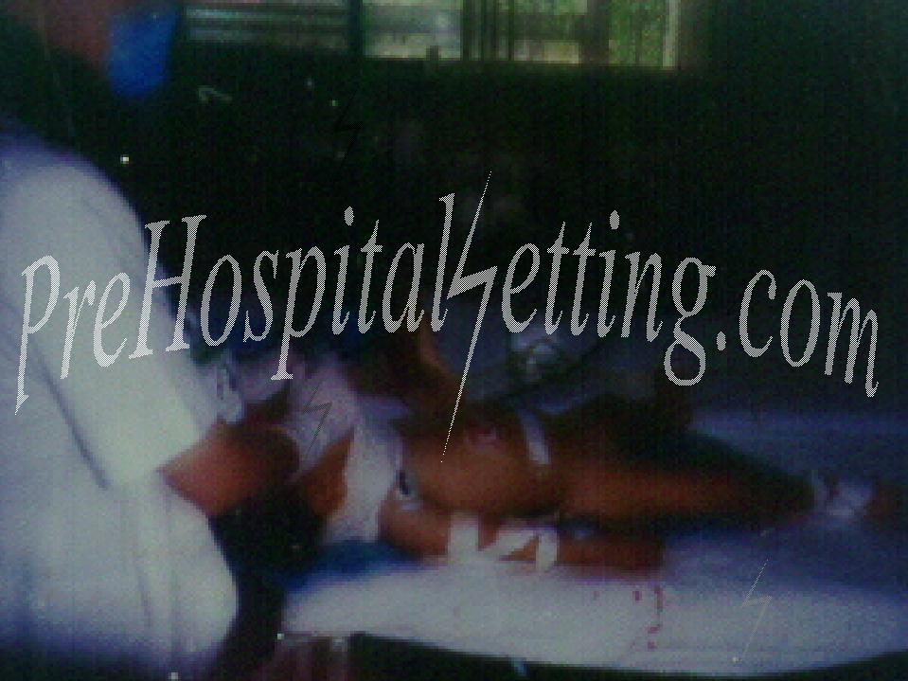
5 y/o male involve in a rollover being ventilated in pediatric trauma center

Quick guide for cerebral injury in children

A quick guide concern to conditions for transfer to specialist assessment of head injury on pediatric population include:

- Kinematics
- Altered mental status
- Skull Fractures suspect by:
- Open Fractures, depressed or penetrating injuries in head.
- Suspect of Basal skull fractures show by:
- Raccoon eyes
- Battle’s Sign
- Hemotímpanum
- Cerebrospinal fluid drainage
- Signs concern increase on intracraneal pressure
- Persistent Emesis
- Amnesia
- Abnormal Neurological exam (AVPU or Glasgow)

Continuous Seizures

