

The Million-Dollar Project

brought to you by the 5th graders at The Somerville Charter School

Team Members:

Financial Advisor (Excel)
&
Marketing and Design (PowerPoint)

Your mission: Plan an all-expense-paid vacation!

When is it? Plan it for either this summer, or next summer
Who will go? The entire graduating class, some teachers and chaperones
Total: 200 people
    - 150 students & friends
    - 50 adults/chaperones
Where? Your group will decide where, how to get there, what to bring, and what you will do while there!
Budget: $1,000,000 (plus-or-minus 5%)

Remember, although this is a fictitious trip, all normal rules and laws apply!
Each group will have 2-3 people.

Each group member will have a role in the project. Part way through the project, members will have the opportunity to switch jobs. Each group member is responsible for a part of the project and needs to know how to use each application (program).

You will have 9 class periods with Miss Moline to complete this project. At the end of the time, your group will be expected to present the trip that has been planned and how you spent the million dollars.

There is a website of links that you will use to find the items that your group wants to buy for the trip. However, if your group chooses to go to a site that is not on the list, that group will be fined. The fines run as follows:
1st offense $10,000
2nd offense $20,000
3rd offense $40,000
etc. (each offense, the fine doubles – it adds up quickly!)

If you are looking for something that is NOT part of the link-list already, submit a form to Miss Moline with a suggested topic or website. She will look for a site and if one is found, she will add it to the link-list for no charge.

Job Descriptions:
- You both are allowed to go online
  - Using Internet Explorer and the specified web site, you will find out the prices for each of the items that your group wants to buy.
- Financial Advisor
  - Using Excel record how much of everything that you buy, including the price, so that you know how much money is left
  - As a group, you may choose to allocate a certain amount of money per-person for meals rather than selecting specific restaurants. For this situation, the website column may be left blank.
  - As a group, you may choose to allocate a specific amount of money to be “spending money” during the trip. For this situation, the website column may be left blank.
- Marketing & Design
  - Using Power Point, you will record the information about your trip and create the presentation

Job Descriptions and Tips

- When online
  - Using Internet Explorer and the specified web site, you will find out the prices for each item that your group wants to buy. Make sure that everyone has the information that they need to do his/her job.

Financial Advisor needs to know:
      - website used
      - item purchased
      - price per item
      - number of items to be purchased (the quantity)

Marketing & Design needs to know:
      - details about the choices
      - features of the hotel and other products
      - What will everyone get for the money?

Don’t forget that you are planning a trip for 200 people!
150 students & friends
50 adults/chaperones

- Financial Advisor
  - Using Excel record how much of everything that you buy, including the price, so the spreadsheet can compute how much money is left
  - Use formulas to compute how much everything costs and keep a running balance
  - Don’t forget to include everyone who is going on the trip when purchasing items!
  - If you choose a hotel, figure out how many people stay in each room and make sure you “book” the rooms for each night

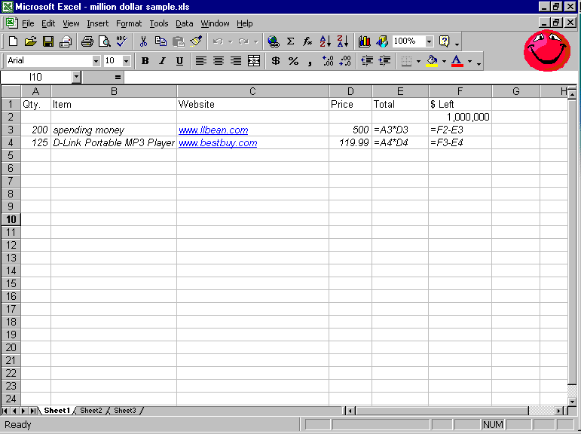
Sample Spreadsheet:
This formula will compute the total cost

Formulas:

Total: =[click qty]*[click price]
$ Left: =[click cell above (how much money is now available)]-[click total in current row]

- Marketing & Design
  - Using Power Point, you will record the information about your trip and create the presentation. Don’t forget to include the fun stuff!
    - Does the hotel that you chose have a pool?
    - What is there to do at the hotel?
    - What are you going to do and see on your trip?
    - How are you getting to the destination?
    - How long is your trip?
    - What “stuff” does everyone get?
  - You are creating the presentation that you will show to the entire class at the end of the project!
  - Always have this in the back of your mind…You want everyone in the class to want YOUR trip, even though they are creating their own.
  - Include any information that you would want to know, and information that you will want to be sure to tell the rest of the class.
  - The slides can be re-arranged later, get the necessary information onto each slide

Although you are in charge of the Power Point presentation, your whole group will be presenting at the end. It’s your job to design it, but it belongs to the whole group so everyone needs to take part in the presentation to the class.

Notes:

