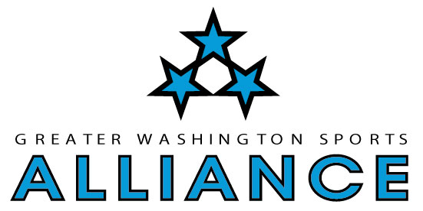
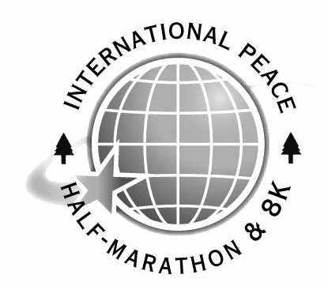
International Peace
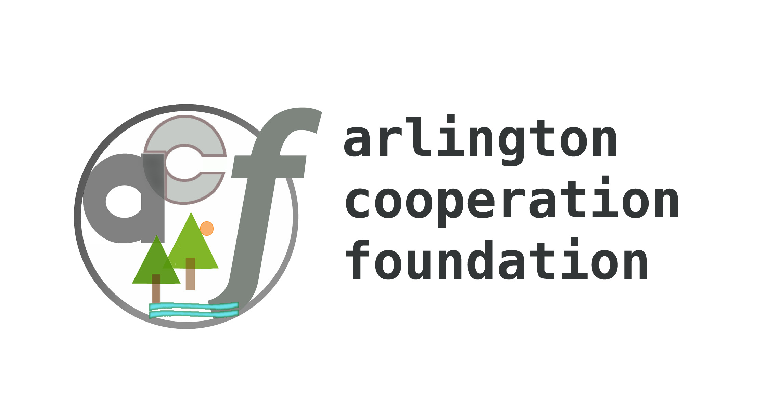
Half-Marathon & 8K


“Imagine World Peace, One Step at a Time”


Sunday, July 16, 2006

7:00 am Half-Marathon ⬇ 7:05 am 8K

Registration limited to 300 total
Register on-line at www.marathoncharitypartners.org/prrhalf

Start and finish: Belle Haven Park, 2 miles south of Old Town Alexandria
13.1 miles of park trails along the Potomac River, along George Washington Memorial Parkway
Beautiful views of the Potomac – Shady and cool – A runner’s paradise (except for the hills)

Conducted by Arlington Cooperation Foundation, Greater Washington Sports Alliance, and Imagine Peace Network
A benefit for Marathon Charity Partners (MCP)
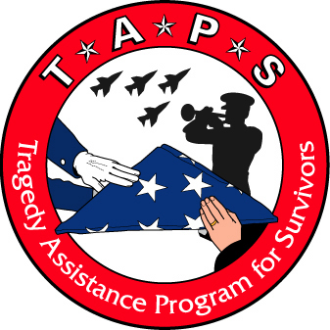
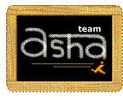



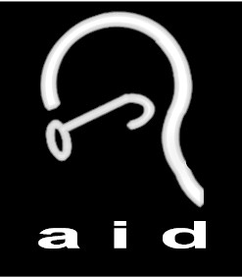
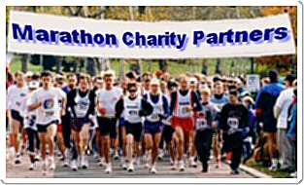
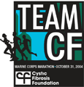

Supported by Capitol Hill Runners, Chesapeake Bay Running Club, Northern Virginia Running Club, and Potomac Valley Track Club

USATF-certified half-marathon & 8K course VA04011RT
High-Tech performance jerseys for all registered runners ● Medals & certificates to all finishers ● Sumptuous post-race picnic

Awards to top 3 M/F overall and by 10-year age group in both the half-marathon and the 8K (4.98 miles)
Awards to top 5 Male & Female teams. You are automatically on the team of your Nation or U.S. state of citizenship
Teams may be of any size, top 3 count, cross-country-style scoring
● $10 discount for early registration by June 15 by July 14 on July 15

● Members of ACF, MCP, and supporting clubs $20 $25 $30

● Members of other marathon training programs $25 $30 $35

● Non-members $30 $35 $40
No complimentary entries, but you may join ACF or MCP and take the member discount. Members of MCP get guaranteed entry to Marine Corps Marathon

- Hosted by Courtyard by Marriott, 2700 Eisenhower Avenue, Alexandria VA 22314
- For room reservations at a discount rate, call 703-329-2323, group code “International Peace Run”
- Saturday, July 15:
- 7:00 am Marathon Charity Partners international training run at Belle Haven Park
- 2:00-6:00 pm Packet pick-up, late registration, vendor expo, College of Running & Peace at Courtyard by Marriott * Earn a CME Certificate
- 6:00 pm International Dinner ($12) at Courtyard by Marriott with worldwide ethnic song & dance
- Sunday, July 16:
- 6:00–6:45 am Packet pick-up at Belle Haven Park (no race-day registration)
- 6:30 am Non-competitive Early-Bird Start (Early Birds get the same post-race picnic and medals) (no early bird start for 8K)
- 6:35 am Warm-up w/ Parade of Flags & anthems. Please bring your national or state flag (2’x 2’max.)
- 6:57 am American national anthem
- 7:00 am Competitive half-marathon start – worldwide ethnic song & dance all along the course
- 8-10 am Post-race international picnic. Awards ceremony begins at 9 am race day on-site
- 6-10 am Shuttle limos from Courtyard by Marriott to Belle Haven Park in continuous loop
Anyone so noble as to run both Rockville Twilighter and International Peace Run wins a Noble Prize
For questions or to sponsor this event, please call 703-218-2726 or e-mail RACEDIRECTOR@ATT.NET

Note: Parking is limited on race day. Please car-pool to the start. Free off-site parking on Belle Haven Road.
George Washington Memorial Parkway is a historic natural area.
We will follow all National Park Service conditions and “leave our campground cleaner than we found it.”
International Peace
Half-Marathon & 8K

Sunday, July 16, 2006

Register on-line at www.marathoncharitypartners.org/prrhalf
- Call 703-218-2726 or e-mail RACEDIRECTOR@ATT.NET with any questions

Please mail this form to ACF, 611 South Ivy Street, Arlington VA 22204

By entering this event, you agree, warrant and covenant as follows: I know that running is a potentially hazardous activity. I should not enter or run in club activities unless I am medically able and properly trained. I agree to abide by any decision of a race official relative to my ability to safely complete the run. I assume all risks associated with running in this race including, but not limited to, falls, contact with other participants, the effects of weather, including high heat and/or humidity, the conditions of the road and traffic on the course, all such risks being known and appreciated by me. Having read this waiver and knowing these facts, and in consideration of your acceptance of my application, I, for myself and anyone entitled to act on my behalf, waive and release National Park Service, USATF, Arlington Cooperation Foundation, and all sponsors, their directors, officers, employees, agents; representatives and successors from all claims or liabilities of any kind arising out of my participation in this event even though that liability may arise out of negligence or carelessness on the part of the persons named in this waiver. I acknowledge that the application fee shall be non-refundable. I agree that Arlington Cooperation Foundation may use my name and likeness for publicity purposes.
_______________________________________________
Signature

First Name ________________________________________ Last Name: _______________________________________________________

Gender: [Male] [Female] Birthdate ___ ___/___ ___/___ ___ ___ ___ (mm/dd/yyyy)

Address _________________________________________________________________________________________________________

City: ________________________________________ State:__________________ ZIP _______________________________

Email: _______________________________________________________________ Day Phone ________________________________

What is your t-shirt size? [_] S / M / L / XL I am a citizen of __________________________________________ Nation or State

Start: [_] 6:30 am Non-competitive Early-Bird Start [_] 7:00 am Competitive Half-Marathon Start [_] 7:05 am 8K Start

What is your best time in a previous half-marathon? ___:___ ___ Where? Or is this your first? _________________ Date ____________

[_] I will volunteer. Call me. (You get t-shirt, goodies, and dinner) Passport # ________________________ (for international guests only)

[_] Pre-race planning [_] Help at packet pick-up on July 15 [_] Help at race on July 16

Enclosed is my entry fee: by June 15 by July 14 on July 15
- Members of ACF/MCP/supporting clubs [_] $20 [_] $25 [_] $30
- Members of other marathon training programs [_] $25 [_] $30 [_] $35
- Non-members [_] $30 [_] $35 [_] $40
- Pre-race dinner at Courtyard by Marriott [_] $10 [_] $11 [_] $12
- Sunday, July 16, 6 am shuttle, Courtyard to Belle Haven by July 14 [_] $ 1 July 15 [_] $ 2 July 16 [_] $ 5

[_] Additional tax-deductible donation. Please make your donations payable to ACF or directly to:
[_] Imagine Peace Network [_] Big Brothers Big Sisters of the National Capital Area
[_] AIMS India Foundation [_] Asha for Education
[_] Association for India’s Development [_] Cystic Fibrosis Foundation
[_] Stop the Silence: Stop Child Sexual Abuse [_] Tragedy Assistance Program for Survivors
[_______] Total amount enclosed

Please join Arlington Cooperation Foundation for $10 -- and get a $10 discount on your entry fee.
Mission: Arlington Cooperation Foundation works toward a sustainable future for our community by supporting, encouraging, educating, and disseminating information about good health, healthy nutritional choices, physical fitness, issues of public health, and the benefits of co-operative living. I support the mission and activities of Arlington Cooperation Foundation, and I want to contribute to its future activities.
I understand that the Board of Arlington Cooperation Foundation must approve my application.
[_] I apply for 2006 membership in Arlington Cooperation Foundation. Enclosed is my check for $10 payable to ACF.

Please make your checks payable to ACF, 611 South Ivy Street, Arlington VA 22204, or to any of the beneficiaries
For marathon information, call 703-218-2726 or e-mail RACEDIRECTOR@ATT.NET

