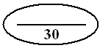
Name: __________

Kinematics Assignment #1
Gr. 11 University Physics

1. Making Connections questions often take multiple strategies and questions from the regular course and combine them together into single situations. Thus, the concentration isn’t on how to plug into formulas, but rather on understanding which formulas to use and how things relate to one another.

You are standing on an overpass, wishing to drop a parcel into your friend’s convertible when they pass under you. Your friend starts their car and begins traveling in the direction of the overpass from 100 m away, accelerating at a rate of 5 m/s². The overpass is 30 m high and you are planning on throwing the package downward at an initial velocity of 30 km/h.

The package must be released at the correct instant to land in the car. How many seconds should you wait after the convertible begins to accelerate before throwing the package downwards?

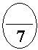
2. Relative velocity is expanded in grade 12 to include the concept of relative acceleration: combining the accelerations of two moving objects in one question. In grade 11, most students lack the math skill required to solve such questions (you need what math class calls 2-equation-2-unknown solving strategies). We can handle such questions in grade 11 by instead graphing them rather than solving them algebraically.

Two sprinters are identical in every detail except their capable acceleration. Sprinter A can accelerate at 0.7 m/s², while Sprinter B accelerates at a measly
0.2 m/s². Both runners start from rest facing each other from opposite ends of a 500 m long track. Sprinter A begins to run. Five seconds later, Sprinter B begins to run. How many seconds will elapse after Sprinter B begins to run before he/she passes Sprinter A? Construct a detailed position-time graph that gives a good approximation of the solution.

Use the space below to show rough calculations that you required to determine point positioning on your graph.

3. Velocity-time graphs displaying lines both above and below the origin (zero) can be quite confusing. Work on such graphs is exclusively left to assignments only, in order, to give you all the time you need to think carefully.

The velocity-time graph, from 0 to 30 minutes, of two speedboats is shown below.

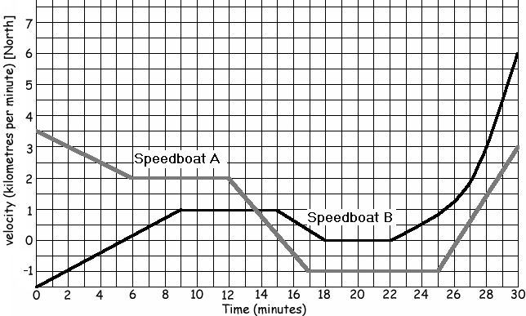

Carefully analyze the graph and solve the following question: which speedboat had the greatest displacement from 4 to 18 seconds, and by how much?


4. Throughout human history, different units of measurement have come and gone. Historic units were often based on rather strange and inconsistent reference points, which made it mandatory to change or eliminate these units as technology increased. We can still find descriptions of such ancient units in historic sources such as the Bible (for example, the construction of the Ark of the Covenant is described in detail using a mysterious measurement unit called the cubit).

During medieval times, land was being divided up into acres, a unit still used in real estate today. But what exactly was the acre? Read the following description from a historic source:

It is remembered that the Iron Ulna of our Lord the King contains three feet and no more; and the foot must contain twelve inches, measured by the correct measure of this kind of ulna; that is to say, one thirty-sixth part [of] the said ulna makes one inch, neither more nor less.... It is ordained that three grains of barley, dry and round make an inch, twelve inches make a foot; three feet make an ulna; five and a half ulna makes a perch (rod); and forty perches in length and four perches in breadth make an acre."

Using the information provided in the above description, solve the following relative velocity question:

A knight leaves the castle of the King travelling at a rate of three thousand perches per hour. After a twenty-four minute headstart, it is realized that a message must immediately be delivered to the knight. A squire leaves the castle in pursuit, galloping forward at a constant, top speed. How fast must the squire be travelling (measured in our common units of kilometres per hour) if he intercepts the knight exactly 6.7 minutes later?

