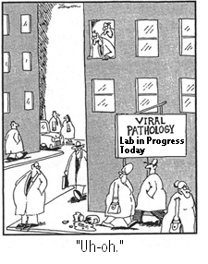
Writing Senior Physics Lab Reports

It is now an expectation that you write formal lab reports that are fully suitable for submission to university professors. You must understand this fact, as the flexibility you may have been shown on lab reports from grades 9-11 will no longer be present.

Before getting to a breakdown of the actual sections, read through the following vital points:

1. All group members must hand in an identical copy of the lab. Therefore, you must be capable of sharing your entire lab report electronically in a single file. That is, when you hit the print button on your computer, the entire lab must come out completed. You will receive heavy mark deductions for any detail added in afterwards. All diagrams must be completely computerized. All calculations must be completely computerized with all proper format included (for example, you will receive automatic mark deductions for pencilling in a few exponents or square roots signs because you couldn’t find the keyboard functions). Rough data pages that you wish to include must be scanned and included in the single, original file.

2. Every word written must be there for a specific purpose. No flowery words should be used. At no time, should personal pronouns be used in your lab reports. We don’t want to know about “I” or “my group”. It doesn’t sound professional. If you include funny comments, hacks on classmates, etc. I will probably laugh – but marks will certainly be deducted.

3. Lab reports must be handed in single-sided and stapled together. Do not use duo-tangs, binders or age protectors at any time. They make it difficult for the teacher to write on or take margins away.

TITLE PAGE:
Must include a descriptive title of the experiment placed in the centre of the page. Titling is extremely important with published work in physics. You will title your lab imagining that it is included in a database of lab reports shared by scientists around the world. In other words, if your lab title does not adequately reflect exactly what the lab is about, you will lose marks. The way you kept titles short and to the point in earlier grades is WRONG. Professional lab titles are made up of full sentences that give a tremendously detailed description of what the report is about. Take a look at a few cited examples:

Raman Scattering in the RTiO₃ family of Mott-Hubbard Insulators. ( from Phys. Rev. B, 55, 1442-8, 1997.)

Microstructural analysis of YBa₂Cu₃O_{y} thin films deposited on SrTiO₃ and LaAlO₃ substrates by off-axis magnetron sputtering. (from J. Appl. Phys, 78, 353-9, 1995.)

Molecular and morphological identification of Trichoderma isolates causing losses on North American mushroom farms. (from Appl. Environ. Microbiol. 64:133-137.)

As you can see, the days of “Accleration Lab” or “Rocket Lab” are over. You need to start titling your reports like a real scientist because you almost are.

In the bottom right-hand corner of the lab must be the following information:

STUDENT NAMES (CAPITAL LETTERS)
Course code and period number
Teacher’s name
(more about title page…) Date
This must be on blank paper and placed on a separate page from the rest of the lab. Note: title pages need not be decorated as no marks are given for this feature. Many university professors will actually deduct marks for this.

INTRODUCTION:
Introductions are not what they were like in previous grades. Most senior physics labs are going to be mathematical determinations of final values. Your introduction is therefore going to be more formula-based than information-based. However, you still want to start with a brief history or introduction of the base physics concept to be studied (especially in a way that doesn’t immediately plunge into wording that already assumes the reader knows what the lab is about). A brief historic background is still a very good way to “set the stage” in your opening lines. As well, you will want to explain the logistics behind any unusual or new equipment that you will be using in the lab. For example, not every reader is going to know what a ticker timer is. You will want to explain how data will be collected using the device. Quickly though, your introduction will point out specifically how you are going to go about collecting data and the formula methods you will use to extract final values from that data. Each formula must be clearly presented, separated from the paragraphed text (above and below) and centred across the page. All variables in these formulas are to be clearly and individually identified and defined in the proceeding paragraph, regardless of how “easy” or common they are. In this proceeding paragraph, you will want to bold-face or italicize the variables so that they stand out.

PURPOSE:
This is a statement in sentence form of what you want to discover or prove by conducting the experiment. This must be well-worded and exact. Most labs have a dual purpose. Make sure you know what the secondary purpose is.

MATERIALS:
This is just to be a list. However, this is now the senior level. Specific quantitative details must be included for every item on your list (eg. length, volume, number of, etc.)

APPARATUS:
This is a diagram of your lab set-up. It must have the following format for full marks. Placement is important. Don’t just do it on a separate sheet of paper and stick it into the lab where ever you feel it best fits. This section needs to be part of the body of your lab! If you can’t adequately stick the diagram in the right spot, attach it to the back of the report and call it by an associated “appendix” title. However, you still need to have an Apparatus section titled and placed right after your Materials section. Instead of showing the diagram, you would say “See Appendix I for diagram of set-up” or something similar.

Keep in mind the best method is still to have the diagram right there in the middle of your report. If it doesn’t fit… resize it! If you can’t because you only have a copy of it on paper… scan it and resize it! The days of excuses are over.
Title of Diagram

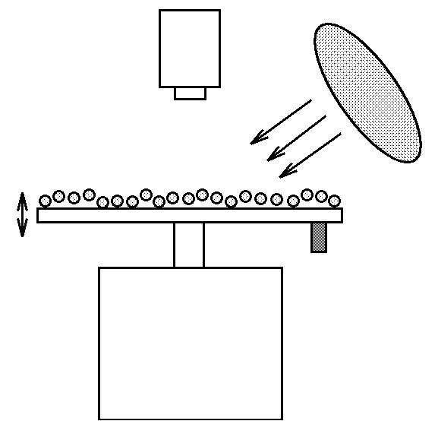
____________________________ label
_________________ label

________________________ label

_______________________________ label

SCALE: 1 cm (diagram) = ___ cm (true)
PROCEDURE:
Procedure must be written in past passive verb tense. This means that you are writing a report of what has already happened. If it sounds like a recipe, you have done it wrong. An example done correct would read: “2 N of horizontal force was used to drag the mass across the desk”. The wrong way to write the same step would be: “Use 2 N of horizontal force to drag the mass across the desk.” Procedures must be written out with numbered steps – do not use “bullets” or happy faces to mark each step. There is a reason for this! It may become important during your discussion later to refer back to a specific step in your procedure. The numbers will allow you to zero right in on the step in question. As well, procedure sections must be complete. That is, every single step required for someone to reproduce this lab needs to be included in full detail. If I hand your procedure to another science teacher and they say “But how did they actually do that step?” marks immediately begin to drop.

DATA: Any values collected during the lab must be presented in chart form. No calculations must be performed here – not even averages! Make sure that units are clearly marked.

CALCULATIONS:
All labs in this class will have a calculation section. Every single variable and formula detail must be typed. All units must be included perfectly. Repeat calculations (calculations that are all done the same, just with different numbers) are never shown. Instead, repeat calculations start with a sample calculation and have the remaining numbers in a chart. Great format would look something like this:

The following is a sample calculation for the determination of velocity from tangent #1
(see graph 2):

$\begin{aligned}v=\frac{d_{2}−d_{1}}{t_{2}−t_{1}} \\ v=\frac{\text{10}−5m}{4−2s} \\ v=2\text{.}5m/s\end{aligned}$

All of the remaining tangent calculations were done in the same way. The complete results are as follows:

Tangent | Calculated Velocity
1 | 2.5 m/s
2 | 5.4 m/s
3 | 14.0 m/s
4 | 36.2 m/s

ANALYSIS:
This section is what you used to call Discussion. Remember how you used to answer questions that somehow pertained to the lab? That is not what a true discussion section was supposed to be about. Discussion is more of an analysis of your calculated value – thus the new (and true) name for this section.
This is the only section that will be done different between grade 11 and 12, so read carefully.

If you are in grade 11, this is a section where you poke some doubt at your final values. You will want to discuss any uncontrollable errors that you feel affected your final numbers. “Discuss” does not mean “mention”! Do not just mention errors. You need to explain how the error affects your final value. This often means showing hypothetical calculations in an attempt to decide whether the source of error reduced your values or inflated your values. You need to show that you know HOW the error affects your numbers.
In grade 12, error analysis is much more complicated. In fact, the very first lab in grade 12 will give you far more details on error analysis. We will leave the details until then.

In a nutshell though, you won’t just be discussing errors and deciding whether they reduce or inflate your numbers – you will be calculating a numerical value for just how much this reduction or inflation is! Error analysis is the absolute bane of university labs. It will be a pain in your backside for years to come. Sometimes the error section alone takes 2-3 times as long to do than the rest of the report!

CONCLUSION:
Firstly, be sure that your analysis section does not come after your conclusion. This is a very common error fostered through earlier science classes in high school. Teachers would often have you conclude and then have a “Source of Error” section after the conclusion. Well…. your error analysis section isn’t a side-note to be mentioned in the end. This section should play an integral part of your final conclusion. Thus, it must come before the Conclusion section! Your conclusion is the culmination of the entire lab and needs to pull the entire report together. That is, it will be a statement of the final value determined in the lab, but will include the effects of errors associated with that value (as determined in your analysis section). Again, for grade 12 students, you won’t just be discussing the effects – you will have actually calculated a ± numerical range of “confidence” on the final value.

Be absolutely certain to look up, state and cite the actual/known value whenever possible.
As well, anecdotal comments will be included about the confidence in your final determined value, knowing what the real value is.

Good lab writing skills are going to save your life in university.
They may be the only make-or-break difference between attaining 80% grades or not. If you leave St. Mikes with only one good science skill, let lab report writing be it.

