Nathan Tang
Mr. Putman
SPH 3UO
15 October 2003

Rocket Lab

Introduction

Newton's first law of physics states that, “All objects will remain in a state of rest or continue to move with constant velocity unless acted upon by an unbalanced force.” This concept applies to how a rocket works, for two reasons. Firstly, a rocket remains at rest, unless an applied force, or an unbalanced force, is acted upon it. In this case the rocket fuel is to provide the rocket with the necessary thrust in order for it to escape the pull of gravity and lift off from the surface of the Earth. Next as the rocket is in the air, we can see how the next part of this law comes into effect, being that on object will move constantly unless acted upon by another force. In this case the rocket will continue to accelerate after its launch unless a force, being in this case gravity and air resistance, slows the rocket down. In the horizontal directions, left, right, forward and back, the forces must be balanced in order for the rocket to have a steady launch and flight path. If there is an unbalanced force in one of these directions the rocket will veer off track, suggesting why it is important to consider this rule.

Newton’s second law states that, “The acceleration of an object depends inversely on its mass and directly on the unbalanced force applied to it.” By Newton’s second law we can understand that the weight and applied force of the rocket will determine how much it accelerates. By comparing the thrust of an object to the mass we can determine the acceleration using this formula:
a = F_{net}
m

Where a is the acceleration in m/s², F_{net} being the net force being applied to it in N (Newtons), and m being the mass of the in kg. Although no calculations involving this formula were made in this lab, the variables can help us better understand which factors affect rocket designs.

Newton’s third law states that, “For every reaction force, there is an equal and opposite reaction force.” This law has an effect on this experiment because when the pressure produced by the combustion of the propellant exerts a force on the ground, the ground resists the force and pushes back on the object causing it to lift off. This resistive force is being exerted in an opposite direction of the applied force, therefore allowing the rocket to move in an upward direction.

These three statements form the basis for all motion in the universe, whether it be the space shuttle or a basic rocket. These statements collectively are known as Newton’s three laws.
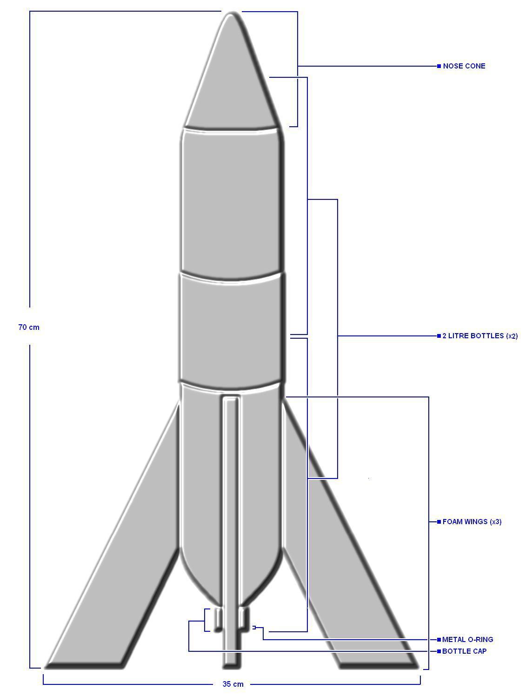
Diagram of Design I:

Figure 1

Explanation of Design I (Refer to Figure 1)

Utilizing two 2 L bottles, the main combustion chamber of the rocket was formed, because there was no physical way to allow the chambers to connect without destroying the strength of the bottle, only one bottle is functional. The nose cone of this rocket is made with a pylon, because of the polyurethane used it is very strong, but it also added excess weight to the overall structure. The wings were designed to utilize lightweight foam materials to stabilize the rocket during flight. The fins are constructed using two layers of foam board, which give the rocket a stable base. Next the combustion chamber was topped off with a metal washer than has a smooth even hole that provides ample space for the pressure of the explosion to exit the rocket base. Also used was a launch pad that consisted of a wood base and metal shaft. The flaw of this design was that the indentations around the shaft did not provide a smooth surface for the rocket to travel up. This friction may be a factor in the effectiveness of the rocket. The rocket has a fairly long design, approximately 70cm, mainly for the purpose of stabilizing it during takeoff and flight. The width of the rocket, at 35 cm, may be oversized considering the slim body. The rocket has a complex design but due to its weight it may have trouble collecting enough thrust to become airborne.

Purpose:

To determine which characteristics in a rocket’s design are necessary to overcome and utilize Newton's Laws to engage in a smooth successful flight.

Hypothesis:

If the design structure of the rocket is aerodynamically sound then chemical propellants will be able to launch the rocket upwards and maintain a straight path during the entirety of the flight.

Materials:

Rocket #1
- 2 - 2 L bottles
- Foam board
- Pylon
- Metal washer
- Hot glue
- Chrome spray paint

Rocket #2
- 1.5 L bottle
- Foam board
- 2 funnels
- Chopstick
- Hot glue
- Chrome spray paint

- Retort stand
- Matches
- Desk
- Metre stick
- Paper towels
- Lighter fluid

Procedure:

1. Characteristics of the rocket were discussed, debating the advantages and disadvantages of each design.
2. Rocket was filled with lighter fluid.
3. Metre stick was wrapped with paper towel and wet with lighter fluid.
4. Rocket was placed on the retort stand.
5. Paper towel was lit with a match.
6. Flame was placed under the outlet nozzle of the rocket to ignite the lighter fluid.
7. Observations of the combustion and pattern of flight, if any, were recorded.
8. Steps 1-7 were repeated for each rocket design.

Observations:

 | Design | Result
Natasha | - 2 L bottle  - Nose cone made of light paper  - Cone had flaps on either side of the rocket creating air resistance  - Wings were unstable | - Blasted off cleanly  - Rocket flipped in the air, most likely because of flaps.  - Better nose cone would have produced a better flight path
Sean | - 1.5 L bottle  - Combustion chamber smaller  - Hot glue may have produced holes in the plastic bottle  - Fins were unstable | - Lighter fluid did not ignite  - Possible speculation based on natural gas being placed inside the bottle before launch  - May have reacted with propellant
Bryan | - 2 L bottle  - Longer rocket  - Longer paper nose cone  - 4 fins made of flimsy card paper  - May be more stable in air | - Launched cleanly off platform  - Blasted off, but weight may have contributed to lower height  - Possible revisions include stronger wings and nose cone
Derek | - 2 L bottle  - Heavy rocket  - Duct tape nose cone  - 3 wings not evenly spaced | - Did not light because of natural gas inside rocket  - Also hot glue holes present  - Possible revisions lighter design
Mike | - 2 L bottle  - Very sturdy  - 4 styrofoam 1” fins  - Nose cone very well constructed | - Also did not light due to natural gas  - Possible revisions: don’t use natural gas
Dan | - 2 L bottle  - Loose fins  - Light design  - Very little complexity  - Masking tape application | - Launched but with little effectiveness  - Fins contributed to bad flight  - Possible Revisions: stronger adhesives
Nathan | - Dual 2L bottles  - Polyurethane nose cone  - Grossly overweight  - 3 Strong foam wings  - Launch pad created friction | - Rocket had clean combustion  - But due to excessive weight the propellant was not strong enough to successfully launch rocket  - Possible revisions: reduce weight
Alex | - 2 L bottle  - Flimsy wings  - Nose cone made of paper | - Flight pattern not very successful  - Possible revisions: improve fins and nose cone
Matt A | - 2 L bottle  - Very light weight  - Fins attached with tape  - Loosely applied nose cone  - Weak materials | - Due to light weight and weather conditions, wind blew over rocket and ignited the through the side of the rocket  - Revisions: slightly increase mass
Anna | - 2 L bottle  - Two wings  - Unstable wings  - Lightweight design | - Ignited cleanly  - Because of only two wings the rocket flipped in the air rapidly  - Had good momentum  - Revisions: more wings
Matt P | - 2 L bottle  - 2 smaller 500mL bottle attached to side  - 4 smaller wings  - Paper nose cone | - Lit cleanly  - Bottles on side produced drag causing rocket to spin uncontrollably  - Revisions: Remove small bottles
Kristien | - 2 L bottle  - Fins uneven  - Lightweight  - Cone was adequate | - Flipped in air  - Possibly due to odd number of fins and spacing  - Revisions: even placement of fins
Chuke | - Well designed rocket  - Sturdy nose cone  - Fins evenly spaced  - Medium weighted rocket | - Did not lit cleanly because of natural gas used  - Possible revisions: same design with not natural gas
Francesca | - 2 L bottle  - Heavy design  - Nose cone made of strong paper  - 3 fins on the bottle | - Ignited cleanly  - Combustion was not strong enough to over come weight  - Revisions: reduce weight
Mike II | - Same design as last time  - Washed out bottle from previous launch  - Still wet | - Side of bottle imploded  - Because of uneven combustion  - Residue from last launch may have effected second launch
Jueun | - 2 L bottle  - Strong cardboard tip  - Tape used to attach features  - Simple design | - Ignited effectively  - Flew not very high but  - Did not have a straight path  - Revisions: use better adhesive
Chuke II | - Rocket used previously  - No revisions except did not use natural gas  - Same design  - Still moist with water | - Rocket ignite but flew in a curve  - Path was deterred possibly by uneven combustion  - Possible revisions: clean out bottle better
Sarah | - 2 L bottle  - No wings  - Smooth exterior surface  - Popsicle stick base  - Even nose cone | - Ignited but flipped on table  - Lack of wings may have caused odd flight path  - Revisions: add wings and remove popsicle sticks on base
Caroline | - 2 L bottle  - Had now apparent wings  - Round cylindrical shape  - Nose cone made of paper | - Flew adequately  - Combustion was clean  - Possible revisions: stronger nose cone
Johnny | - 2 L bottle  - Large nose cone wrapped heavy in plastic wrap  - Discrete extrusions form wings on sides of the rocket  - Heavy rocket | - Because of heavy weight the rocket few a mere few metres  - The rocket had good combustion  - Possible revisions: reduce weight and redesign nose cone and fins
Derek II | - 1.9 L bottle  - Heavy duct tape nose cone  - Longer nose cone  - Weight may be too excessive. | - Did not produce a successful launch  - Possible revisions: reduce excess weight and revise overall shape
Nathan II | - 1.5 L bottle  - Complex nose cone with long shaft at the top  - 4 strong foam wings placed evenly at the base of rocket  - Longer and lightweight rocket | - Combustion was not as strong due to the smaller chamber  - Flew well in a smooth line  - Wings helped stabilize the rocket  - Possible revisions: Use larger bottle with same design.
Jonathan | - 2 L bottle  - Paper nose cone  - No wings present  - Utilized launch pad  - Extremely light weight | - Strong take off  - But lack of wings to stabilize rocket caused it to veer off course  - Possible revisions: Add some wings and restructure nose cone

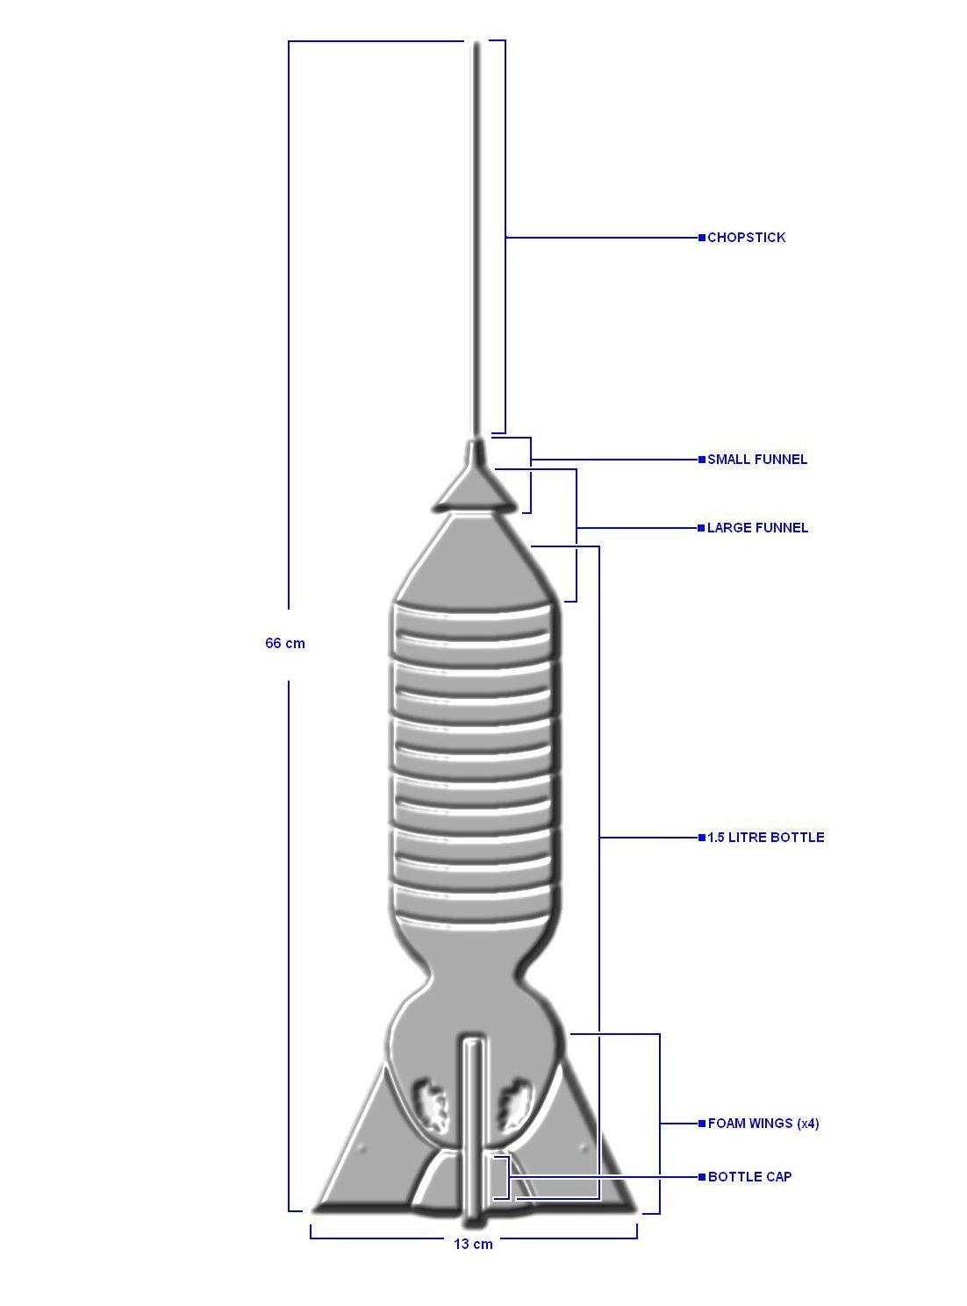
Diagram of Design II:
Figure 2

Explanation of Design II (Refer to Figure 2)

This revised version of the rocket has many new features. The new body and combustion chamber of the rocket was composed of a single 1.5 L bottle. It has an oddly shaped region near the bottom were it forms a spherical shape. This could positively or negatively affect the combustion results. The new nose cone is very intricate; it is built using a small funnel placed on top of a large funnel, topped with a chopstick spike at the top. The newer nose cone is lighter yet stronger than the original because of it’s dual layered design. By utilizing the longer structure it can pierce through the air more easily and produce less drag. The four foam fins on this design have a smaller shape than the original design and flow more easily with the main part of the rocket, producing a more stream lined shape. The length of this new design was 66 cm with a width of 13 cm, this ratio is much better than the first because air resistance has a smoother path around the object. Finally, the overall design has less mass than the first rocket, which will allow for enough acceleration to overcome the force of gravity.

Conclusion:

By observing each of the results the best characteristics for a rocket design can be depicted. Starting of with the main part of the rocket the combustion chamber, the individuals that utilized the 2 L bottles had an advantage over those using other shapes and sizes. This is apparent because the 2 L bottles had a larger volume area and smooth reaction centre for the reaction to occur. Also the gas inside the combustion chamber should not be natural gas, as some individuals though the gas would help ignite the fluid better. This however was not the case; the natural gas actually prevented the ignition of the lighter fluid. The nose cone on the rocket was necessary for smooth flight. By comparing the results, it is clear that the nose cone should be made of strong materials. Those with paper cones did not fair so well, because the resistance of the air was too much for it to withstand. Those with strong lightweight nose cones proved to have better results. The rockets tended to fly straighter and some higher. The fins of the rocket were essential in stabilizing the rocket. There were a variety of fin materials in this test. Centring on those that were evenly spaced with, 3-4 wings, strong and lightweight, we can see that they helped cut through the air and keep the rocket from veering off course. The way features were attached to the rocket was also important. Those who used such adhesives as tape tended to have more flimsy designs, and those who used glue had more stable rockets. And lastly the overall weight of the rocket was crucial, those will heavy rockets did not fly as high or did not launch at all, and adversely those with light rockets tended to fly uncontrollably due to the wind throwing them off course. The weight of the object needed to be just right for the rocket to fly smoothly and successfully. Newton’s laws of physics were apparent throughout every launch. Some experienced problems with unbalanced force and others rockets staying at rest. By using Newton’s laws to aid in our design we can solve the physical problems opposing rocketry. In conclusion, there are various physical factors that contribute to the success of a rocket; by harnessing the most appropriate of these characteristics will allow for a truly exceptional and admirable flight.

