Answers for Conservation of Electrical Potential Energy Homework
Gr. 12 University Physics

Conservation of Electrical Energy | - Section 8.8 (pg. 404 – 411) | - Pg. 428 (76, 77, 81)  - 3 photocopied questions from previous textbook

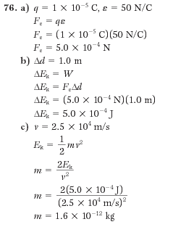

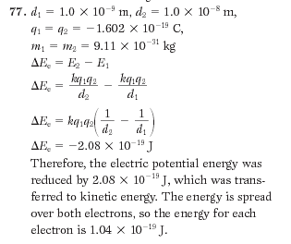

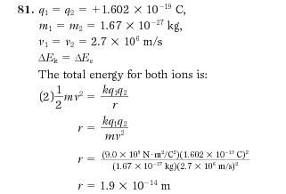

Additional Questions 3, 4, 5

3. Answers are provided in brackets at the end of the question. These are straight plug-ins. If you have problems, check your math.

4. This is a standard question like the examples we did. The only difference is that, instead of telling you details about how far the electron has been repelled, the book simply says “a large distance”.
$\begin{aligned}E_{\text{before}}=Ealignl{\begin{aligned}\text{after}\end{aligned}}_{}\end{aligned}\frac{{\text{kq}}_{1}q_{2}}{r}=\frac{1}{2}{\text{mv}}^{2}\text{etc}\text{.}\text{etc}\text{.}$ Quite simply, the translation of this is that all the electric potential energy in the beginning will be completely transferred into kinetic energy, with nothing left over. Quite simply, you will be using a relationship like this:

5. We did a question just like this in the examples. I would waste time writing up a formal solution but there isn’t any point. The answer is in brackets at the end of the question. There is no reason that you should not be able to get this answer when you have examples just like this question in your notes.

