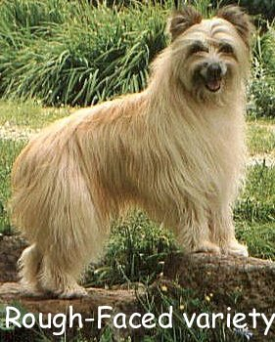
Size Pyr Sheps are small, but they have a large range of acceptable size. They run 15”-20” and 15-35 lbs.

Size is very hard to predict. Large dogs may come from small parents and vice-versa.

Biddability Pyr Sheps are highly affectionate, but are hard-headed compared to many herding breeds, and can be overly sensitive to correction. Success requires a handler with lots of experience & mature self-discipline.

Socialization Pyr Sheps require more socialization than any other breed. In their hearts, they are one-person dogs. They see no need for the rest of the human race to exist. Your job is to convince them that other people can be fun too. Successful socialization starts at birth and continues throughout the life of the dog. Even the most outgoing puppy can easily become shy & snappish if not given a lot of socialization.

Temperament The Pyr Shep is a small dog bred for thousands of years to boss hundreds of hundred-pound animals around on a daily basis. In some circumstances, their dominant-aggressive streak can be very amusing. But an under-socialized, out-of-control Pyr Shep can be problematic.

Pre-History Be skeptical of stories that the Pyr Shep is represented in the Lascaux cave paintings of 25,000 years ago, or that the Smooth-Faced variety was the original dog of the Cro-Magnon people. But Archeologists do say that from 6000-3000 years ago, the ecology of the Pyrenees underwent a radical transformation from forest to meadow and open woodland primarily due to overgrazing by goats and sheep. These Neolithic people had dogs, and these dogs may indeed be the foundation stock for the Pyrenean Shepherd.

History Pyr Sheps have inhabited the Pyrenees Mountains for hundreds or thousands of years. Until WWI, the Pyr Shep was subject to fairly stable geographic and cultural conditions. They are a product of a medieval feudal system, used in transhumance agriculture by peasants. The Pyr Shep was the constant companion of the human shepherd (often a younger son of a poor family). People who had this breed in their families for generations developed the Pyr Shep standard in the 19th century. The standard took its modern form in 1923 when the breed was FCI recognized and began competing in conformation shows and herding trials. There is no split between working and show lines.

The Present & Future The quality of the breed rests in the hands of the breeders themselves and what they make of their national breed club, the Pyrenean Shepherd Club of America. The breed has full recognition in FCI & Canada (in French it is called the Berger des Pyrenees), and has had AKC FSS status in the US since Jan 1, 2004. Beginning Jan. 1, 2007 they will be eligible to compete in the AKC miscellaneous conformation class, agility, obedience, rally, tracking and herding.

Performance Pyr Sheps love agility, flyball, herding, obedience, freestyle, rally, canicross, ring sport, frisbee, clicker, etc.

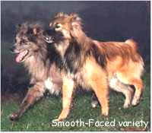

Drive Pyr Sheps are very high drive & love action. They love games; they love to show off their speed and power. You must provide them with opportunities to indulge these propensities and to keep physically fit.

Speed The Pyr Shep has one speed – Fast! There’s no denying that. But with great speed comes great responsibility. In agility this breed goes joyriding off-course and misses contacts at the speed of sound.

Genetics I Pyr Sheps are highly inbred. The breed comes from a mountainous area about the size of Ohio, and divided into valleys. For thousands of years, many Pyr Sheps lived their entire lives in the same valley and bred with their brothers and sisters. This produced a lot of genetic drift in which rare recessives –both good and bad- showed up often enough to be selected against or selected for. Many diseases were eliminated by natural selection, while good traits were generalized to the whole valley’s population and spread to other valleys via gene flow as a result of the periodic migrations involved in transhumance.

Genetics II Pyr Sheps are very healthy because of this genetic heritage, but certain diseases do show up including hip dysplasia, subluxated patellas, PDA, epilepsy, and some eye defects. The percentages are low, but no bloodline is immune to these. A breeder who tells you his line is clear might be lying or might be blissfully ignorant, but he is most assuredly wrong.

Genetics III The breed remains virtually unchanged. Modern breeders have worked hard to maintain the traditional standard. There is great superficial variation in color and coat length, but the underlying dog is surprisingly uniform in structure, temperament, and working ability. Pyr Sheps are divided into 2 varieties: Rough-Faced and Smooth-Faced. These are shown together in all classes except the Open classes, and also bred together and occur in the same litters. Ears & tails may be cropped & docked, or left natural. The breed is so inbred that it’s not really useful to think in terms of different bloodlines. In Pyr Sheps, there is no such thing as a true outcross.

