NAME : ARTI RAYSEE
ROLLNO. : 112
CLASS : III YR (PHARM D)

Assignment

Ammonium Chloride
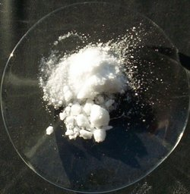

Submitted to
Ma’am Arfa

