Week Two

Question and answer
The system decides the nature of the next input by providing the question. It displays the prompt identifying the nature of the required response and the user has to input this information. The method of display can vary between teletype, page mode and pop up. Figure 3.1 shows an example taken from a game. Here, the potential answers can be selected by clicking on the appropriate radio button. Figure 3.2 shows an example taken from a command line system (MS DOS). He system has failed to read from drive and needs the user to decide what to do next. The input provided by the user is a single value and this may be free format or from a limited set of possible inputs.

Are you sure you want to Quit?

○ Keep Playing

◉ Yes, Quit
Figure 3.1 Question and answer (GUI interface)

Not ready error reading drive A

Abort, Retry, Fail?

Figure 3.2 Question and answer (Command line interface, MS DOS)

These dialogue types are moderately supportive of the user in that such a structure indicates the nature of the required response but not the actual value to be input.

Advantages
- Flexible - they are able to handle a variety of input data types and accommodate shortcuts. Question and answer dialogues can provided such facilities as defaults and answer ahead which will obviously help the novice user (defaults) and provide accelerators for the expert user (answer ahead).
- Useful for leading novices in the right direction.

Disadvantages
- It requires careful placing of prompts.
- It is important to ensure consistency between the different areas of the interface in order to ensure success.
- Question and answer can be tedious and does sometimes lead to feelings that the system is in control rather than the user. It is important that the user understands the nature of the information that the user understands the nature of this information that has to be supplied. It can be very frustrating for novice users who get stuck with a particular dialogue box because they are unsure what value the system is looking for. It is probably wise to provide defaults as a method of prompting the user for an appropriate value.

Menus
This is an interface type in which the system decides the nature of the next input. However, unlike question and answer, it displays a list of possible values in a variety of formats. Menus can offer a range of possible inputs, saving the novice user the task of trying to work out what sort of value might be required. The menu has the advantage that the user does not have to remember anything but merely to recognize it.
The types of menu available are many and varied. They range through all of the following examples:
- bar
- block
  - button
  - scroll bar
  - full screen
  - pop-up, pop-down, pull-down, drop-down
  - tear-off
  - walking menus (cascade menus)

The menu requests a selection from a list and the selection is made by:

- keying in an identifier
- scrolling down a list
- pointing to an item on a list

Figures 3.3 shows an example of a menu.
Menus can be found on GUI systems and command language systems. Selection is made in a manner appropriate to the particular system. A command language system may involve typing in an identifier. A GUI likely to involve pointing with a mouse or other pointing device. Menus are very supportive but they are do not provide flexibility. For example, only one selection can be made at a time.
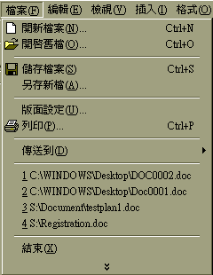
Figure 3.3 Pull down menu

Forms
The system decides the nature of a predetermined sequence of inputs and displays simultaneous requests for a complete set of inputs. Forms can consist of full screen or pop-up and each question may be answered by a question and answer, a switch or a menu. The user completes all input requests but the order in which this task is carried out is unimportant. The movement from one request to another is made by auto skip, where the cursor moves on when the field is complete, or manual skip, where movement is controlled by a control character or with a pointing device.

Users retain control of the form until they think it is complete and then offer it to the system by clicking on an acceptance button or pressing the return or enter key, for example. Most forms can also be cancelled, though this is not always the case. The system can provide validation of the various inputs by checking the values as they are input but more often, complete validation may not be attempted immediately but is deferred until the form is passed over to the system. At this point feedback may be given.

There are two types of forms: those that are designed for transcription input (that is, the screen matches a document that the user is working from) and forms which do not have corresponding documents. Where a form is used in conjunction with a printed document then the screen must match the document or errors are bound to occur.

These interface methods are very supportive but they are not very flexible. Short cuts can be accommodated by the use of defaults and abbreviations.

Care must be taken in the ordering and division of requests. The order must be logical to the users and must follow their idea of the task. Again, it is important to consider the positioning of those requests. Where input errors occur these need to be dealt with. The timing of error trapping is important. If the form is validated when the user sends it to the system then that could be a source of annoyance if an error has already occurred and the process of sending for validation causes unacceptable delays. Where possible it is better to trap each error as it occurs and to ensure that each input is correct before the form is sent to the system. On the other hand, errors can be trapped and corrected by default by the system. Obviously, the way in which this is dealt with will depend on what the user is doing, the level of user expertise and what is feasible. Incidentally, although automatically correcting user input to a default value that the system finds acceptable is one way of helping the user it can also be a source of frustration if the user does not know that the original value was not acceptable to the system nor why.

Forms have become much more important with the first generation of Web interfaces. Figure 3.4 shows an example of a World Wide Web form and Figure 3.5 shows an example of a typical set-up form.

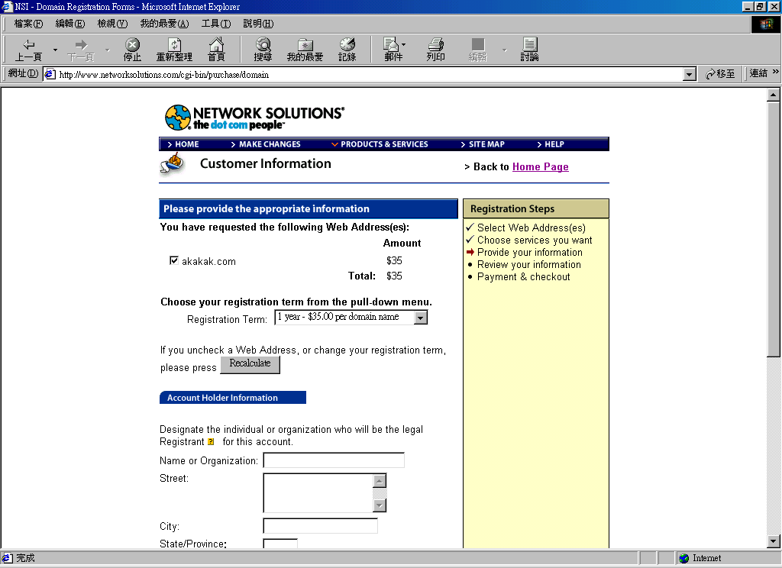
Figure 3.5. A world Wide Web Form

Command language systems

Command language systems were one of the earliest forms of communicating with a computer. The command language system offers a prompt which can range from a dot to a word or short phrase. The system issues request for input via a prompt and the user decides the nature of next input. The input is a complete task request and consists of commands which operate upon objects of interest. In many ways the structure of the command language is like a sentence. It has a subject which is understood to be the system, it has a verb which is the action part of the command, for example delete, and an object which is the item of interest which is to be acted upon, for example mytile.txt. Figure 3.6 shows a screen from a command line system. The modifiers are like adverbs and adjectives. Input can be seen as commands for what is to be done and keywords to describe what it is to be done to. The command keywords or operations can be used with optional modifiers if necessary. What is to be done to it is represented by positional parameter values and keyword/ parameter pairs.

Generally, most command language systems are not very supportive since users have to know what it is they want to do and how they can achieve that goal. With command language systems it is not possible to proceed unless the appropriate commands are known. But conversely flexibility is high and should not be underestimated since the user is free to use commands, keywords and parameters so long as the syntax is what is expected by the system. Some tasks are therefore very quick to perform because the modifiers can select the areas these commands will operate on.
The choice of commands and parameter keywords needs to be done with care; it is necessary to consider the command syntax and the structuring of the command hierarchy. The choice of language is important and difficult. There must be great care taken in whether or not commands will be shortened and in what way. Error messages have to be supportive and the help system has to be readily accessible and thorough. It is sometimes useful to have the help system structured in such a way that there are more detailed accounts available. The user is able to choose between simple or more complex help if necessary.
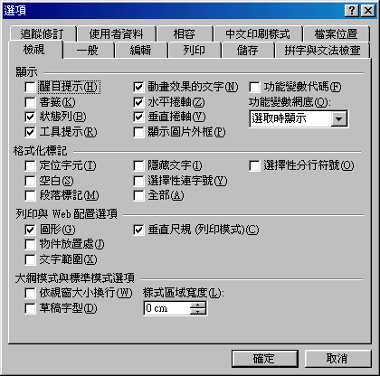
Figure 3.5 A form for setting up Word on PC

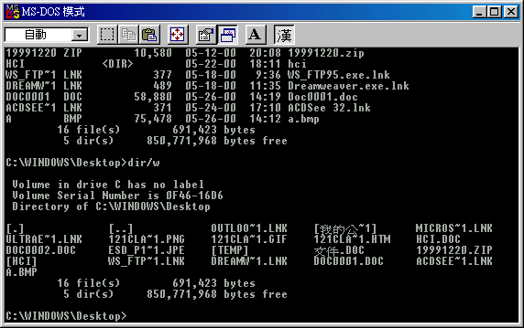
Figure 3.6 Example of command line system.

This is probably the most difficult type of interface to do well as there are many areas where grave errors can be made. A good command language system can be a joy to use because of the feelings of control it can offer the user, but sadly many command language systems are idiosyncratic to the extreme.

Direct versus linguistic manipulation

The previous section considered the major aspects of interface design. This section examines some of the advantages and disadvantages of direct manipulation systems (GUI) and linguistic manipulation systems (command language systems).

Linguistic manipulation
Linguistic manipulation systems consist of issuing commands and providing labels for objects which those commands will operate on. The task has to be translated into appropriate system commands which need to be remembered and typed in for the system to act. This puts a considerable burden on the user of the system since the commands have to be learned. They cannot be deduced from interacting with the system.
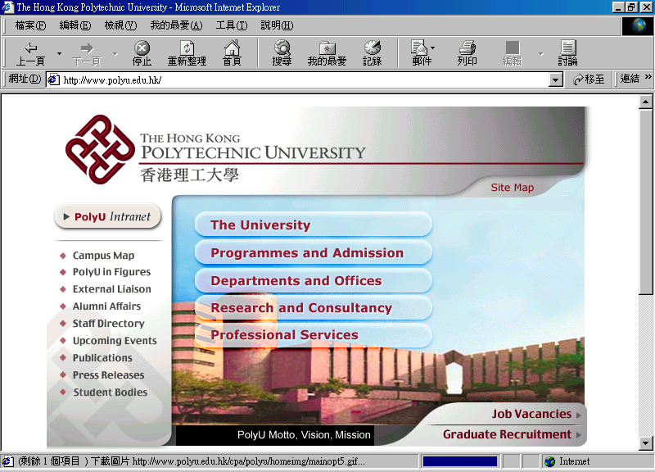
Figure 3.7 The World Wide Web using IE in PC.

Direct manipulation
This type of interaction provides a continuous graphical representation of current objects of interest that are physically manipulated by some sort of pointing device. There are labeled buttons to be 'pressed', icons can be dragged and their names overwritten. Menus can be pulled down and items selected. All manipulation is transparent and objects are represented by icons. Such systems can be seen as extended metaphors of the real world that they represent. Figure 3.8 shows an example interface from a game called Seahaven Towers. This consists of a click and drag interface which mimics a deck of cards. Metaphors are useful because learning involves the acquisition of new information into working memory, the retrieval of associated schemas from long term memory and the consolidation of new and old information into new schema. The generation of new metaphors is certainly an important part of the learning process. Principles are more readily absorbed from graphic- cal representations of problems rather than from symbolic (linguistic) representations.
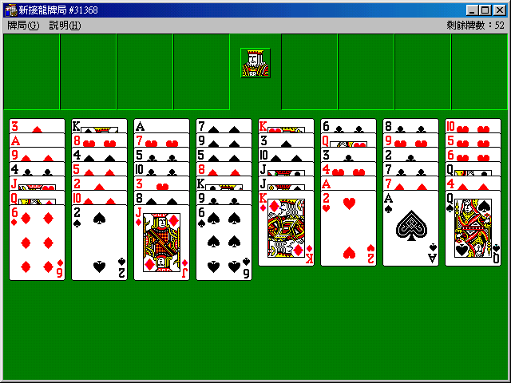
Figure 3.8. Click and drag interface mimicking a deck of cards

The iconic interface is designed to mimic familiar tasks and there are a variety of metaphors currently in use. The most obvious and common are:

· desktop
· paintbox
· spreadsheet

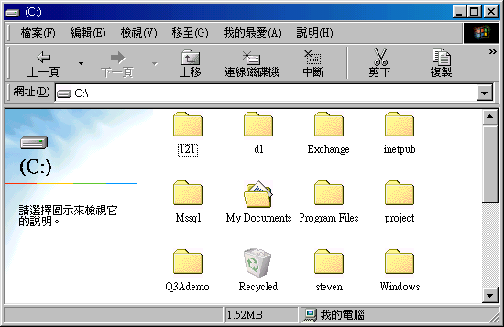
Figure 3.19 The directory folder of Windows 98

Figures 3.19 show example of this metaphor. Although graphical representations are easier to remember and recall than the equivalent linguistic token the icon still has to be interpreted accurately. In other words the user may well remember seeing an icon but that is no guarantee that its purpose will be recalled. Some icons are by no means obvious and even if the representation is recognized it does not mean that the functionality it supports will be obvious.

More importantly, there are no perfect matches available. For example, an icon must be selected before it is dragged. In the real world dragging and selection are much closer. There is no need to make the intention clear in two such separate steps. Furthermore, the user may well draw the wrong conclusions because of a misunderstanding of the metaphor or an interpretation of the metaphor that was not meant by the designer. For example, the user may use the wastebasket as temporary storage because a real wastepaper basket has been a useful temporary storage area in the past. The icons may not be understood by the user.

There is no guarantee that the iconic representation will be less verbose than the equivalent linguistic representations.

The advantages of the iconic interface are considerable. The user mimes the action by manipulating representations of objects. These actions have their equivalence in the real world. All this implies that the interface must support both continuous WYSIWYG (what you see is what you get) status feedback on all current objects and reversibility of actions. Iconic interfaces are easy to learn since the operation of the system relies on task domain knowledge and this operation can be learnt by demonstration. It makes retention of knowledge easier for intermittent users since there is no syntactic knowledge to remember. The knowledge of the system is held by the system itself, it is knowledge in the world rather than in the user's head. Such an arrangement reduces the memory load on the user since whenever a task needs to be performed, an examination of the system will tell the user what needs to be done. The interface is consistent since it represents the current state and the user can confirm progress towards the goals and adjust behavior if necessary. Status feedback is continuous and immediate. Because of this continuity of status representation and the WYSIWYG nature of the interface, there is easy reversibility.

Possible advantages of direct manipulation
Direct manipulation can be used rapidly by experts but it is true that for some things typing is quicker and shortcuts are not easily supported by a GUI. An examination of the short cut keys listed alongside the menus of a GUI word-processing package for example, will show that the short cut keys are many and varied.

Furthermore, the shortcuts are not particularly logical and cannot therefore be derived from common sense. They have to be learned.

It is argued that direct manipulation supports a wide variety of tasks but in reality it is seldom used for transaction processing and the limited set of operations represented by icons must be supplemented by quite large menus. Sometimes the structure of the menus can become quite large and GUI can still be forced into creating modes which are not transparent or obvious.

Finally, some people say that direct manipulation effectively allows the elimination of error messages but the truth is that using direct manipulation they make different ones. However, it is possible to decide what sort of errors will be made and which ones will be eliminated. A user is still quite capable of deleting important and needed files in a GUI as in a command language system, or making the wrong menu selection, or opening the wrong package etc. Direct manipulation does not and cannot eliminate all user errors! It simply means that the user makes a different set of errors from the ones that would have made with a command language system.

However, it is fair to say that the choice of the interface is an important consideration in deciding what sort of errors the user will make and that for some types of task the use of a GUI and direct manipulation might well reduce the occurrence of error.

Possible drawbacks of direct manipulation
It is argued that direct manipulation is based on a low-level of human intellectual development on the Piaget scale. Some people seem to think this is important. The same thing could be argued for a number of other activities. Personally, 1 do not need to be challenged by my computer interface, 1 have my video recorder to do that! However, 1 can understand that some people might feel that GUI interfaces talk down to them. If that might be a problem then another solution would have to be used.

Semantic errors are made rather than syntactic/lexical errors. It is a case of having to decide which errors the user will be permitted to make. It might be that the interface designer decides to prevent certain kinds of error from occurring.

Initial learning time is brief but it is necessary to consider the costs in terms of lost flexibility. The type of user is probably important here. If staff turnover is high then learnability might be the most important consideration. If speed is more important then an equivalent command language system might be faster.

There is the need to swap between keyboard use and the use of the pointing device. In the case of the mouse, some learning is required. Some people find it difficult to get on with. The skill does not come naturally!

It might be rightly conclude that direct manipulation is not superior to command language/menus but just different and it is necessary to consider the user's task before deciding which method would be best.

Not every user takes to GUls and some tasks do not easily lend themselves to graphical representation. Some people find the icons difficult to remember and guess the meanings of.

Nowadays, it is unfashionable to be a fan of command language systems. But even so, it is important to see that the type of interface offered to the user has to be appropriate to the task that is being performed. The very best interfaces will be a mixture of the various techniques available, according to the task that needs to be done. They will not be a product of fashion but the result of careful consideration of both users and the tasks they are attempting to perform.

Some design considerations

The following sections look at some of the problems of designing for particular types of work.

Reaction time
Reaction time is between 150 and 200 ms (0. 15-0.20 s) with 200 ms being typical. Reaction time can be affected by the following:

1 Simple auditory or tactile reaction time is approximately 40 ms faster than simple visual reaction time.
· When a stimulus is not expected or occurs infrequently reaction time increases. A study by Warrick et al. (1965) showed an increase of 100 ms when typists were asked to press a button if a buzzer sounded without warning. The typists reacted more quickly if they were pre-warned.
· Reaction time changes little between the ages of 15 and 60. More time is needed for those under 15 and there is a slight slowing of reactions after 60 (Keele, 1986).
· Stimulus in the periphery of vision are reacted to about 15-30 ms more slowly than centrally presented stimuli (Keele, 1986).

Movement time
This is the time needed to make the physical response called for by the stimulus. It is a measurement taken from the beginning to the end of the movement.
Human beings can move in some directions more quickly than in others. For example, controlled arm movements based primarily on the pivoting of the elbow take less time than those requiring upper-arin and shoulder movement. These former movements are also more accurate.

Attention
Attention seems to be something that can be directed. For the purposes of designing computerized systems for people, the following forms of attention can be examined:
· selective attention
· focused attention
· divided attention
· sustained attention (monitoring or vigilance)

It is important to remember that where systems do not take into consideration the user's capabilities, stress is likely to be the result.

Selective attention
Selective attention requires monitoring several channels of information in order to perform the task. As the number of channels increases so the individual's performance decreases. When people have to sample several channels they tend to sample those in which signals occur frequently rather than those where signals occur infrequently. Furthermore, the limitations of human memory cause people to forget to sample channels when many are present. People also tend to sample sources more often than would be necessary if they remembered the status of that source when it was last sampled.
Under stressful conditions, fewer sources are sampled and those that are sampled tend to be the ones perceived as being the most important. The actual importance of the source might not be as perceived by the end user.

Guidelines for selective attention
· The number of channels to be scanned should be kept to a minimum.
· The relative importance of the various channels should be made clear.
· The environment should be as stress free as possible.
· Information should be available as to where the next likely source of information will be.
· Users should be trained to scan effectively.
· Multiple channels should be as close together as possible.

Focused attention

The problem in designing for focused attention is to maintain the single channel of information without distraction. The ability to focus attention depends on the proximity in space of the sources of information. It is difficult to focus attention on one source if others are within one degree of the visual angle from each other. The designer of a system requiring focused attention should endeavor to make the information as distinct as possible so that the user is not confused by the various channels nor do those channels compete for attention or become muddled in the user's mind.

Guidelines for focused attention
· Competing channels should be as distinct as possible.
· Competing channels should be as far apart as possible.
· Competing channels should be kept to a minimum.
· The channel of interest should be bigger, brighter, louder or more demanding of attention.

Divided attention
Humans have a limited capacity to process information and that can be exceeded if several tasks have to be performed simultaneously. However, people do tend to try to do many things at once even if they do not make a good job of dividing their attention between many tasks. The more expert the behaviour, the more the likelihood of the user attempting to perform several tasks at once. When error occurs it might not be noticed and if it is it can lead to stress.

Guidelines for divided attention
· Potential sources of information should be limited as far as possible.
· The user should be encouraged to prioritize and prioritizing should be supported.
· The tasks should be as easy as possible.
· The tasks should be dissimilar in terms of input/output/modality so as to reduce the likelihood of confusion between them.

Sustained attention
The incidence of systems that require sustained attention or vigilance may increase as automated control systems increase.

Vigilance has been studied closely. Laboratory studies show a decline in speed of detection/accuracy as the task time increases. This occurs over the first 20 to 35 minutes of vigilance (Reason, 1990).

In real-life situations people perform better at vigilance. This could be accounted for by differences between laboratory and real-life situations. Perhaps the person performing a real-life task that requires sustained attention is able to summon up extra powers of care that the laboratory subject is not able to call upon. Or perhaps there are subtle and unnoticed differences between the laboratory task and the real-life situation. It is unclear why there should be these differences. There is not general agreement on why performance should decline during vigilance (Reason, 1990). Vigilance can be extremely stressful.

Guideline for sustained attention
· Work-rest schedules should be provided and different tasks done in order to reduce the amount of time spent on vigilance.
· The signal should be as conspicuous as possible.
· Uncertainty about when the signal is likely to occur should be reduced.
· Artificial signals and feedback should be provided.
· There should be adequate training and the skills acquired should be maintained.
· Motivation is important.
· Environmental distractions and stress should be minimized.

