Module: 1233
Title: Introduction to Hypertext and Hypermedia
Unit 7 Java Script Syntax & Program Structure

Objectives:
- Understanding JavaScript Data Type
- Understanding JavaScript Operator
- Understanding JavaScript Conditional Statement
- Understanding JavaScript Looping Structure

- Data Types
Unlike other Programming Language (e.g. Java, C++), the Data Type in JavaScript is simplified.
To declare a variable, you only need to define a variable name and assigning a value to it.

x=8; | Integer
x=0.123 | Floating point
x=3.14e3 | 3.14 x 10³
str=”Hello World” | String
Table 6.1 Summary of JavaScript Data Type

- Operator
There are two types of Operators: Arithmetic, Logical Comparison, String& Assignment.
  - Arithmetic:
-,+,*,/,%,++,--,-(negative)

  - Logical operators
&& AND
|| OR
! NOT

  - Comparison
== equals
!= not equal
< less than
<= less than or equals to
> greater than
>= greater than or equals to

  - String
+ Combining two string

  - Assignment
= i = 1;
+= i += 1; ➔ i = i + 1;
-= i -= 1; ➔ i = i - 1;
*= i *= 1; ➔ i = i * 1;
/= i /= 1; ➔ i = i / 1;

- Conditional Statement
Conditional Statement is used to check that some condition is true or not, it always used in if..else statement, switch statement.
Syntax: x(variable) logical operator y(variable)

Conditional Statement | Meaning
x == y | Is x equals to y?
x != y | Is x not equals to y?
x < y | Is x is smaller than y?
x > y | Is x is greater than y?

Example 7.3.1
<HTML>
<HEAD>
<TITLE> Java Script Lesson </TITLE>
</HEAD>
<BODY>
<H1><CENTER> Java Script Example 4 </CENTER></H1>
<SCRIPT LANGUAGE = "JavaScript">
num = 1;
if (num == 1) {
document.write("num is equals to "+num+".");
}
else {
document.write("num is not equals to "+num+".");
}\
</SCRIPT>
</BODY>
</HTML>

Output:
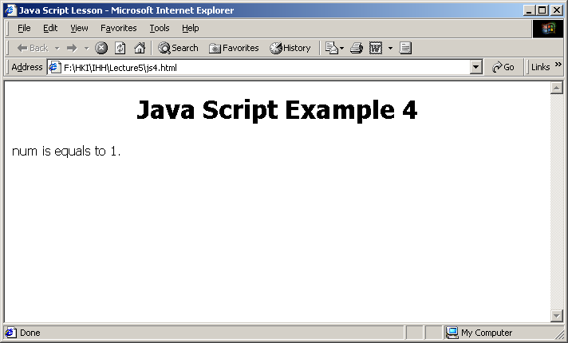

- Looping
Looping means something will repeat to execute. In programming language, Looping is common technique to make a segment of a program to execute many time until some conditions are achieved. So, a looping statement has two characteristics:
  - A conditional statement to check that the loop should stop or not.
  - An indicator to specify when the loop start and end.

There are three types of Loops in JavaScript: for, while, do…while

7.4.1 for Loop
When to use: if you know that how many time the loops will run, then for Loops is the most suitable choice.
Syntax: for(initialization ; conditional statement; increment)

Example 7.41. (filename:js5.html)
<HTML>
<HEAD>
<TITLE> Java Script Lesson </TITLE>
</HEAD>
<BODY>
<H1><CENTER> Java Script Example 5 </CENTER></H1>
<SCRIPT LANGUAGE = "JavaScript">
for(i=1;i<=10;i++){
document.write("num is equals to "+i+".<br>");
}

</SCRIPT>
</BODY>
</HTML>

Output:
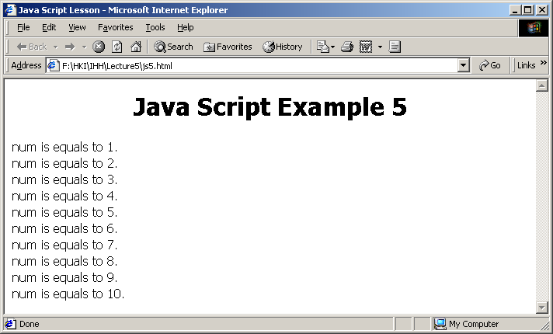

7.4.2 while Loop
When to use: If you don’t know when the loops will stop and the loop will run at least one time, then use while Loop.

Example 7.42. (filename:js6.html)
<HTML>
<HEAD>
<TITLE> Java Script Lesson </TITLE>
</HEAD>
<BODY>
<H1><CENTER> Java Script Example 6 </CENTER></H1>
<SCRIPT LANGUAGE = "JavaScript">
num =0;
while (num <=10) {
document.write("num is equals to "+num++ + ".<br>");
}
</SCRIPT>
</BODY>
</HTML>

Output:
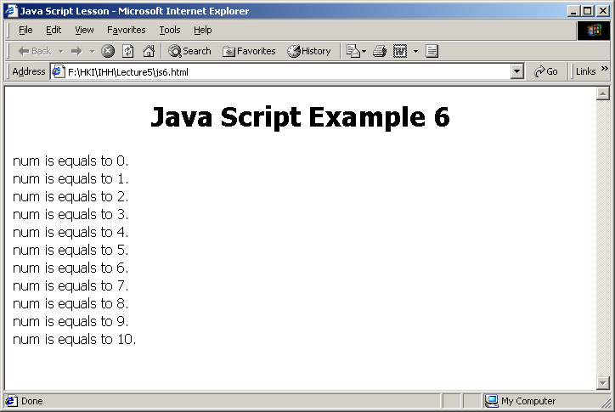

7.4.3 do while Loop
When to use: If you don’t know when the loops stop, then use do…while Loop.

Example 7.4.3. (filename:js7.html)
<HTML>
<HEAD>
<TITLE> Java Script Lesson </TITLE>
</HEAD>
<BODY>
<H1><CENTER> Java Script Example 7 </CENTER></H1>
<SCRIPT LANGUAGE = "JavaScript">
num =1;
do {
document.write("num is equals to "+num++ + ".<br>");
}while (num <=10)
</SCRIPT>
</BODY>
</HTML>

Output:
