Unit 9 Java Networking
Objectives:
- Introduction to Networking
- Understand TCP, UDP, port
- Understand Socket Programming

9.1 Introduction to Networking
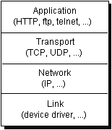
9.1.1 TCP
When two applications want to communicate to each other reliably, they establish a connection and send data back and forth over that connection. TCP guarantees that data sent from one end of the connection actually gets to the other end and in the same order it was sent. Otherwise, an error is reported.
TCP provides a point-to-point channel for applications that require reliable communications. The Hypertext Transfer Protocol (HTTP), File Transfer Protocol (FTP), and Telnet are all examples of applications that require a reliable communication channel. The order in which the data is sent and received over the network is critical to the success of these applications. When HTTP is used to read from a URL, the data must be received in the order in which it was sent.

9.1.2 UDP
The UDP protocol provides for communication that is not guaranteed between two applications on the network. UDP is not connection-based like TCP. Rather, it sends independent packets of data, called datagrams, from one application to another. The order of delivery is not important and is not guaranteed, and each message is independent of any other.

9.1.3 Ports
Generally, a computer has a single physical connection to the network. All data destined for a particular computer arrives through that connection. However, the data may be intended for different applications. the computer can forward the data to corresponding application by use of ports.
Ports are identified by a 16-bit number, which TCP and UDP use to deliver the data to the right application.

In connection-based communication such as TCP, a server application binds a socket to a specific port number. This has the effect of registering the server with the system to receive all data destined for that port. A client can then rendezvous with the server at the server's port, as illustrated here:

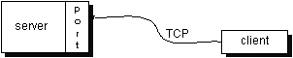
Fig 9.1

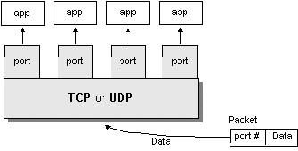
Fig. 9.2

9.2 Socket
Normally, a server runs on a specific computer and has a socket that is bound to a specific port number. The server just waits, listening to the socket for a client to make a connection request.
On the client-side: The client knows the hostname of the machine on which the server is running and the port number to which the server is connected. To make a connection request, the client tries to rendezvous with the server on the server's machine and port.
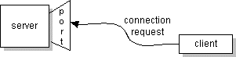
If everything goes well, the server accepts the connection. Upon acceptance, the server gets a new socket bound to a different port. It needs a new socket (and consequently a different port number) so that it can continue to listen to the original socket for connection requests while tending to the needs of the connected client.
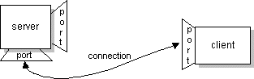
On the client side, if the connection is accepted, a socket is successfully created and the client can use the socket to communicate with the server. Note that the socket on the client side is not bound to the port number used to rendezvous with the server. Rather, the client is assigned a port number local to the machine on which the client is running.
The client and server can now communicate by writing to or reading from their sockets.

9.2.1 Reading from and Writing to a Socket
client = new Socket("wivern", 5000);
output = new DataOutputStream(client.getOutputStream());
input = new DataInputStream(client.getInStream());

The first statement in this sequence creates a new Socket object and names it client. The Socket constructor used here requires the name of the machine and the port number to which you want to connect. The example program uses the host name “wyvern”. This is the name of a hypothetical machine on our local network. When you type in and run this program on your machine, change the host name to the name of a machine on your network. Make sure that the name you use is the fully qualified IP name of the machine to which you want to connect. The second argument is the port number. Port number 5000 is the port on which the Echo server listens.

9.2.2 General Step of creating a socket program
This client program is straightforward and simple because the Echo server implements a simple protocol. The client sends text to the server, and the server echoes it back. When your client programs are talking to a more complicated server such as an HTTP server, your client program will also be more complicated. However, the basics are much the same as they are in this program:

- Open a socket.
- Open an input stream and output stream to the socket.
- Read from and write to the stream according to the server's protocol.
- Close the streams.
- Close the socket.

