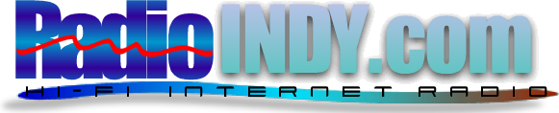
 | RadioIndy.com has named you a Gold Artist
Dear Hylton The Whistler Brown,
We screen thousands of songs by indie artists and name the best artists RadioIndy.com Gold Artists. We focus on musicianship, songwriting and recording quality when determining your Gold artist status. Congratulations - You are a Radioindy Gold Artist! Feel free to copy/paste the Gold Artist Logo above onto any website(s) to announce your award.
If there is ever anything we can do to improve your experience on RadioIndy.com, please let us know.
Congratulations,
Manny and Greg
Co-Founders, RadioIndy.com
MikVacch Enterprises, LLC (Radioindy.com)

support@radioindy.com • RadioIndy.com

