Ancient
China and India

India:
Brahmans
Kshatriyas
Vaisyas
Sudras
Untouchables
- Is the land of synthesis
- Civil Duties Pyramid→

- Caste system: system of Reincarnation’s Actions and religions.
- Mandate of heaven→the approval of the gods for a ruler to rule
- Beuracrat→politcal scholars and teachers
- Filial piety→ respect for the ancestors
- Dharma→Duty, responsibility
- Kharma→fate and the respect and duty you owe to your caste
- Advantages of caste→Order is kept, laws to live by, religion to follow
- Disadvantages→you were stuck in your caste until your next life, corrupt.
- In a caste system…reincarnation is taught→as you die, you move into your next life as a higher or lower classmen depending on how your previouse life was

China→
Shang | Chou
- Language came about and a period of great learning.
- Ch’in is the most successful ruler.
- Feudalistic

Qin | Han
- The great wall was built  - Fudalism NONO  - Legalism Thrived | - Confucianism and feudalism  - The golden age for china!!!!
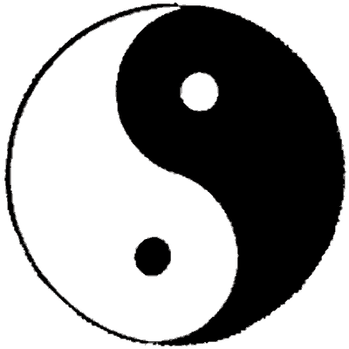
Yin and yang are the Chinese belief of the forces that control all of nature and the universe

