CCNA 2—Module 5 Study Guide

This study guide is not intended to be answered in one word or a short phrase. Aim for a complete answer of several sentences. Answer completely and exactly. You may have to reference more than one page of the curriculum to completely answer these questions.

Open this document and type your written answers—do not handwrite your answers on this sheet.

- What are the three main goals of the router startup routine?

- Generally, where does the router look first for the location of the IOS? What is the fallback sequence if the IOS is not found in this location?

- What is the configuration register, and how is it used? Where can you see the current settings? How can you edit the settings? How many of the hexadecimal digits can be edited? How many bits is that?

- What command allows you to customize the fallback sequence for booting the router?

- What is the effect of this command sequence?

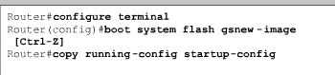

- Why is TFTP generally used to access a network server location for the IOS, rather than FTP?

- Should your router fail to boot, what four possible problems should you investigate?

- For each of the above possible problems, describe the steps you would take to troubleshoot each one.

- Clearly explain the differences between the three files shown.

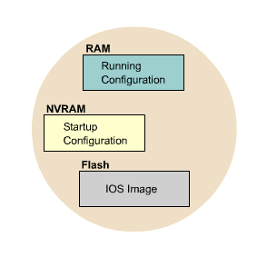
- What information can you get from the name of a Cisco IOS file? What does this filename tell you:

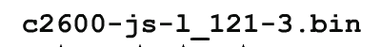

- What is the difference between the command router#copy run start and the command router# copy run tftp?

- What is the difference between the command tftpdnld and the command router# copy run tftp?

- How would you force your router to boot from the IOS image stored in flash? Why might you want to do that?

- What is the purpose of this command: xmodem -c image_file_name? Under what circumstances might you need to issue this command, and at what router prompt?

