CCNA 2—Module 6 Study Guide

This study guide is not intended to be answered in one word or a short phrase. Aim for a complete answer of several sentences. Answer completely and exactly. You may have to reference more than one page of the curriculum to completely answer these questions.

Open this document and type your written answers—do not handwrite your answers on this sheet.

- Distinguish between static and dynamic routing.

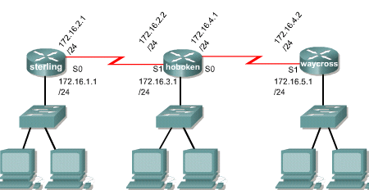
Figure 1

- Using the network configuration shown, enter the command to configure a static route from the network on the hoboken router to the network on the waycross router. (Use next-hop address)

- Using the network configuration shown, enter the command to configure a static route from the network on the hoboken router to the network on the sterling router. (Use out-going interface)

- What is meant by “administrative distance”? Explain the default values of administrative distance.

- Yesterday, you configured a group of static routes. Today, you see that one of the routes is not working. On checking your documentation, you see that you entered the command correctly. What is a likely reason for the route’s down status?

- How is the ip route command used to specify a default route?

- show running-config and show ip route are both used to verify successful configuration of static routes. What is the difference between these two commands?

- Compare and contrast: routing and routed protocols. Give examples of each in your explanation.

- What is an autonomous system, and what is the source of their numbering system?

- Define convergence and its advantages.

- Compare and contrast: distance vector and link-state routing protocols. Give examples of each in your explanation.

- Define the term metric as used in routing. Give several examples, with explanations.

- Routers operate primarily at OSI layers 2 & 3. Explain the functions at each of these two layers.

- Using Figure 1 above, give the commands to configure RIP on the hoboken router. Include the IOS prompts.

- Compare and contrast the key characteristics of RIP, IGRP, OSPF, and EIGRP.

- Differentiate between interior and exterior routing protocols.

