
B
CAA
EAA
DAA
AAA

Write and explain your answers:
A.
B.
C.
D.
E.

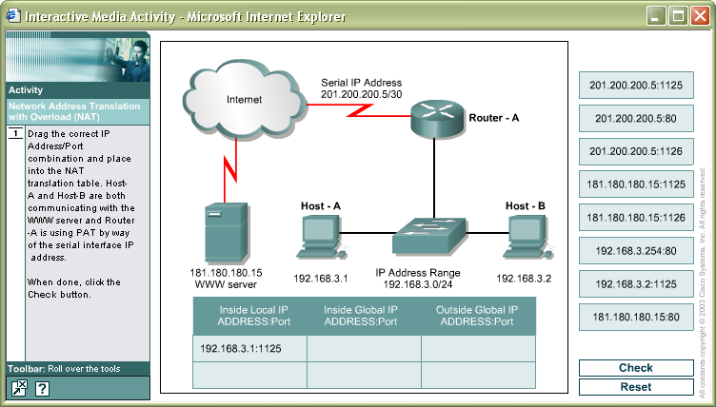
AAA
BAA
CAA
DAA
EAA

Write and explain your answers:
A.
B.
C.
D.
E.

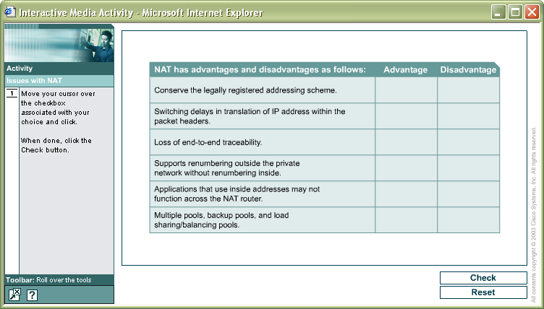
AAA
BAA
CAA
DAA
EAA
FAA

Write and explain your answers:
A.
B.
C.
D.
E.
F.

